BM – Base MES – Practical Training Document – Part 1

Contents

1. Preface 2
2. MES in Theory 2
2.1. OEE (Overall Equipment Effectiveness) 2
2.2. Technical Background 3
3. Sample Plant 4
3.1. Product Structure 4
3.2. Production Structure 4
3.3. Bill of Material (BOM) Structure 5
3.3.1. Hatchback Bill of Material 5
3.3.2. Sedan Bill of Material 6
3.4. Production Route 7
3.5. Operations 8
3.6. Quality Process 9
3.7. Availability 10
4. Case Scenario, Design Overview 11
4.1. Upper Part Bending 1 Operation Centre 12
4.2. Upper Piece Bending 2 Operation Centre 13
4.3. Wheel Operation Centre 13
4.4. Bottom Parts Bending Operation Centre 14
4.5. Upper & Lower Parts Assembly Operation Centre 14
4.6. Wheel Assembly Operation Centre 14
5. Case Scenario in MES 15
5.1. Case Scenario, Master Data 16
5.1.1. Layout 17
5.1.2. Employee Sub-Menu 28

Preface

Simply put, MES (Manufacturing Execution System) solutions primarily allow Production or Operations Orders transferred from applications such as Manufacturing Execution Systems, ERP, Planning Systems or Excel to appear on Operations Terminals in the workshop.
In the production area, Operators initiate and finish the relevant Operation Orders by using the Operator Terminals. They enter the Downtimes and Quality Losses that encountered during the operation into this terminal. Finished operations and production quantities are reported and transferred to systems such as ERP, APS, etc.
Thus, production is monitored online, and wastes such as Speed Losses, Downtimes, Quality Losses are reduced. In other words, the business makes money.
This document has been prepared to explain the BM Module in a basic way and with examples, and to enable the end user to set up their system.
This document is the first book in the series and there are similar books for other modules. But since the whole system is built on the BM module, it is very important to understand this module first.
This document consists of four parts
- MES in Theory
- Sample Plant
- Sample Scenario
- Application of the Sample Scenario to the Sample Plant

MES in Theory

In order to work cost-effectively, data related to production resources such as labour, machinery, materials and equipment used in production processes are collected instantly at the points where they arise and the necessity of instant monitoring of the processes has emerged.
MES systems and OEE (Overall Equipment Effectiveness) based production improvement studies to be based on it will lead to a decrease in waste in factories. An operation in production should be carried out at the ideal cycle time, without stopping and with zero quality error, provided that maximum attention is paid to occupational health and safety. Overall Equipment Effectiveness analyses this, providing many opportunities for improvement.
Wastes such as wasted electricity, wasted machinery, material losses and waste of labour time damage a factory by creating many negative consequences. The damage of that factory is the damage of that country, and the damage of that country is the damage of the world. By making our production more efficient, it is possible to be useful for the world to be a better place.
The value provided by a MES system can be expressed simply in numbers as follows:
Let's assume that you have an average turnover of $1,000,000 and a 20% profit and total expenses of $800,000. Assuming general administrative expenses ($100,000), marketing expenses ($100,000), and material expenses ($400,000), then $200,000 is direct labour and operational production expenses.
By applying the continuous improvement philosophy and OEE-based production improvement methods, it is possible to achieve at least 20% improvement in this business (even with Excel, a 10% efficiency increase can be achieved). This is at least 4% of the total annual turnover and means saving around 40,000 USD per year.
- MES systems also have the following benefits:
- Standardization of production
- Increasing capacity utilization
- Better Planning Increased on-time delivery rates
- Improved quality
- Reduction of maintenance breakdown costs
- Problems become foreseeable
MES systems enable the optimization of all production processes, from the start of work orders to the formation of the final product. MES bridges and controls the high-level planning layer such as MRP and the workshop
In addition, implementing MES-based improvement systems is much simpler and more cost-effective than many other tools and techniques

OEE (Overall Equipment Effectiveness)

Definition:
OEE = AVAILABILITY x PERFORMANCE x QUALITY
Availability: Percentage ratio of equipment actual working time to total working time
Performance: Percentage of deviation from the ideal cycle time of operations
Quality: Ratio of defective products to total manufactured products.
An ideal enterprise should make its production without stopping its machines, in full cycle time and with 100% quality. İn such case OEE is calculated as:
OEE= 1 x 1 x 1 = %100
More about calculation terminology:
Total Time
Planned Production Time |  |  |  | Planned Downtime
Run Time |  |  | Availability Loss
Net Run Time |  | Speed Loss
Full Productive Time | Quality Loss

A plant can theoretically operate 24 hours a day, 365 days a year.
Intentionally, we can give up part of our capacity by working 1 shift or 2 shifts or taking lunch breaks. This is “Planned downtime and OEE is not consider such losses.
The best accepted OEE value in the world is as follows
OEE= Availability (0.9) x Performance (0.95) x Quality (0.99) = 0.85 = %85
We believe that taking our businesses to these levels will help reduce waste and benefit the world.
OEE is among the commonly used indicators for measuring the performance of production systems. The main function of a MES is to provide key performance measures that can be used in manufacturing processes such as availability, performance, quality ratios and OEE, which is the product of these three ratios.
With these criteria, the success performance of a machine can be measured as well as the holistic performance of a process, an operation centre, a line or a factory. Availability, performance and quality metrics evaluate the performance of a piece of equipment from different angles. Data collected from manufacturing processes and OEE reports provide managers with invaluable information to maximize a piece of equipment's efficiency and uptime.

Technical Background
The implementation in this document was carried out through BM, a cloud-based MES. The input of the BM module is the operation orders from an ERP, Scheduling software or Excel. There are touch screen terminals in the operation centres in the shopfloor. These terminals are used for operators to make the data entry required for MES. The topic of the terminal is explained in detail in the next section. Remote connections provide the infrastructure for the communication of the whole system.
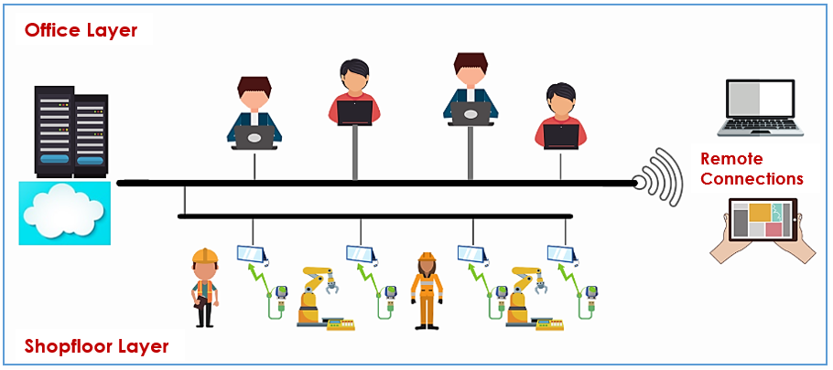
Figure1.4. MES General Overview

For the effective operation of a MES system, it is required to have terminals in the shopfloor.
Terminals are one of the most basic tools used to collect data from production processes. Operator terminals must first be placed within the easiest reach of the operator while working.
The terminals instantly alert the operator when an error occurs. The operator himself solves a problem in a minute, the team leader in an hour, the department chief in a day, and the production manager in a week. Therefore, the operator is the most rational person who can intervene immediately in that error.
Depending on the preferred topology, a different number of operations centres (eg. 4, 2 or 1) can be assigned to the terminals and 1 terminal can be shared by more than one operator. These terminals must be able to connect to the Internet. It is also recommended to be 15" in order to be able to use advanced functions such as Document Management in the future. If the traceability module is preferred, barcode reader and barcode printer interfaces should be available.
As is known, production environments are usually environments with different characteristics. Therefore, the dust, water and heat resistance of the terminals according to the environment is another important issue. In terms of dust, it is already preferred that the terminals are generally fanless. Keyboard, mouse, etc. takes up space and the touch of the screens in terms of practicality of use is another feature that has been requested recently.
If the touch screen is to be used, it should be preferred to be a resistive screen, not a capacitive one. Because resistive screens work with the applied pressure, capacitive screens work with the temperature and contact of the hand. If operators in production use gloves, etc., it is possible to have problems with the use of capacitive screens. For resistive screens, it is recommended to use a small pen. Thus, the fact that the operators have oil in their hands will not affect the system. In addition, it should be preferred to use the terminal under a structure such as a kiosk.
The terminals must be securely installed in the operating area.

Sample Plant
This scenario was carried out on a toy company called Toy Inc. The aim of this study is to explain the basic structure of a MES with a scenario and it is constructed with a simple production structure. Toy Inc. is a company engaged in the production of cardboard cars. In this section, the cardboard car production structure will be explained in detail, and in the third part, this structure will be built on the BM (Base MES – Basic MES) system and production processes will be provided. Afterwards, the reports resulting from production will be examined

Product Structure

TOY INC. (Figure 2.1) produces two models of toy cars, the HB0001 coded Hatchback and the SD0001 coded Sedan.

 | 
Hatchback | Sedan
Figure 2.1. Toy Inc. Product Range

Production Structure
The company has two main divisions, Preparation and Assembly. The preparatory department is divided into two operation centre groups as Upper Part Preparation and Other Preparation. The Upper Part preparation operation centre group consists of two operation centres, Upper Part Bending 1 and Upper Part Bending 2. Under the Other Preparatory operation centre group, there are Wheel and Sub-part Bending operation centres. The parts produced in the Preparation part come to the Assembly section and the production is completed by passing through the Upper-Lower Assembly and Wheel Assembly operation centres under the name of the lower assembly operation centre group.

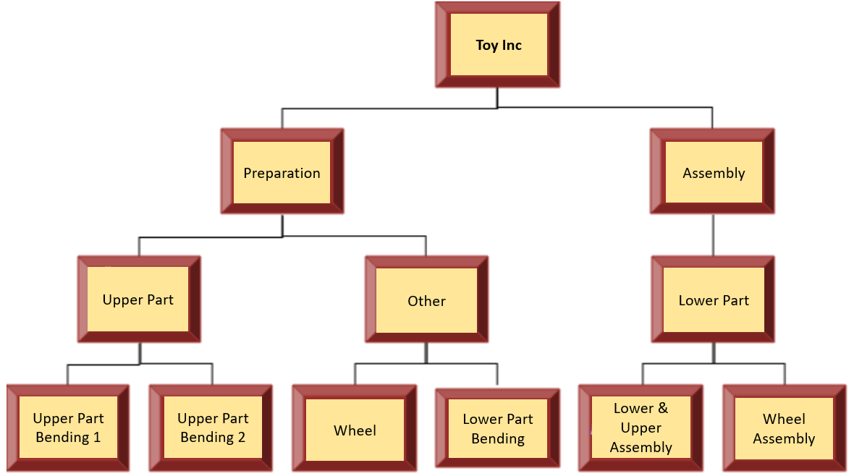
Figure 2.2. Toy Inc. Production Structure

Bill of Material (BOM) Structure
In this section, the BOM structure of the Hatchback and Sedan models produced within the company is explained.

Hatchback Bill of Material
In the production of hatchback model, which is one of the vehicles produced by the company, two types of cardboard raw materials are used: Red Cardboard and Black Cardboard Strip. The lower and upper parts of the vehicle are formed from Red Cardboard and 4 wheels are produced using Black Strip Cardboard. Here, Red Cartons are supplied from the supplier cut to the appropriate size. In other words, there is no Red Cardboard cutting. In the next process, the upper and lower parts are joined with transparent tape. Finally, using the adhesive raw material, the toy car is ready by mounting the wheel on this combined upper and lower part. Figure 2.3 shows the product tree of the hatchback model.
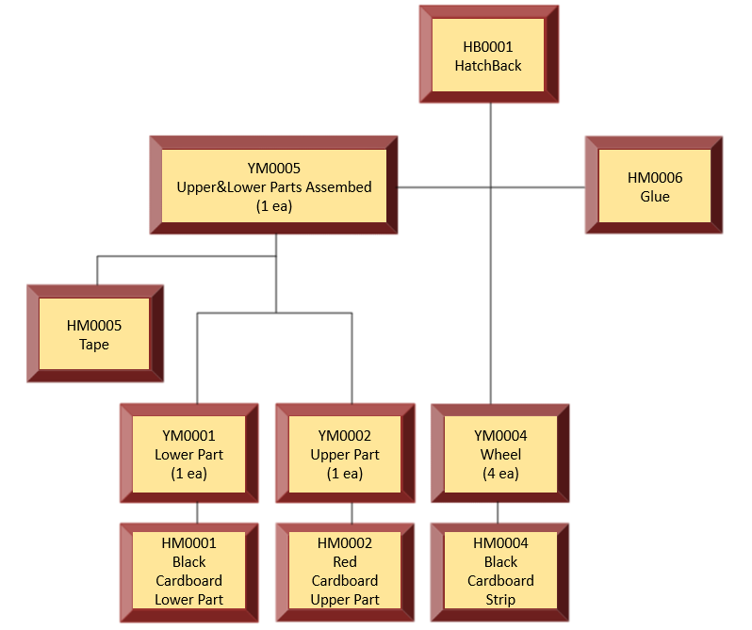

Figure 2.3. Hatchback BOM

Sedan Bill of Material
The sedan's product tree is very similar to the hatchback's pipeline and is shown in Figure 2.4. Accordingly, in the production of this model, two types of cardboard raw materials are used as red cardboard and black cardboard strip. The lower and upper parts of the vehicle are formed from red cardboard and 4 tires are produced using black strip cardboard. In the next process, the upper and lower parts are combined with transparent tape and the vehicle production is carried out as a result of the wheel assembly on this combined lower upper part by using adhesive raw material. Red cartons are supplied from the supplier cut to the appropriate size.

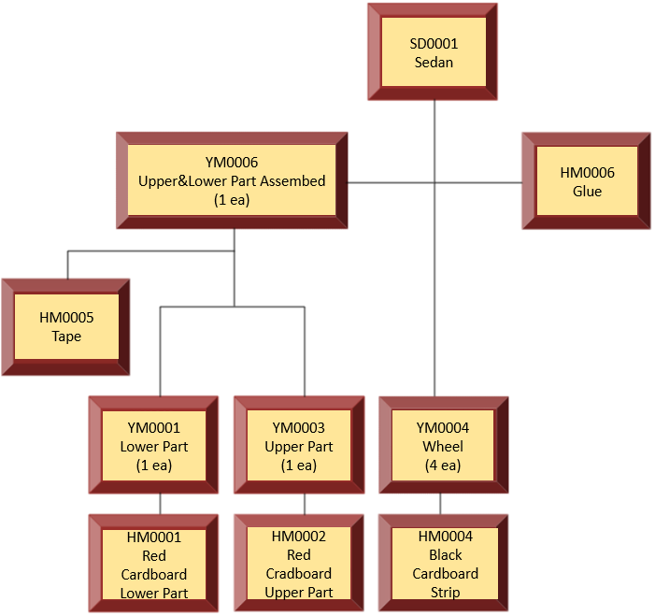
Figure 2.4. Sedan BOM

Production Route
Vehicles manufactured in the company go through a series of operations in a certain order. First of all, the production of Work-In-Process to be sent to the production department is carried out at the preparation stage. Accordingly, wheel cutting (OP0001), upper part bending (OP0002 or OP0003 (depending on the model of the car to be produced)) and lower part bending (OP0004) operations can start at the same time. After the upper and lower parts bending operations are completed, the Work-In-Processes are transferred to the lower and upper joining (OP0005) operation. After this process is completed, the wheel installation (OP0006) operation is performed together with the Work-In-Process from the wheel cutting operation and the toy car is ready as a finished product. The route of both models produced by the company is the same and is given in Figure 2.5.
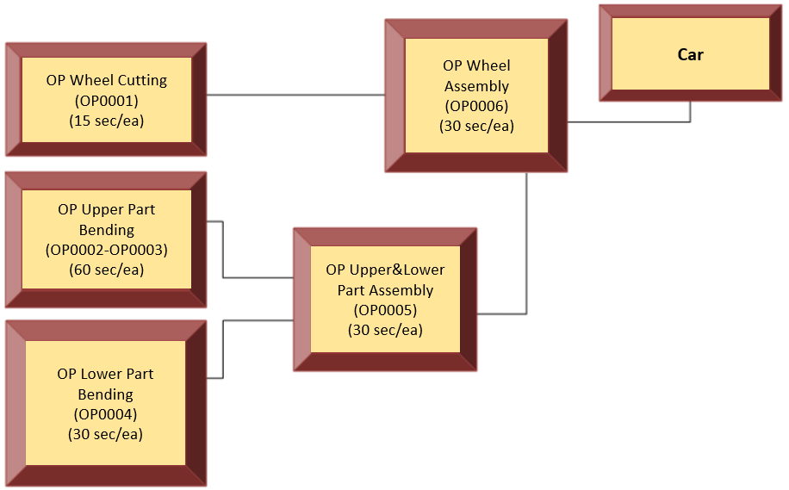
Figure 2.5. General Production Route

Operations
This section describes in detail in Table 2.1 the operations that are linked to the production route from the previous section, together with their images.

Table 2.1. Car Production Operation Descriptions
Explanation | Image
The Work-In-Process (YM0001), which is common to both models, is produced with a cycle time of 30 seconds for 1 piece using red cardboard-AP raw material with the Lower Part Pending Operation in the Lower Part Bending Operation Centre. | 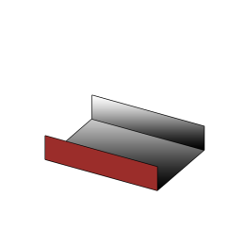  
The cycle time of Upper Part Operation in the Upper Part Bending 1 Operation Centre of the hatchback Model Upper Piece Work-In-Process (YM0002) is 60 seconds. In this operation, Red Cardboard-UHD Raw Material is used. | 
The cycle time of the Upper Part Operation of the sedan model Upper Part Work-In-Process (YM0003) in the Upper Part Bending 2 Operation Center is 60 seconds. In this operation, Red Cardboard-USB raw material is used. | 
The Wheel Work-In-Process (YM0004) is manufactured by Wheel Cutting Operation with a cycle time of 15 seconds using Black Cardboard Strip Raw Material in the Wheel Cutting Operation Center.

YM0001 and YM0002-YM0003 Work-In-Process are combined with a cycle time of 30 seconds by Upper-Lower Assembly Operation in the Upper-Lower Part Assembly Operation Center to form YM0005 Lower-upper Part-HB or YM006 Lower-upper part-SD Work-In-Process. | 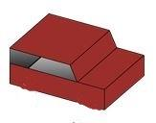  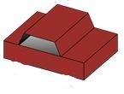
YM005 Lower Upper Part – HB and YM006 Lower Upper part – SD Work-In-Process is assembled with four wheels. The wheel installation operation is glued using adhesive with a cycle time of 30 seconds in the Wheel Installation Operation Center and hatchback and sedan model cars are manufactured. | 

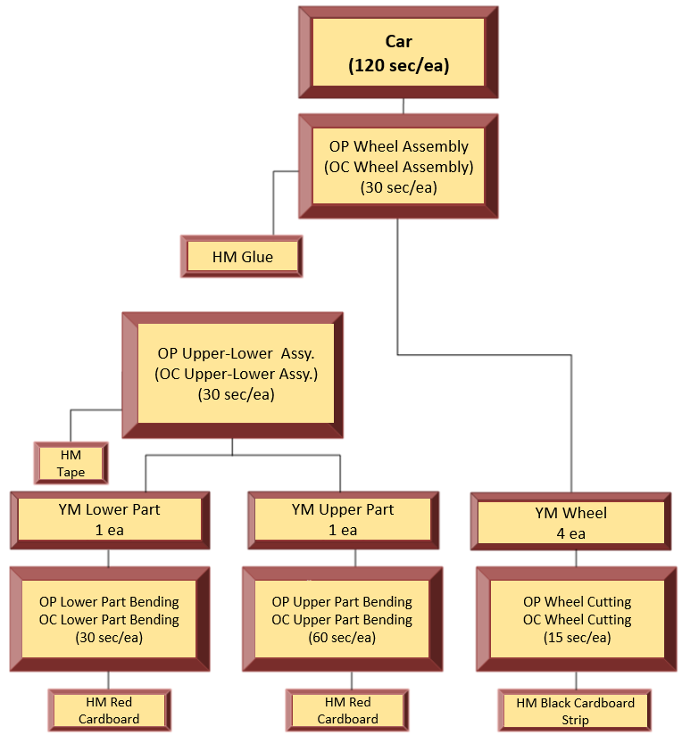

Figure 2.6. Detailed car production structure

Quality Process
One of the parameters of the OEE criterion, which is the cornerstone of a MES, is quality. For this reason, in order to obtain quality-based data in production processes, first of all, the definition of the failure modes that cause faulty production should be made. Each manufacturing process has its own error definitions. Within Toy Inc., faulty production sources are divided into two main groups as “internal” and “external” sources. Internal errors refer to errors arising from internal processes caused by the company, and external errors refer to production errors arising from external sources such as subcontracting, sub-industry, suppliers. In order to define and manage bugs in more detail, it is necessary to divide these groups into more detailed subgroups. Thus, it will be possible to easily define the new problems that will arise under a related group.
The main group of internal errors is divided into two subgroups, "measurement error" and "visual error". Under the measurement error group, "measure short" and "measure long", and under appearance error, "scratched" and "wavy" are defined. Thus, it will be possible to find the errors arising from production and their causes within the company and to analyse more clearly what should be done during the improvement phase. The main group of "external" errors is divided into two subgroups, "measurement error" and "visual error", as is the main group of "internally sourced" errors. Under the measurement error group, "measure short" and "measure long", and under the visual error, "scratch" and "wavy" are defined. With these definitions, necessary measurement, analysis and prevention studies can be carried out to minimize external errors. This entire structure is shown visually in Figure 2.7.
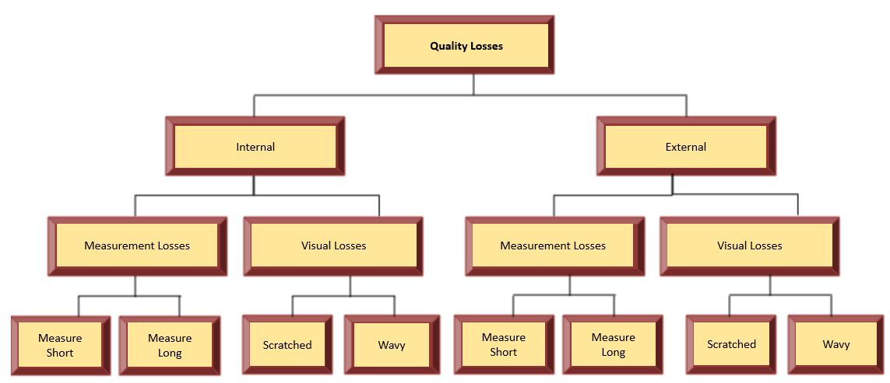
Figure 2.7. Quality Loss Definitions

Availability
Availability is another parameter of the OEE criterion, as is quality. In order to determine the availability rate in a production process, it is necessary to determine the elements that will cause interruptions in the process and to collect data about them.
For this reason, two main Downtimes groups were formed, “From Operation Centre” and the “From Other Sources”. The main downtime group “From Operation Centre” is divided into two subgroups as "Breakdown” and the “Other”.
Breakdowns such as “Scissors Failure”, “Ruler Failure”, and "Fixture Failure” are defined under the "Breakdowns” subgroup. Under the “Other” subgroup, there are three types of breakdown types: “Setup”, “Meal Break” and “Toilet Break”.
“From Other Sources” group, is divided into two subgroups: “Logistics” and “Engineering”. Under the subgroup of the “Logistics”, “No material” and “Missing Material” is available.
In the “Engineering” subgroup, there are “No drawing” and “Wrong drawing”. All downtimes except the “Meal Break” are seen as unplanned downtimes. Since meal break is inevitable, "Meal Break" is defined as "Planned Downtime". See Figure 2.8. for details
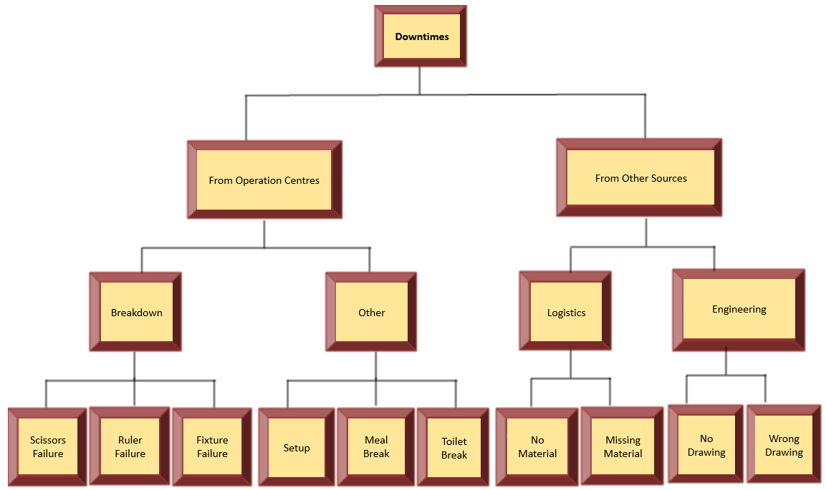
Figure 2.8. Downtime Types

Case Scenario, Design Overview

In this section, a sample application will be made for Toy Inc. 100 of the Hatchback and Sedan cars produced by Toy Inc. will be produced. During production, the stoppages and quality errors described above will occur and OEE will be calculated for each operation centre.
The Work-In-Process and operations required for the 100 hatchback models whose route is shown in Figure 2.9 are as follows:
- 100pcs Hatchback Top
  - OP0002 Upper Part Bending 1 Operation

- 100 pieces of Lower Parts
  - OP0004 Below Part Bending Operation

- 100 pieces Upper- Lower Part HB
  - OP0005 Upper- Lower Part Assembly Operation

- 400 pieces wheel
  - OP0001 Wheel Cutting Operation

- 100 pieces hatchback
  - OP0006 Wheel Assembly Operation
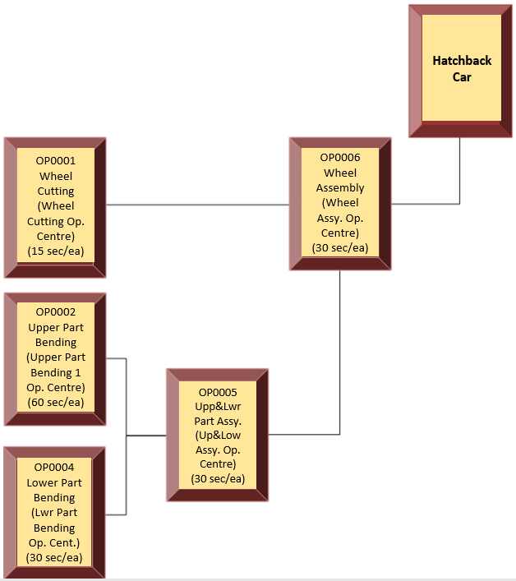
Figure 2.9. Hatchback Model Production Route

Similarly, the Work-In-Process and operations required according to the production route shown in Figure 2.10 for 100 sedans are given below.

- 100pcs Sedan Top
  - OP0003 Upper Part Bending 2 Operation

- 100 pieces of Lower Parts
  - OP0004 Below Part Bending Operation

- 100 pieces Upper- Lower Part HB
  - OP0005 Upper- Lower Part Assembly Operation

- 400 pieces wheel
  - OP0001 Wheel Cutting Operation

- 100 pieces Sedan
  - OP0006 Wheel Assembly Operation

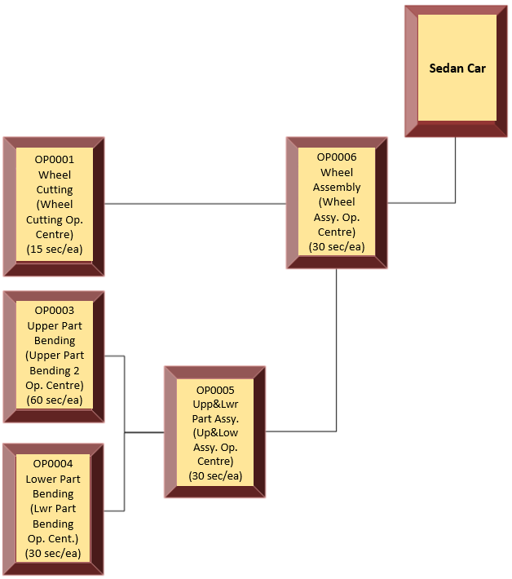
Figure 2.10. Hatchback Model Production Route

Upper Part Bending 1 Operation Centre
In this operation centre, OP0002 upper part bending HB operation is performed. Operation order I00000000000463 was created for 100 YM0002 upper part HBs. In this operation centre, the following operations took place:
- 30 min. production
- 30 min. Fixture Failure
- 80 min. production

As a result, the production of 100 pieces took 110 minutes.
The OEE calculation for the Upper Part Bending 1 Operation Center is as follows:
Availability = Run Time / Planned Production Time
Availability = (30+80) / (30+30+80) = 0,7857 = 78,57 %
Note:
- Run Time = Planned Production Time – Availability Loss
- Planned Production Time = Total time - Planned Downtime

Total Time
Planned Production Time |  |  |  | Planned Downtime
Run Time |  |  | Availability Loss
Net Run Time |  | Speed Loss
Full Productive Time | Quality Loss

Performance= Target Cycle Time / (Run Time / Total Pieces)
Performance = 60 / (6600 / 100) = 0,9090 = 90,90 %
Note:
- 110 min run time = 6600 sec. Run time
Quality Rate = Good Pieces / Total Produced Pieces
Quality Rate = 100 / 100 = 1 = 100 %
Upper Part Bending 1 Operation Centre OEE = 0.7857 x 0.9090 x 1 = 0.7142 = 71.42 %

Upper Piece Bending 2 Operation Centre
In this operation centre, OP0003 Upper Part Bending SD Operation is performed. Operation order I00000000000464 has been created for 100 YM0003 Upper Part SD. Here's what happens in the operation centre:
- 15 min. no material stop
- 100 min. production
- Production of 100 pieces
- 2 Quality Losses caused by “Measure Short”

OEE calculation for the "upper part bending 2" operation centre:
Availability = 100 / (15+100) = 0,8696 = 86,96 %
Performance = 60 / (6000 / 100) = 1 = 100 %
Note:
- 100 min run time = 6000 sec. Run time
Quality Rate = 98 / 100 = 0,98 = 98 %
Upper Part Bending 2 Operation Centre OEE = 0.8696 x 1 x 0.9800 = 0.8522 = 85.22 %

Wheel Operation Centre
In this operation centre, OP0001 wheel cutting operation is performed. With the operation orders numbered I000000000000465 and I00000000000466, 400 YM0004 wheels will be produced each. The operations that take place in this operation centre are as follows:
- Operation order I00000000000465
- 50 min. production
- 10 min. scissor failure
- 20 min. production
- 5 min toilet break
- 30 min. production
- 400 pcs YM0004 Work-In-Process produced
- Operation order I00000000000466
- 5 min. no material downtime
- 30 min. production
- 10 min. scissor failure
- 80 min. production
- Production of 400 pieces of YM0004 Work-In-Process produced

As a result of these operations, the OEE calculation of the wheel cutting operations centre is as follows:
Availability = (50+20+30+30+80) / (50+10+2045+30+5+30+10+80) = 0,8750 = 87,50 %
Performance = 15 / (12600/ 800) = 0,9523 = 95,23 %
Note:
- 210 min run time = 12600 sec. Run time
Quality Rate = 800/ 800 = 1 = 100 %
Wheel operation centre daily OEE = 0.8750 x 0.9523 x 1 = 0.8332 = 83.32%

Bottom Parts Bending Operation Centre
In this operation center, OP0004 sub-part bending operation is performed. Operation orders I00000000000467 and I00000000000468 were created for 100 YM0001 subparts common to both models. Production in the operation center took place as follows:

- Operation order I00000000000467
- 45 min. production
- 15 min. toilet break
- 15 min. production
- Production of 100 pieces of YM0001 coded Work-In-Process
- Operation order I00000000000468
- 60 min. production
- 4 "scratch" quality Losses
- Production of 100 pieces of YM0001 coded Work-In-Process

As a result of these operations, the OEE calculation of the sub-part bending operation centre is as follows:
Availability = (45+15+60) / (45+15+15+60) = 0,8889 = 88,89 %
Performance = 30 / (7200 / 200) = 0,8333= 83,33 %
Note:
- 120 min run time = 7200 sec. Run time
Quality Rate = 196/ 200= 0,98 = 98 %
Bottom Part Bending Operation Centre OEE = 0.8889 x 0.8333 x 0.98 = 0.7259 = 72.59 %

Upper & Lower Parts Assembly Operation Centre
In this operation centre “Upper & Lower Part Assembly” takes place. The operation orders I00000000000469 and I00000000000470 for 100 YM005 “Upper & Lower Part Assembled” HB and 100 YM006 “Upper & Lower Part Assembled” SD were executed as follows:
- Operation order I00000000000469
- 10 min. no material downtime
- 55 min. production
- Production of 100 YM005 "Upper &; Lower Part Assembled" HBs
- 1 "short measure" quality Loss
- Operation order I00000000000470
- 5 min fixture Failure
- 55 min. production
- Production of 100 pcs YM006 "Upper &; Lower Part Assembled" SD
As a result of these operations, the OEE calculation of the Upper & Lower Parts Assembly Operation Centre is as follows:
Availability = (55+55) / (10+55+5+55) = 0,8889 = 88,89 %
Performance = 30 / (6600 / 200) = 0,9090= 90,90 %
Note:
- 110 min run time = 6600 sec. Run time
Quality Rate = 199/ 200= 0,995 = 99,5 %
Upper & Lower Parts Assembly Operation Centre OEE = 0,8889 x 09090 x 0,995 = % 80

Wheel Assembly Operation Centre
In this operation centre, OP0006 wheel assembly operation is carried out. For 100 hatchbacks and 100 sedan vehicles, I000000000000471 and I000000000000472 were made with the following operations.
- Operation order I00000000000471
- 20 min. production
- 20 min. Material Missing downtime
- 20 min. production
- 10 min. toilet break
- 40 min. production
- 10 wavy quality Losses
- Production of 100 hatchbacks
- Operation order I00000000000472
- 20 min. production
- 20 min. No Material downtime
- 60 min. production
- 100 sedans were produced
- 5 Measure Short quality Losses
- 3 scratch quality Losses

As a result of these operations, the Wheel Assembly Operation Centre OEE calculation is as follows:
Availability = (20+20+40+20+60) / (20+20+20+10+40+20+20+60) = 0,7619= 76,19 %
Performance = 30 / (9600 / 200) = 0,6250= 62,50 %
Note:
- 160 min run time = 9600 sec. run time
Quality Rate = 182/ 200= 0,9100 = 91,00 %

Wheel Assembly Operation Centre OEE = 0,7619 x 0,625 x 0,91 = 0,4333 = % 43,33

Case Scenario in MES

In this section, how to design and manage a computer-aided MES system will be explained in detail on the Cloud BM MES system. For this purpose, the TOY INC. structure described in the previous section will be taken as an example. Then, production processes will be realized and analysed by reporting production data.

Figure 3.1. Cloud base MES Login Form

Below is the main form after logging in. This is a form in which the entire MES system is managed and consists of dashboard, operations, reports, definitions and management modules. If there is no design in the system, all fields in the dashboard area are empty. As production is made and downtimes and quality losses occur, all production processes can be monitored instantly with this form. In addition, in the user menu in the upper right corner of this form, the user can make settings such as password change, screen mode change and toolbar mode.
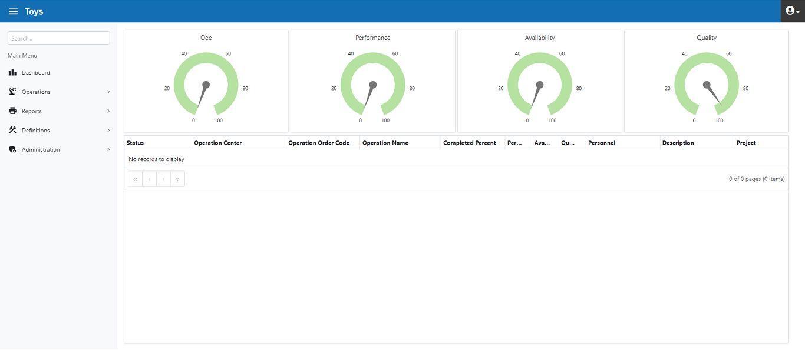
Figure 3.2. Home Screen Form

Case Scenario, Master Data
The main Definitions form is shown below. Under this form are the Layout, Employee and MES modules. The Layout module is the form in which the production process in the company is constructed. In the Employee module, people working in production processes are defined. In the MQ module, Stocks, Operations, Downtimes and Quality Losses are defined.

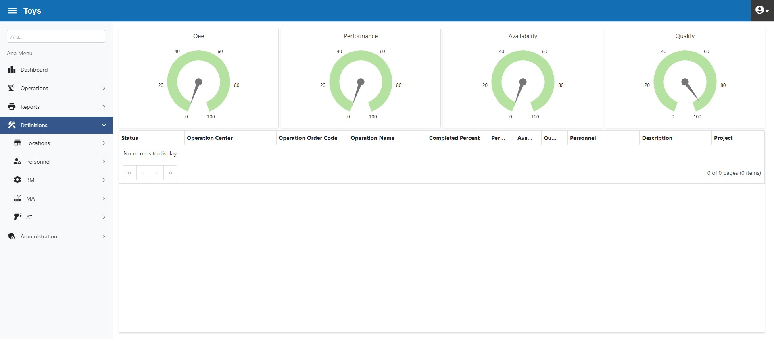
Figure 3.3. Definitions

Layout
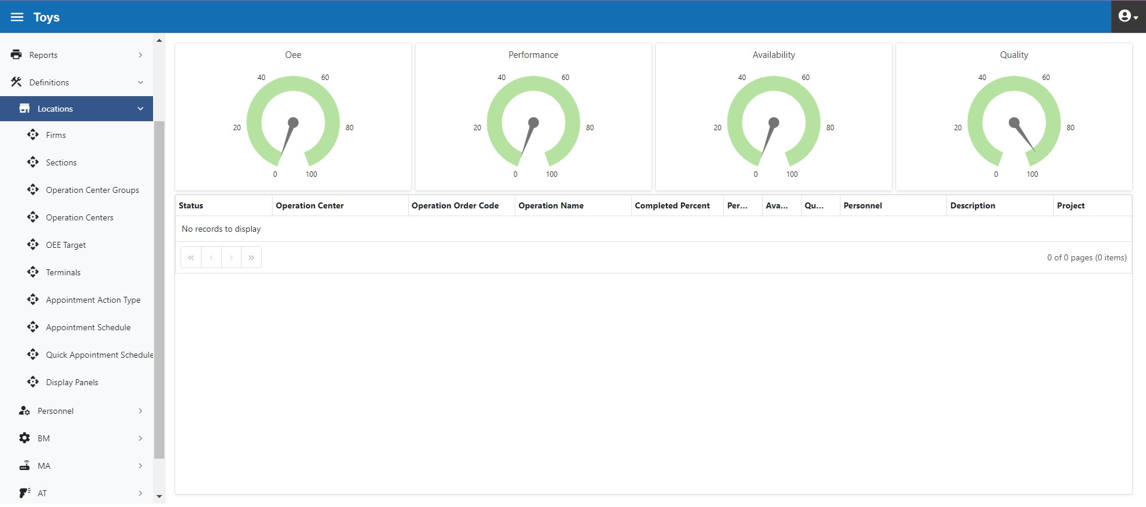
Figure 3.4. Layout Submenu
Below is the description of “Plant” which is the first leg of the “Plant > Department > Operation Centre Group > Operation Centre” breakdown
The plant can be more than 1. However, in the report filter breakdown, it is recommended to define only 1 since "Plant" will be the top segment. If more than 1 plant is defined, it will be necessary to obtain a report for each plant individually. The breakdown "Plant > Department > Operation Centre Group > Operation Centre" is the basic definition required not only for reporting but also for the system to be more understandable. That is why it is important to identify it correctly.
Below is the definition of Plant (figure 3.5).
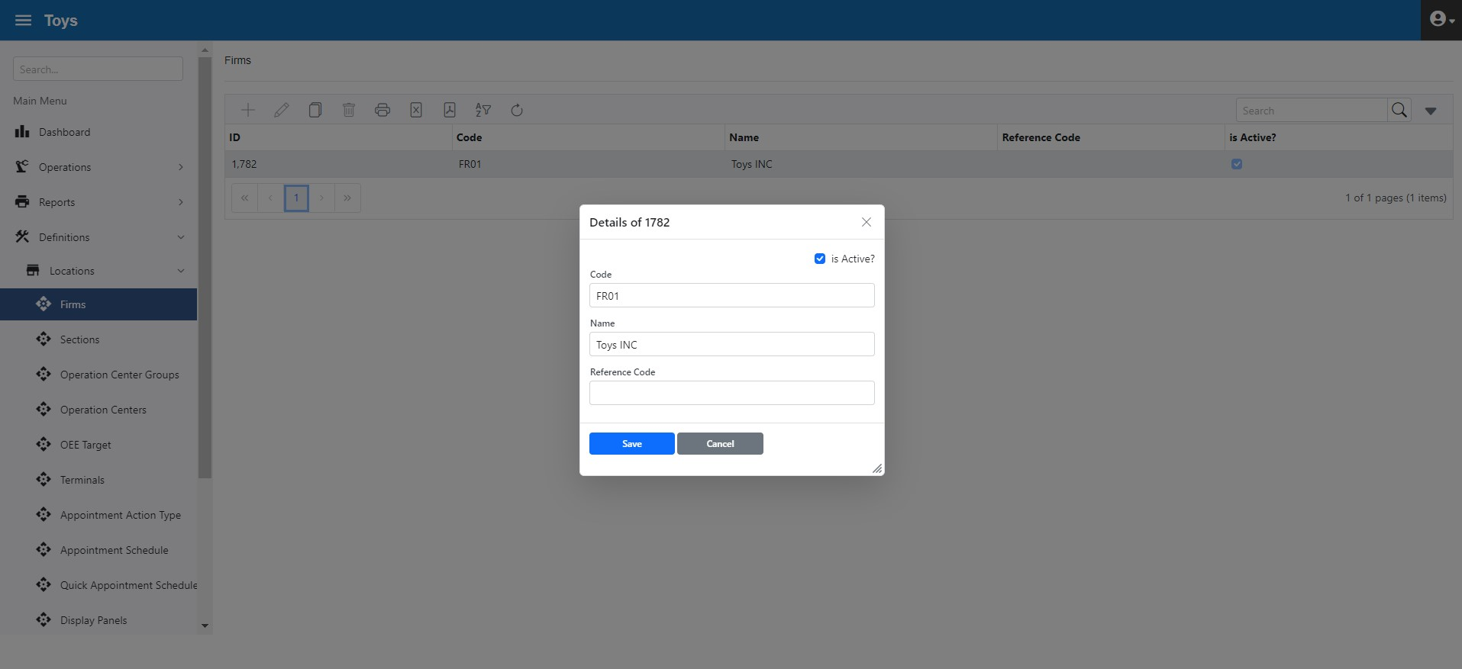
Figure 3.5. Plants Form
Editing, copying and deleting operations can be performed on each recording screen as shown in Figure 3.6. There are also related Excel and PDF export, filtering, and search features.

Figure 3.6. Recording Functions
The Department form defines production departments. In the example below, the company has two departments, "Preparation" and "Assembly" (Preparation with code BL01 and Assembly with code BL02). Departments are associated with the plants. The sample form is shown in Figure 3.7.

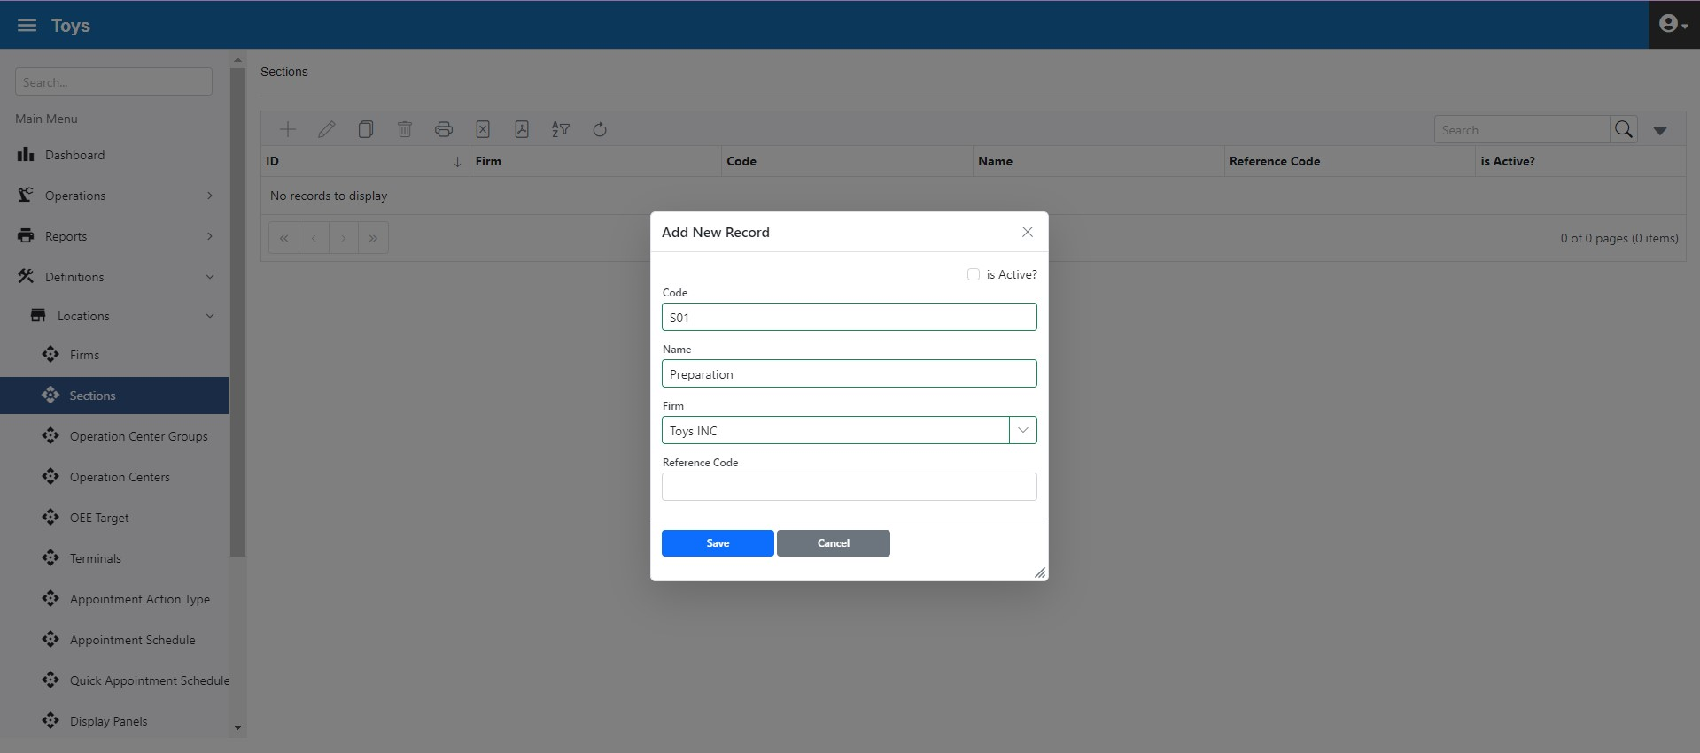
Figure 3.7. Departments Form
The entered records can be seen in the grid form (Figure 3.8). Departments can be switched to active and inactive.

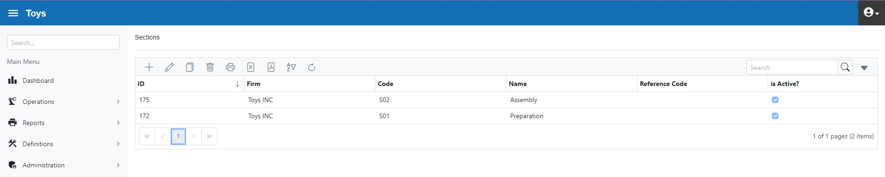
Figure 3.8. Departments Grid form

An operations centre group is used to group operations centres that do the same job. For example, let's assume that there are 5 units of 20 tons, 3 units of 50 tons and 2 units of 100 tons in a company that produces refrigerators. In this structure, an operation centre group is created for 20-ton presses. In addition, an operation centre is defined for each of the 5 presses of 20 tons.
In Toy Inc, under the Preparation department, there are “Upper Part” and “Other” operations centre groups. Under the “Assembly” department there is the Lower Part operation centre group. This hierarchical structure is defined as shown in Figure 3.9.

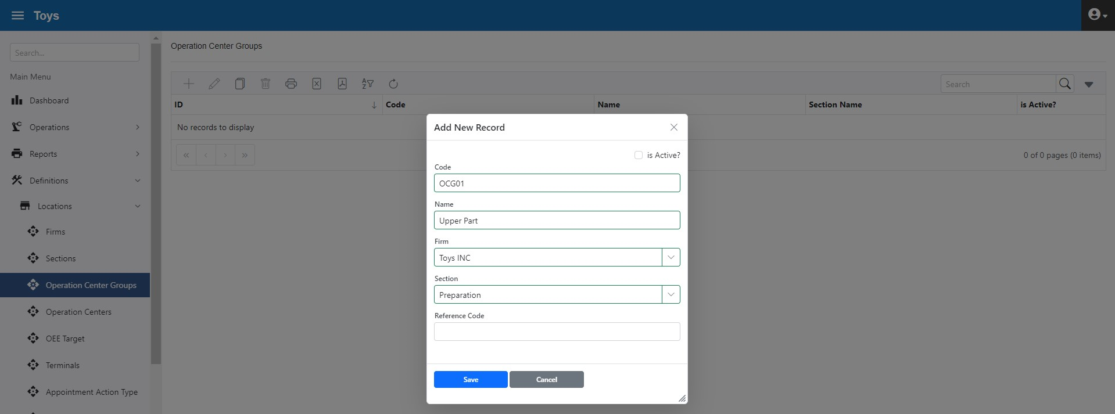
Figure 3.9. Operation Center Group Form

The grid form of the operation centre groups is shown in Figure 3.10.
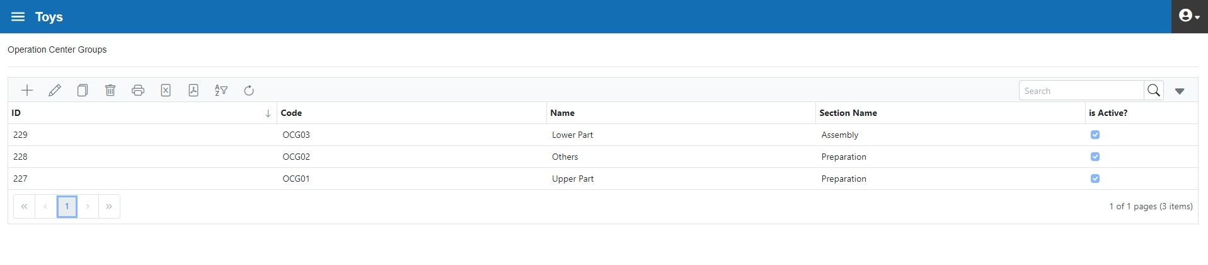
Figure 3.10. Operation Center Groups Grid Form

The Operation Centre associated with the Operation Centre Group. Every piece of equipment within the facility should be defined as an Operation Centre. Stations without a piece of equipment, such as an assembly table, should also be identified as a separate Operation Centre. In other words, all stations for which OEE measurement is required must be defined as an Operations Centre.
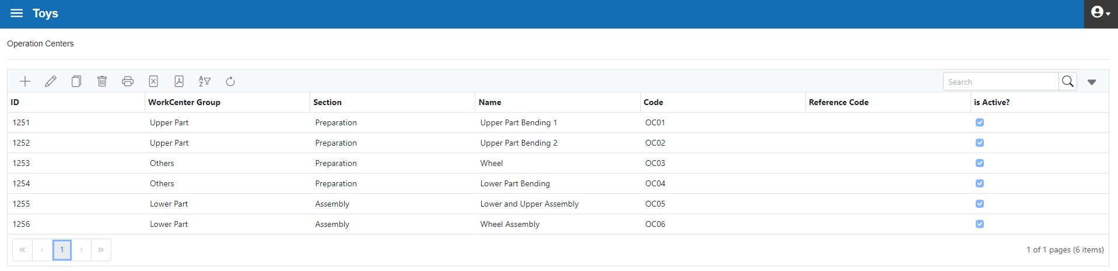

Figure 3.11. Toy Inc. Operation Centres
The "Copy" button allows for the quick creation of similar operation centers.

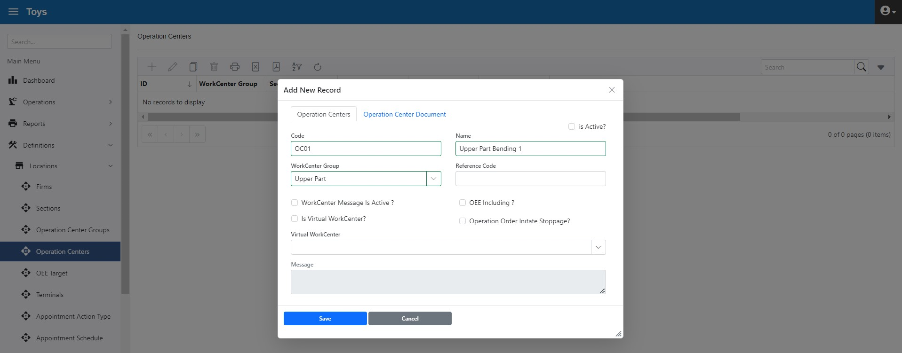
Figure 3.12. Operation Center Form

The parameter information in the Operations Center form is as follows:
"Activate messaging for Operation Centre" enables reciprocal messaging with the operator.
"Exclude from OEE calculation" Excludes the operations centre from the OEE calculation.
Let's explain the use of the "Mock Operation Centre" option with an example. In some cases, it may not be clear at the first moment, in which operation centre the operation orders will be produced. In this case, the Operation Orders are sent to the Mock Operations Center instead of a physical Operations Centre. Eventually, the Mock Operation centre is a virtually created Operations Center that does not physically exist
When it is clear in which physical Operations Centre the operation will be performed, the Operation Order located in the Mock Operations Center is transferred to the relevant physical Operations Centre and becomes selectable by the relevant operators for processing.
By clicking on the "Mock Operation Centre" selection, the respective Operations Centre is assigned for this purpose.
"Initiate downtime out of Operation Order" option allows an Operations Center to start and end any Downtime when no Operation Order has been started (while in idle state).

Figure 3.13. Operation Centers Grid

The "Target" form is the form in which the Availability, Performance, Quality rate, and OEE goals are defined. Targets can be defined in Plant, Department, Operations Centre group, or Operations Centre breakdowns.
For example, 90% availability, 95% performance and 95% quality target values can be set for the plant (Figure 3.14). In this case, the target OEE value of all plant units will be 81%. These targets are also used in factory monitor forms or other reports.
If the actual OEE value is above the value of the targets, the symbols selected in the “Happy Face”, and if below it, the “Unhappy Face”, will appear in the operator form. Alternatives are available for each face icon.
The colour of the facial expression is also important. When viewed from a distance, colour codes provide general information (such as the red colour selection for inappropriate situations).
The OEE parameter is not calculated in such cases where the cycle time is not defined or the production quantity is unknown. In such cases, the system will display the selected symbol in the “No Data Face”.

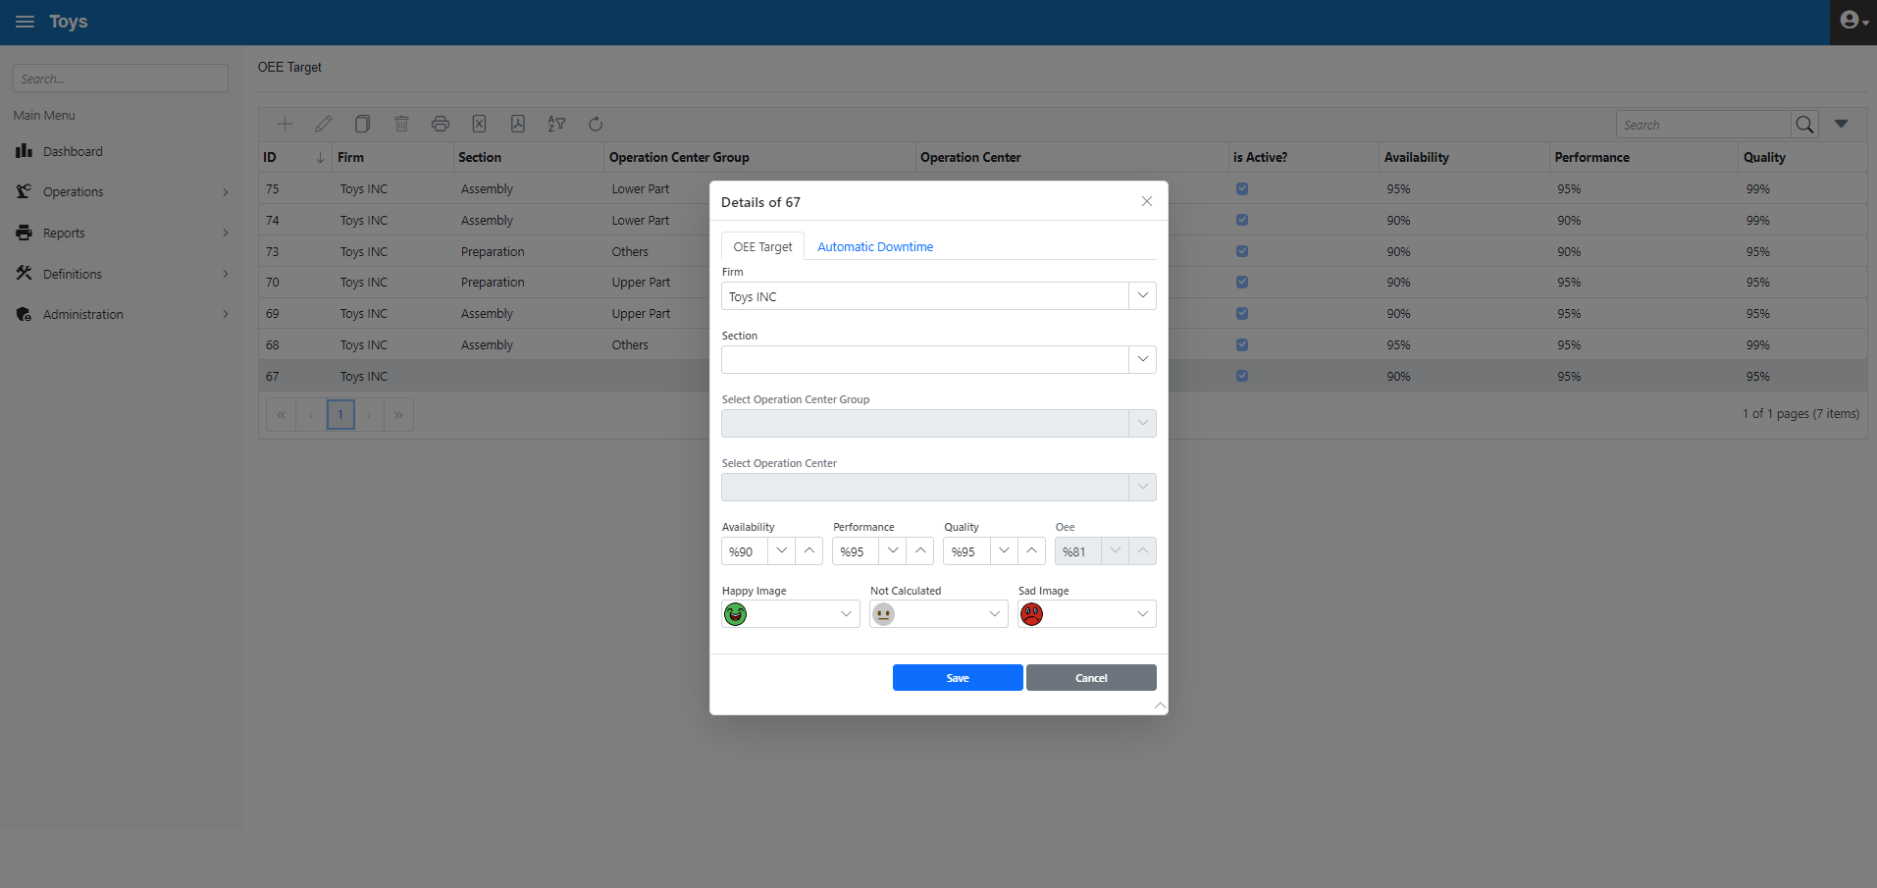
Figure 3.14. Plant based Target Definition

Below (figure 3.15) is a sample for Operation Centre based target definition 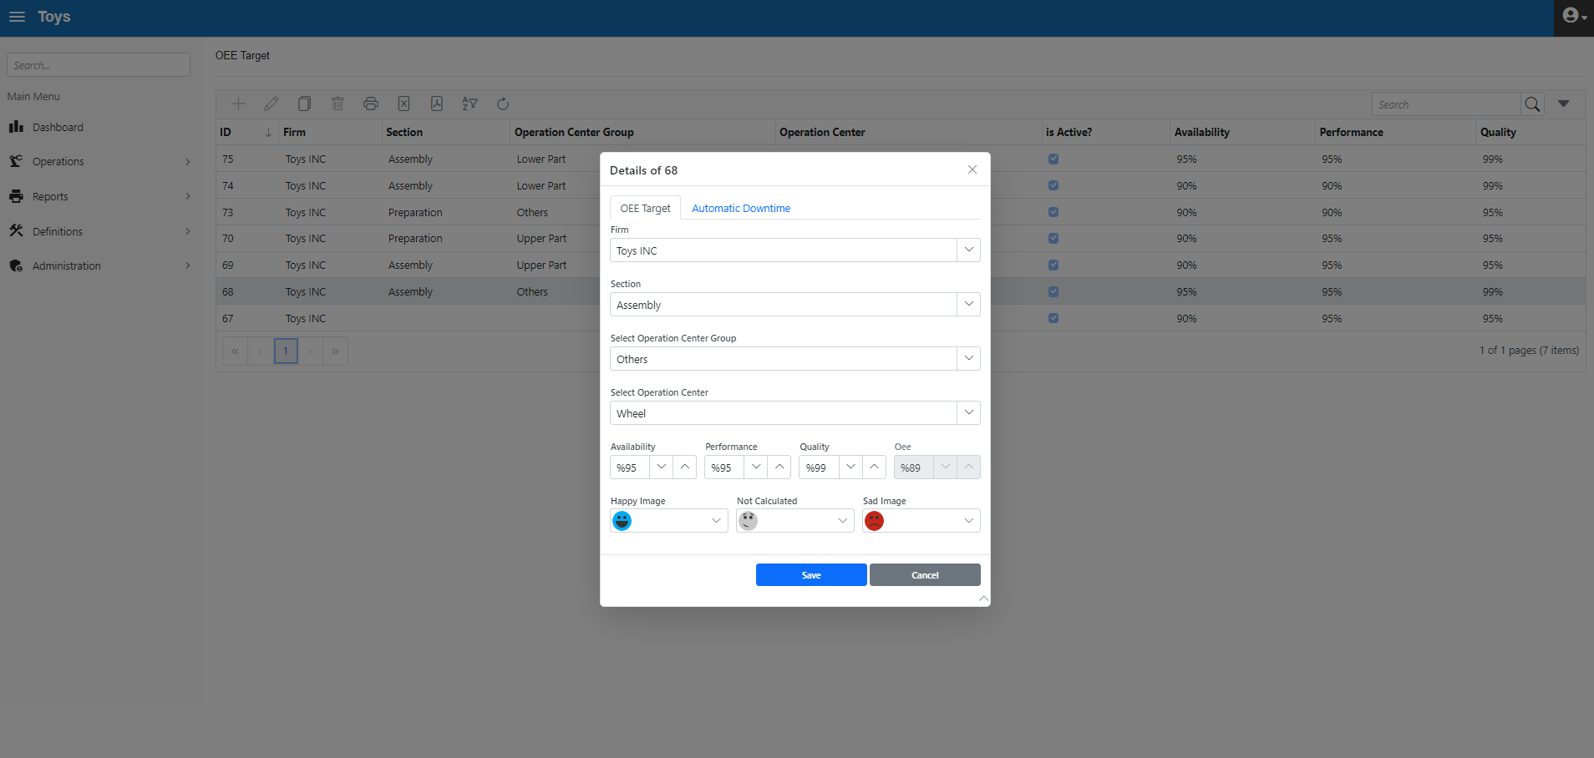
Figure 3.15. Operation Center based Target Definition
Below, the target definitions are shown in grid form
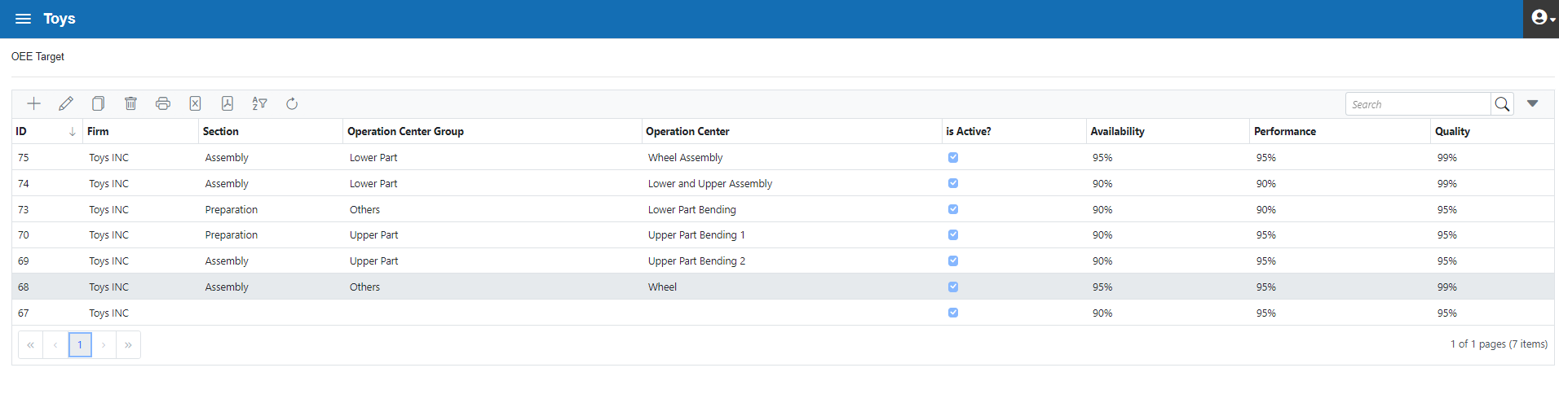
Figure 3.16. Target Definitions in Grid Form

"Terminal" means devices such as kiosks, computers or tablets through which operators enter data. At least one operation centre must be assigned to each terminal. Alternatively, more than one operation centre can be assigned to a terminal. For example, the work centres Upper Part Bending 1 And Upper Part Bending 2 can be assigned to the same terminal. On the other hand, only 1 Operation Center can be assigned with 1 terminal.
It is possible to make different designs in the operator interface form. The "Operator UI Designer" form under "Admin" is used for this purpose (figure 3.17). In the "Additional Fields" field, the necessary fields can be added or removed from the user interface form with drag-drop.
The Parameters field is set with font size and colour. Also, in the "UI Design" section, with the right click, "Add Row" and "Delete Row" options are available. It is a common practice to use the same design in all terminals by making a single UI design. However, it is also possible to use different templates on a terminal basis by creating different UI designs. This is the purpose of asking for the “Template Name” when clicking the "Save Design" button.
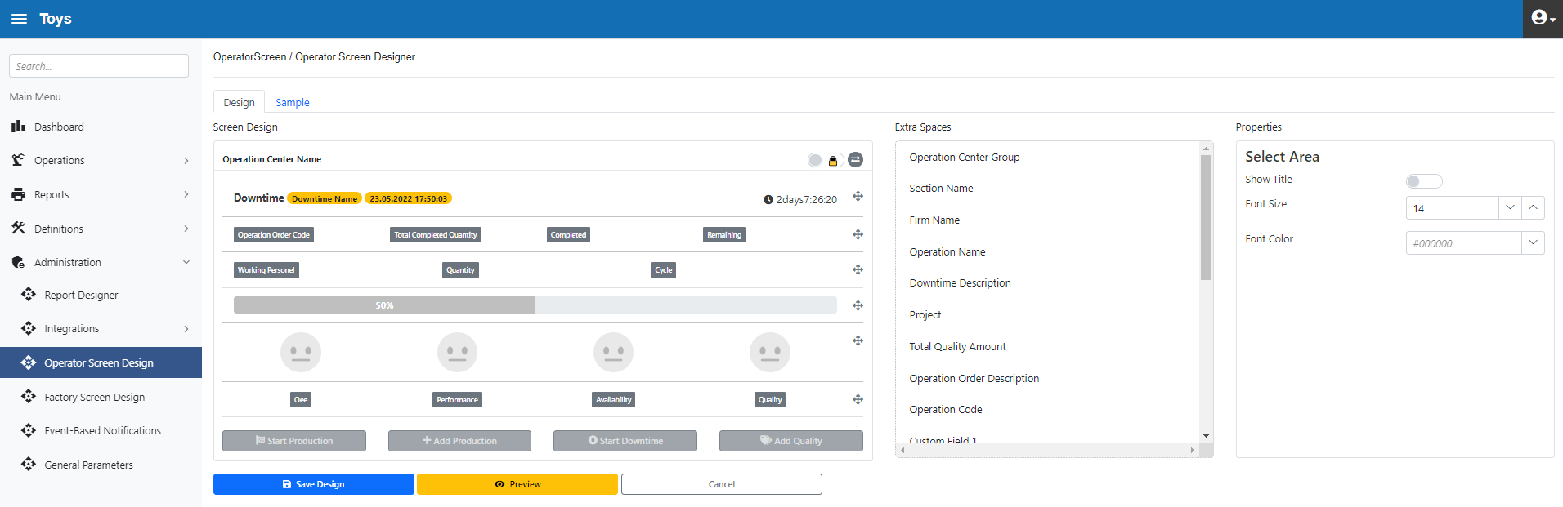

Figure 3.17. Operator UI Designer form

With the template tab, it is possible to define how many operation centres to display in an operator form (figure 3.18)
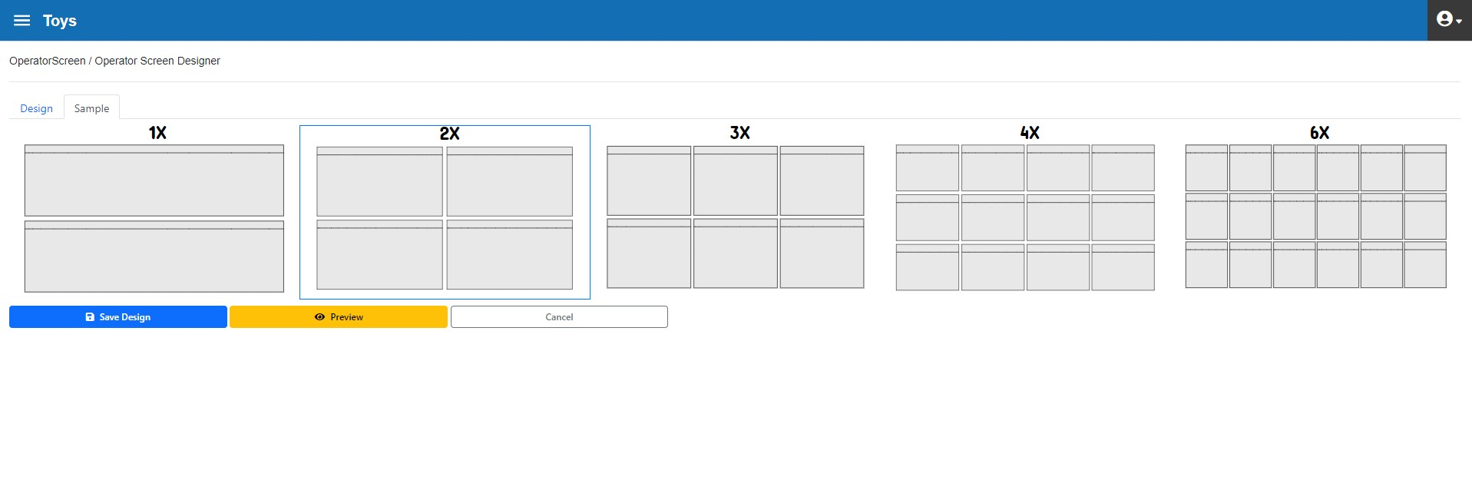
Figure 3.18. Operator UI Designer form, Template tab

There is also an option to "Preview" the design before saving it (figure 3.19)
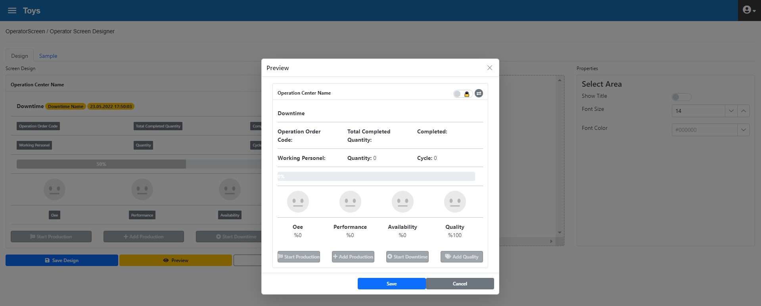
Figure 3.19. Operator UI Designer form, Preview

The "Set as Common Design" button is used to assign any design to all Work Centres at once (figure 3.20)

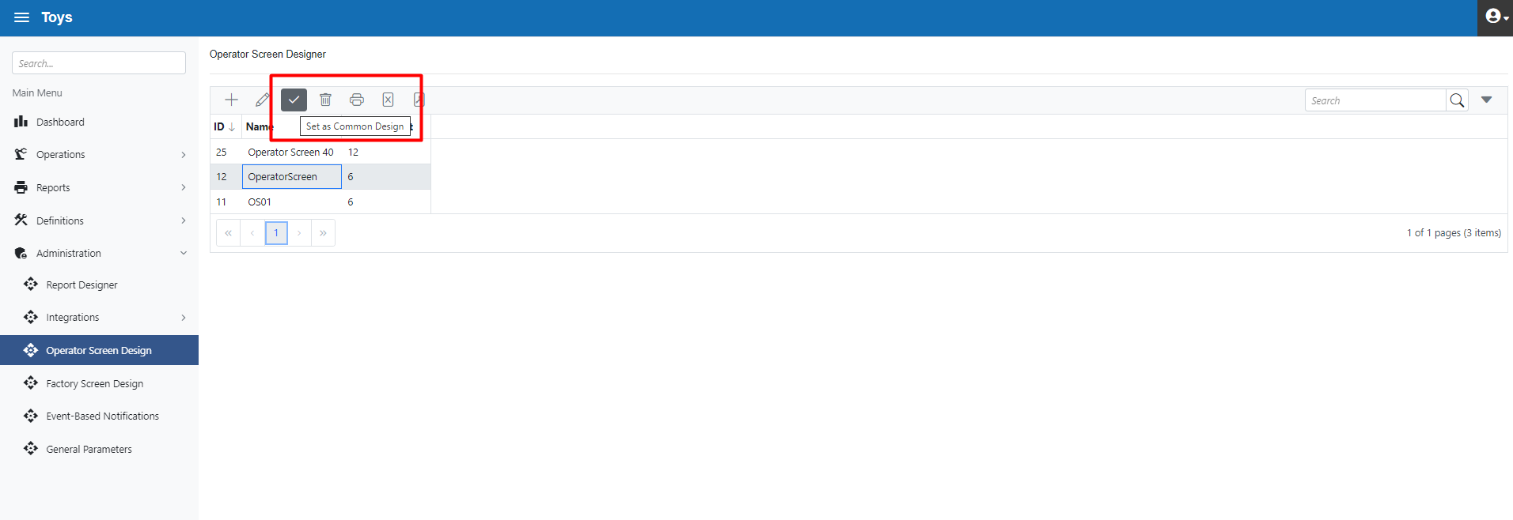
Figure 3.20. Operator UI Designer form, Set as Common Design

The form "terminals" (figure 3.21) is used to identify 2 important features:
Physical terminals are associated with the Operator UI Design form. Thus, when the "Operator Interface" form is opened and "Terminals" is selected, the Operator UI Design template to be used is automatically selected
The other feature is the definition of which Operation Centres will appear when the "Operator Interface" form is opened.
For example, 2 Operation Centers have been selected for the below terminal.
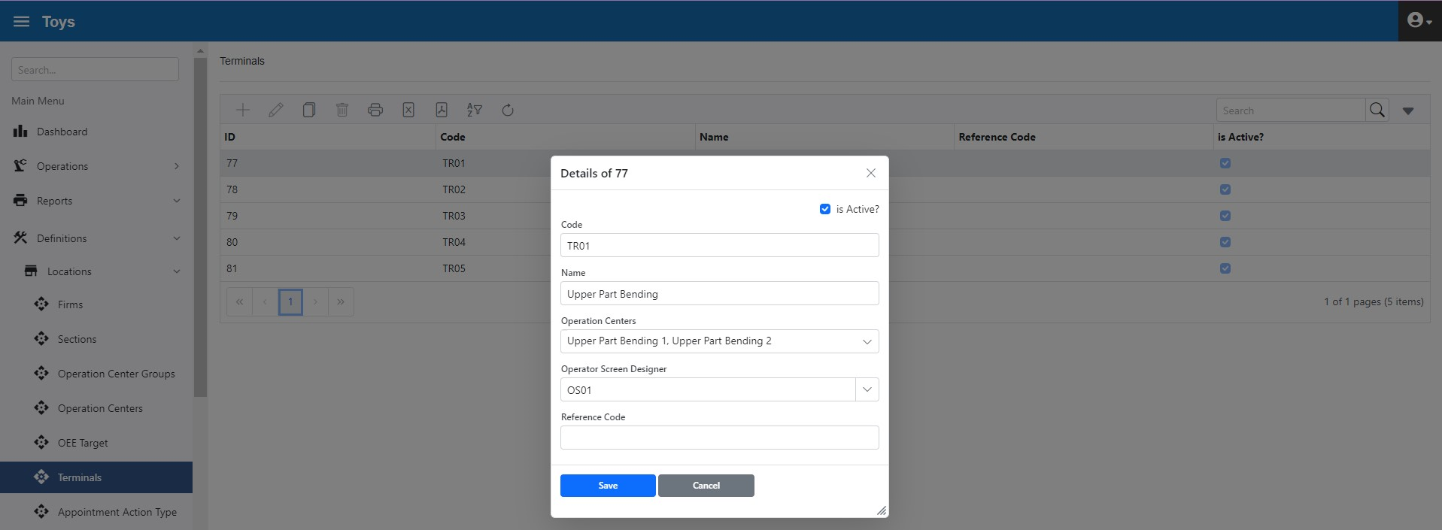
Figure 3.21. Terminals form
The defined terminals (figure 3.22) can be seen in grid form
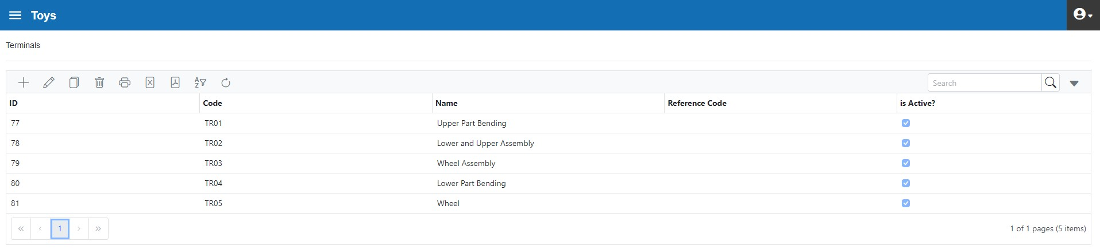
Figure 3.22. Terminals in grid form
The calendar form identifies the firm's regular shift, holidays, and other nonworking days. The calendar activity type must be defined before the calendar definition. Production activities are defined by clicking "Production Activity" on the Calendar Activity Type form. If this option is not clicked, it means that no production was made during the activity (figure 3.23).
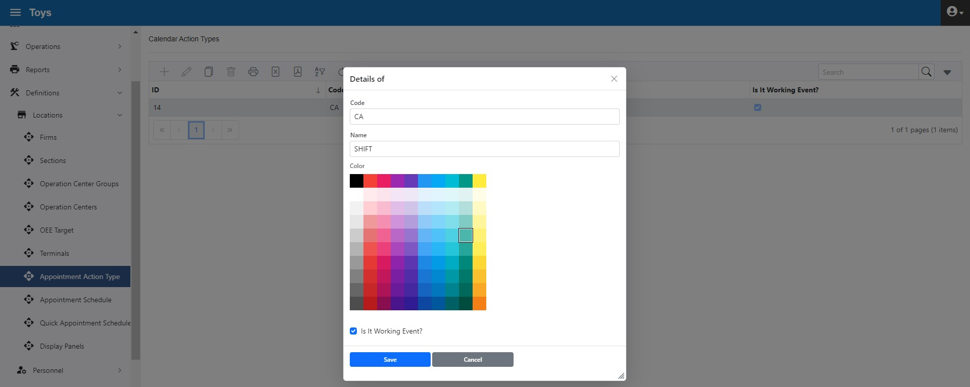
Figure 3.23. Calendar Activity Type Form

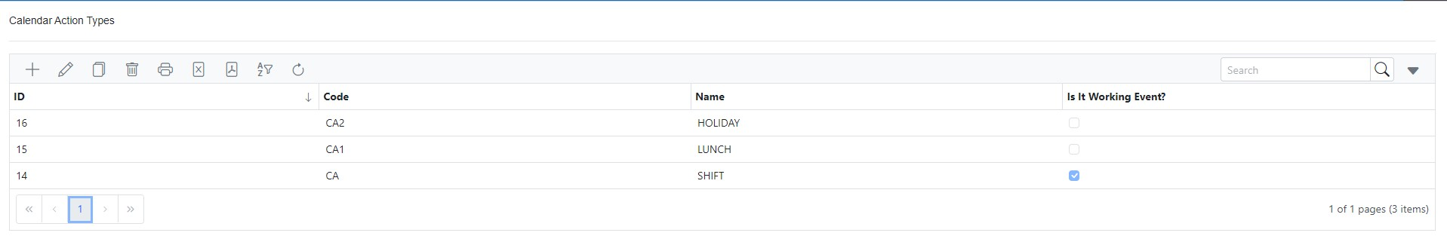
Figure 3.24. Calendar Activity Types Grid form
In the example, the working hours of TOY INC. are from 08:00 to 17:00 on weekdays and 12:00 to 13:00 is the lunch holiday. These shift hours must be defined in the calendar. For this purpose (figure 3.25) "Shift" was selected as the activity type between 08:00-12:00. Saturday and Sunday are not included in the election as there are no working days.
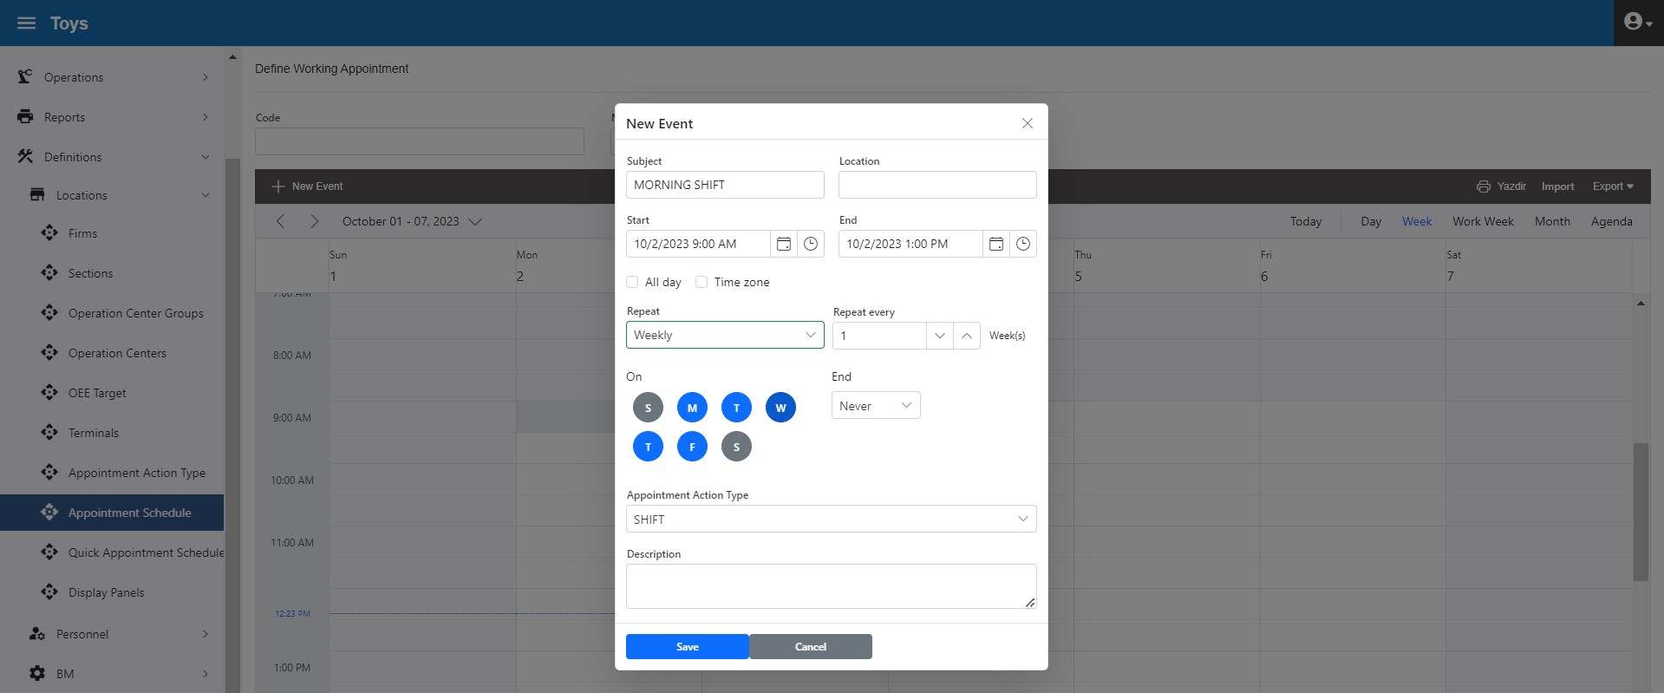
Figure 3.25. Create a calendar
Thus, (figure 3.26) 12:00 to 13:00 is defined as the meal break and 13:00 to 17:00 is the lunch shift.
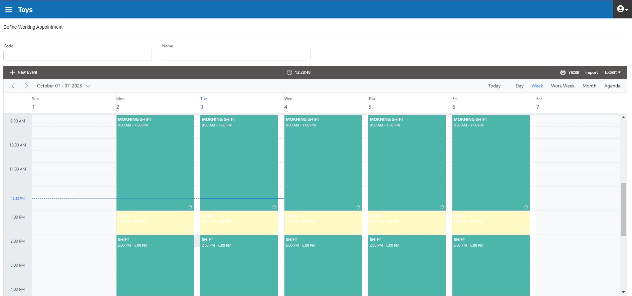
Figure 3.26. Work Schedule

In order to determine the working capacity of the company exactly, the non-working days of the factory, such as official holidays or maintenance, must also be included in the calendar. In the following example (figure 3.27), August 30 is defined as a public holiday
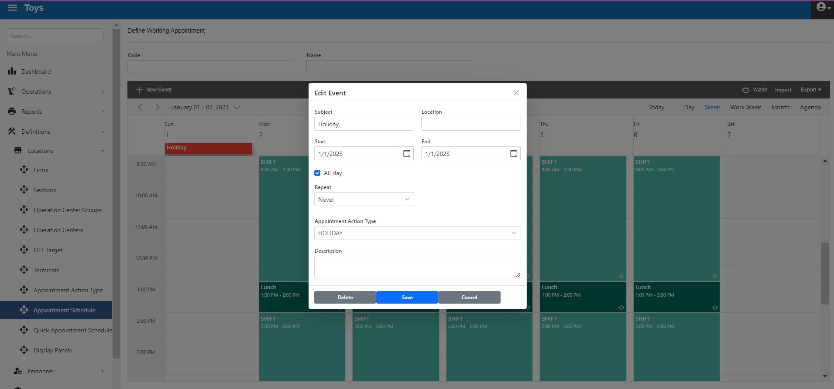

Figure 3.27. Create A Public Holiday in the Calendar

Non-working days, such as maintenance and counting, should similarly be added to the calendar (figure 3.28).
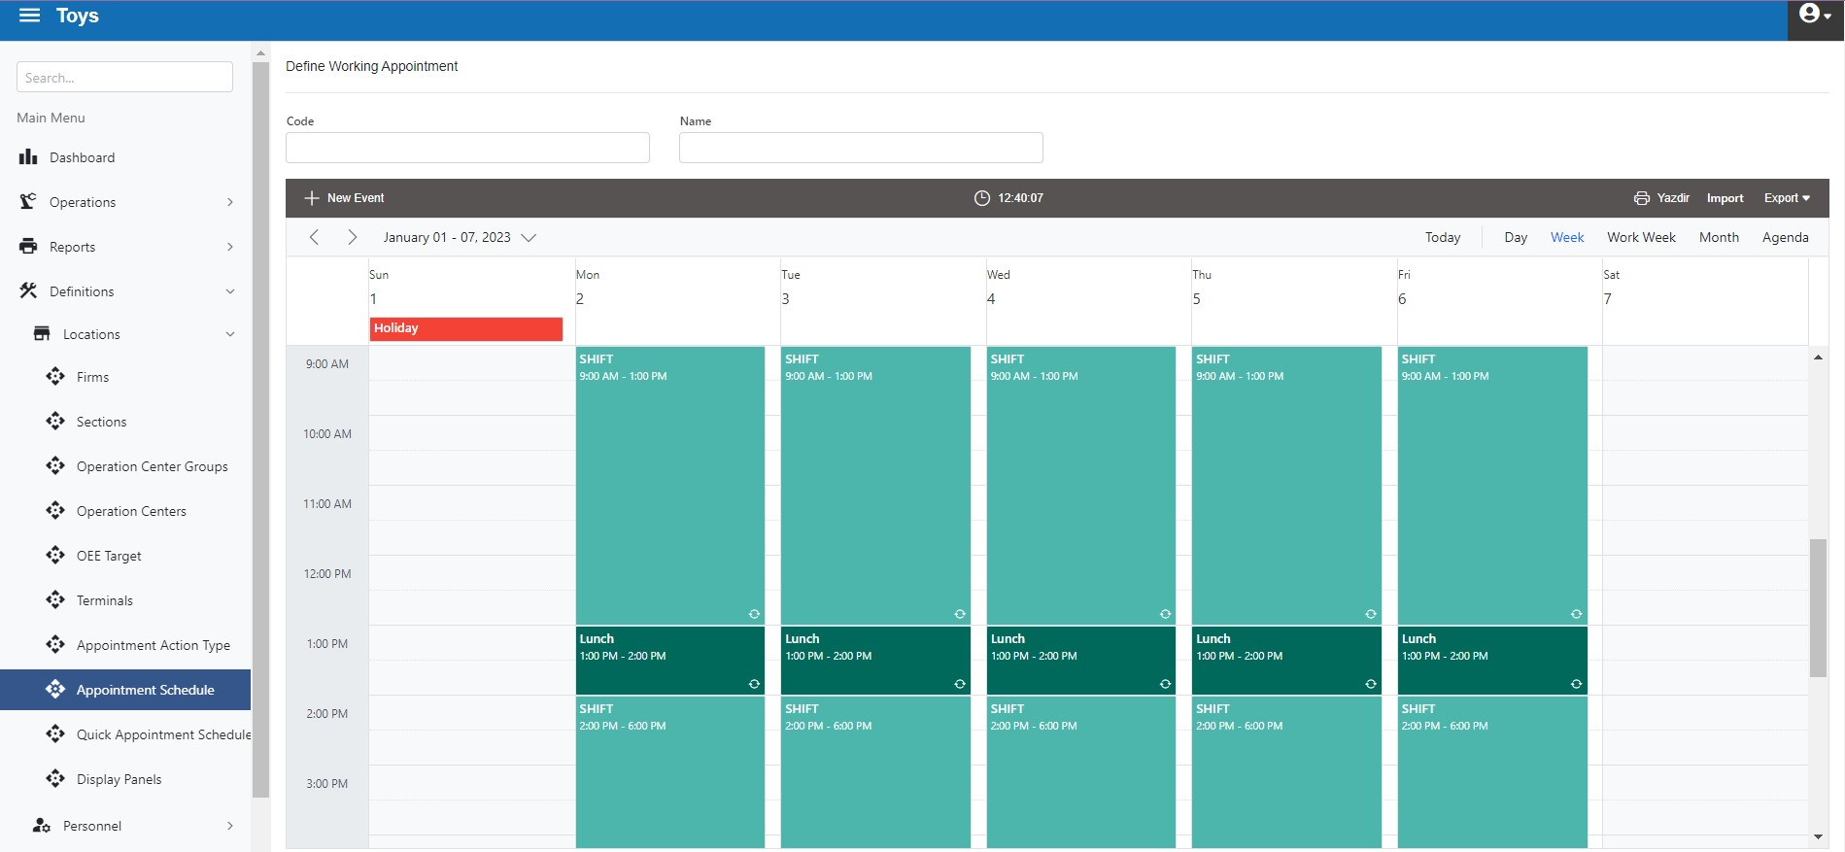
Figure 3.28. Toy Inc. Work Schedule
The Quick Calendar Entry form is used to define a calendar for one or more departments, Operations Centre Groups, or Operations Centres. For example, let's consider that shifts should be made in Upper Part Bending Operation centres. For this purpose, a calendar called "Bending Calendar" with different working hours from the "general calendar" has been created (figure 3.29) and assigned for the dates 15.08.2022-31.10.2022.
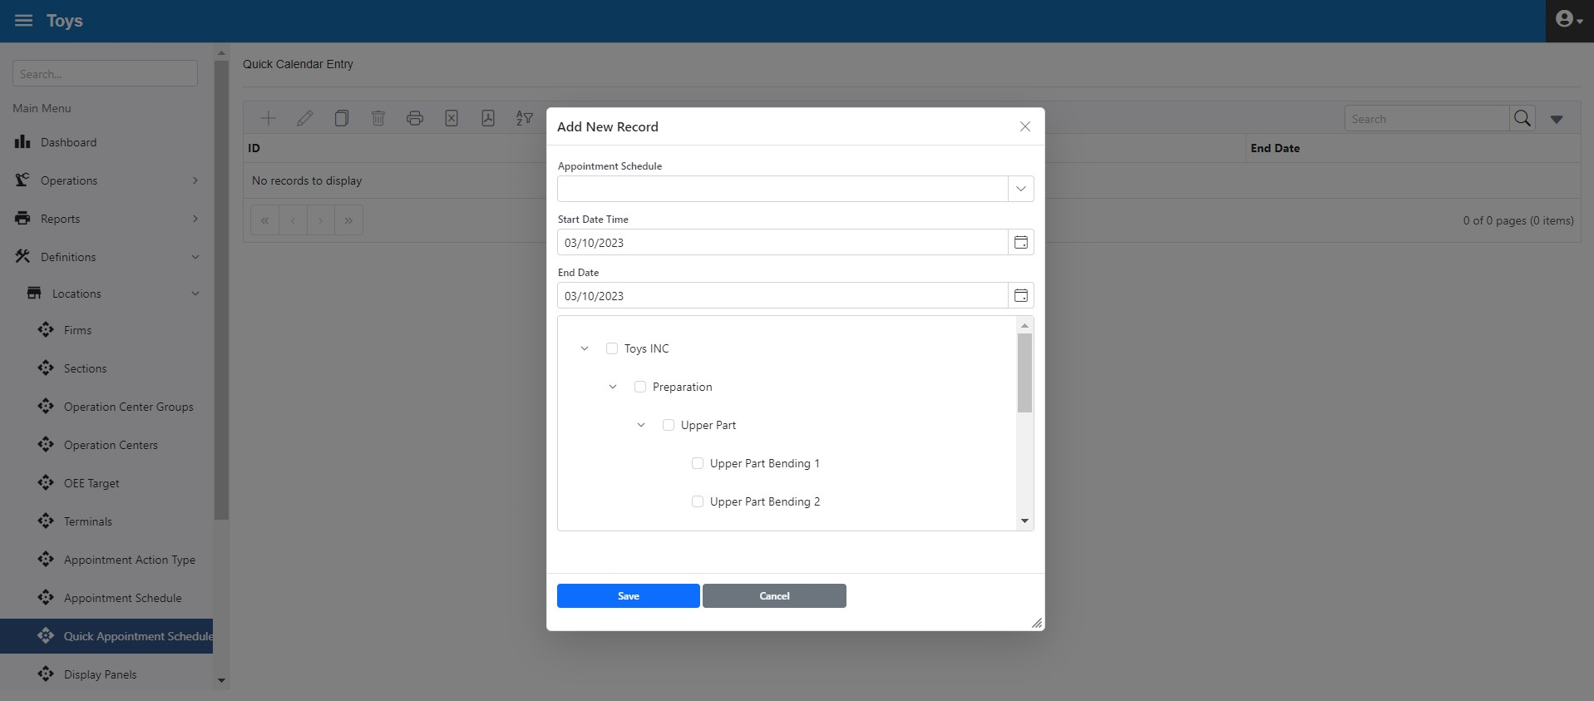
Figure 3.29. Quick Calendar Entry Form
The "Factory Monitoring Templates" form is used to define factory monitoring panels templates. Before this definition, it is necessary to make template designs (figure 3.30).
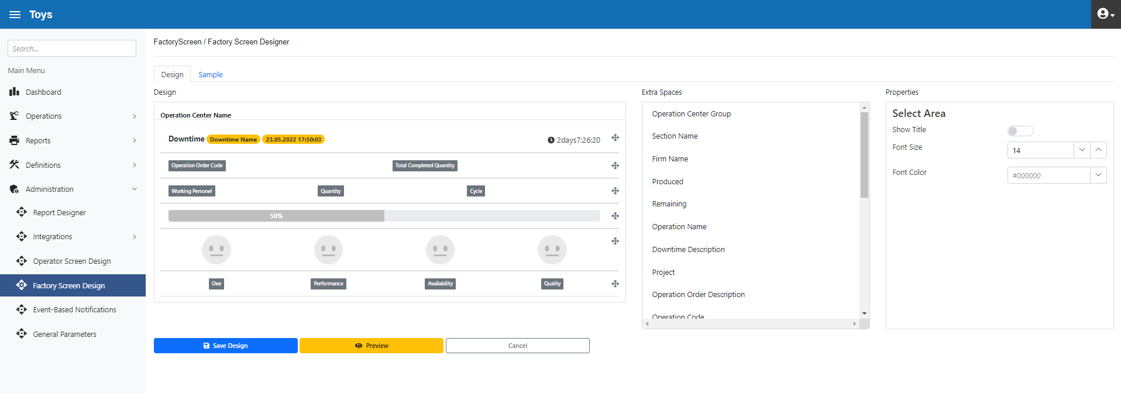
Figure 3.30. Factory Monitoring Designer Form
Below, a template definition is made by selecting a design created in the "Factory Monitoring Designer" form in the "Factory Monitoring Templates" form (figure 3.31)

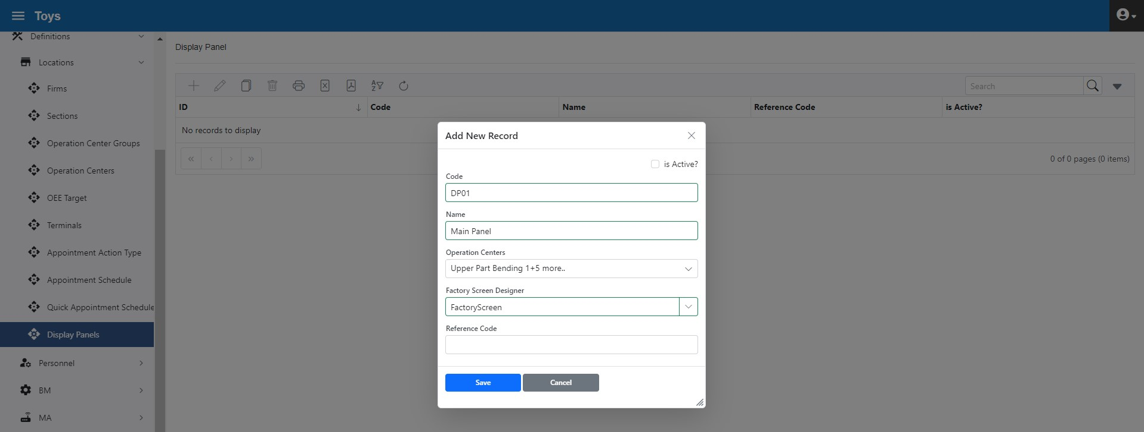
Figure 3.31. Factory Monitoring Template Form

Employee Sub-Menu
In this section, production human resources, their departments and roles are defined (figure 3.32) 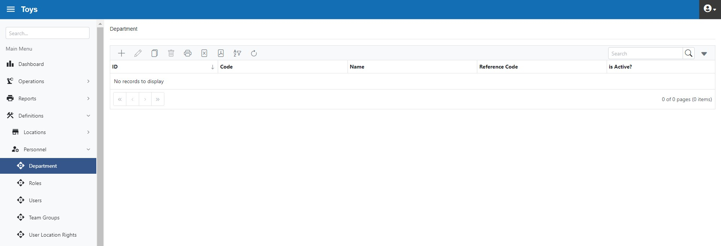
Figure 3.32. Employee Submenu
The Departments section defines departments, as in the below example
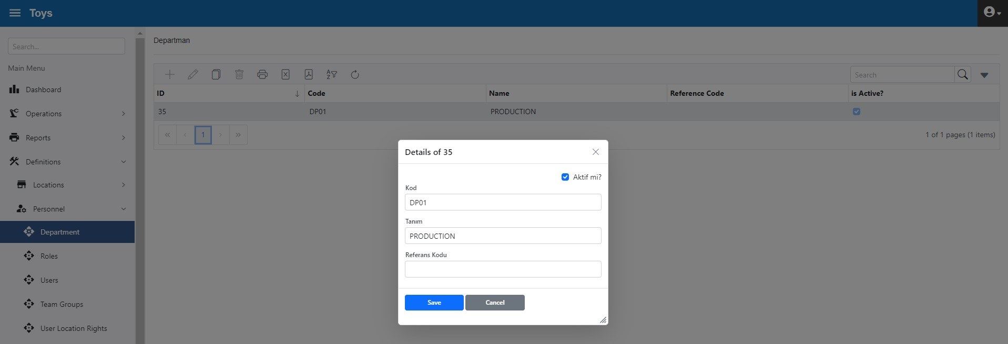
Figure 3.33. Department Form
The "Roles" form is used to grant bulk authority to users. Below are identified four types of roles: "Operator", "Report", "Manager" and "Top Manager". Since other forms are not required for operators in general use, the “Operator Role” is granted for "Operator Interface" form only (figure 3.34)

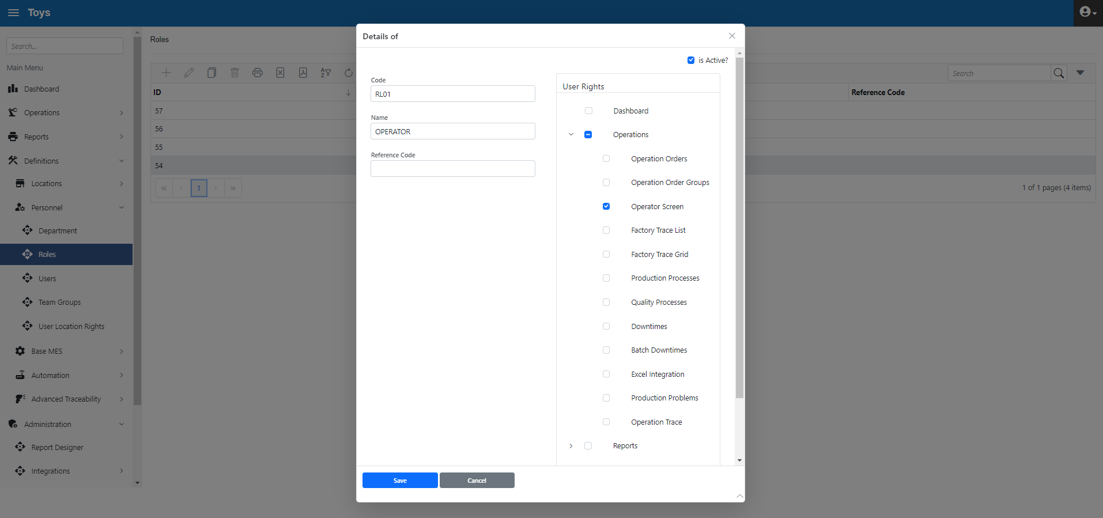

Figure 3.34. Rights for “Operator” Role
Only report access is granted for the "Report" role (figure 3.35) 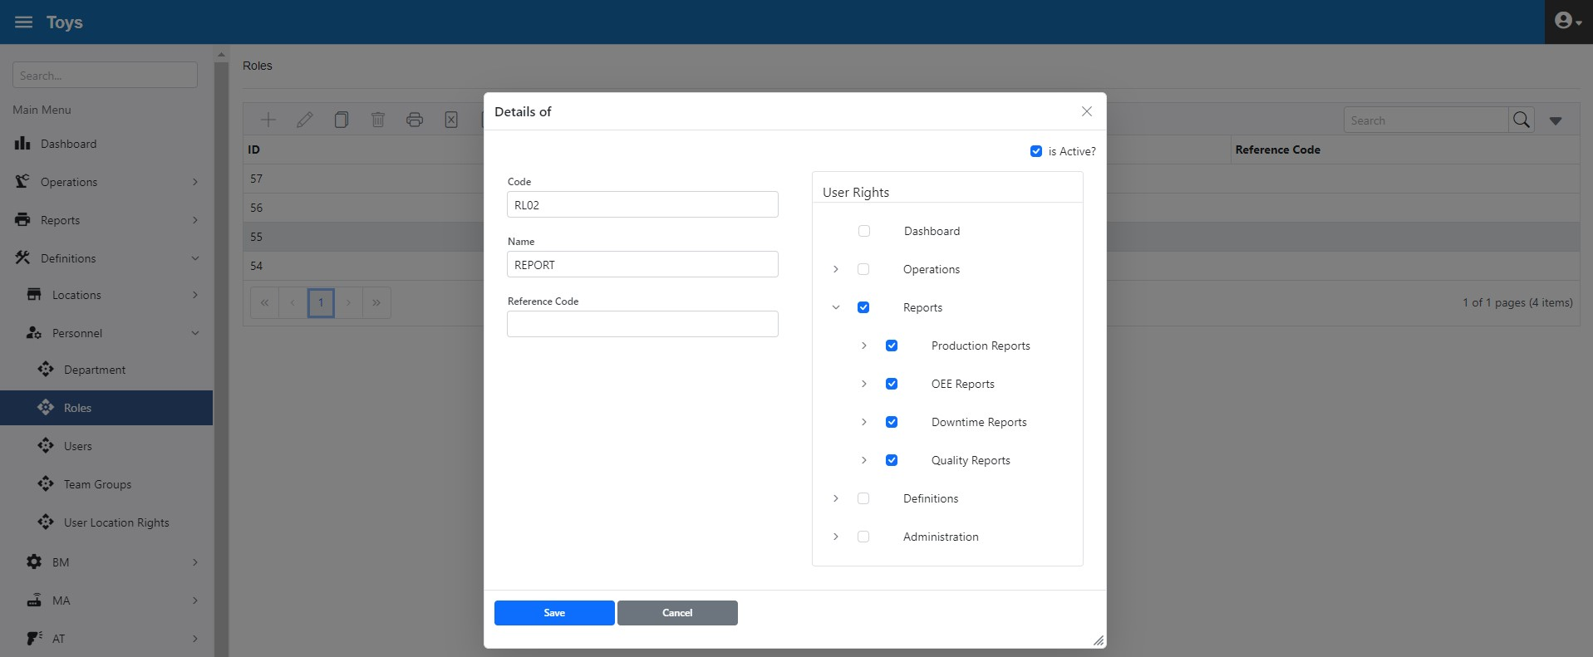
Figure 3.35. Rights for “Operator” Role

All forms are authorized for the "Manager" role (figure 3.36) 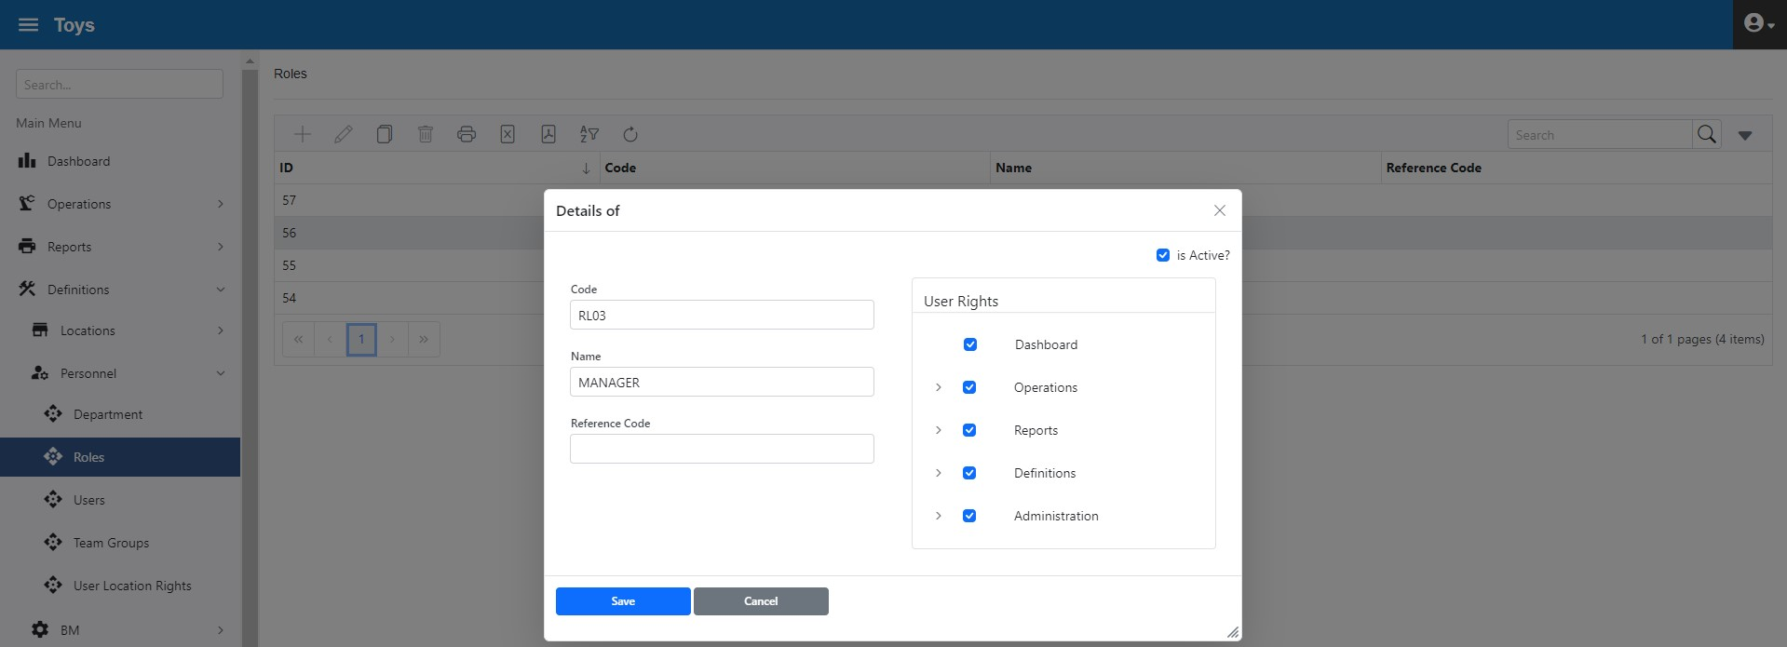

Figure 3.36. Rights for “Manager” Role

Only the “Dashboard” is authorized for the "Top Manager" role (figure 3.37)
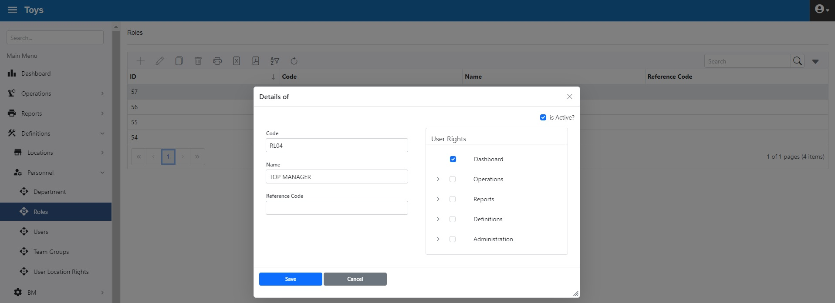
Figure 3.37. Rights for “Top Manager” Role
The "Users" form is used to identify system users (figure 3.38). Users can be assigned one or more roles to define their access rights. A user-specific access right can also be assigned regardless of, or in addition to, a role.
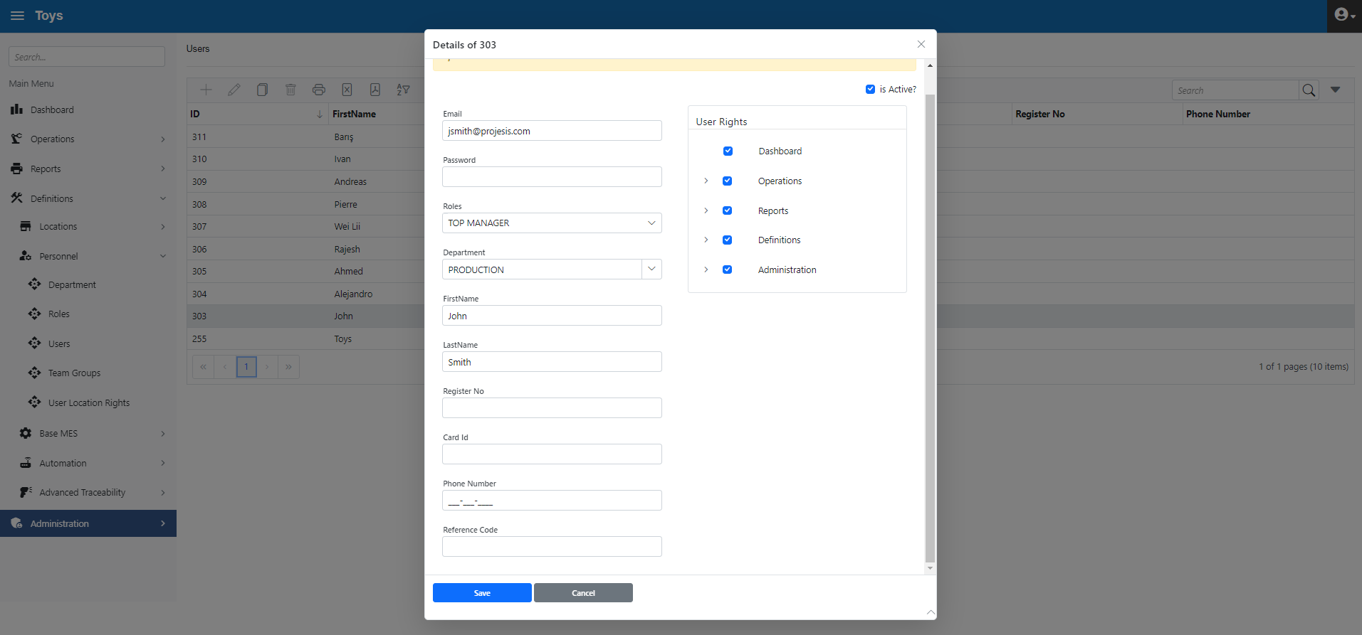
Figure 3.38. User and User Rights
In the example below (figure 3.39), a user is assigned the "Operator" role (can only access the Operator Interface form). In addition, the user is specifically granted access to forms related to operation orders.
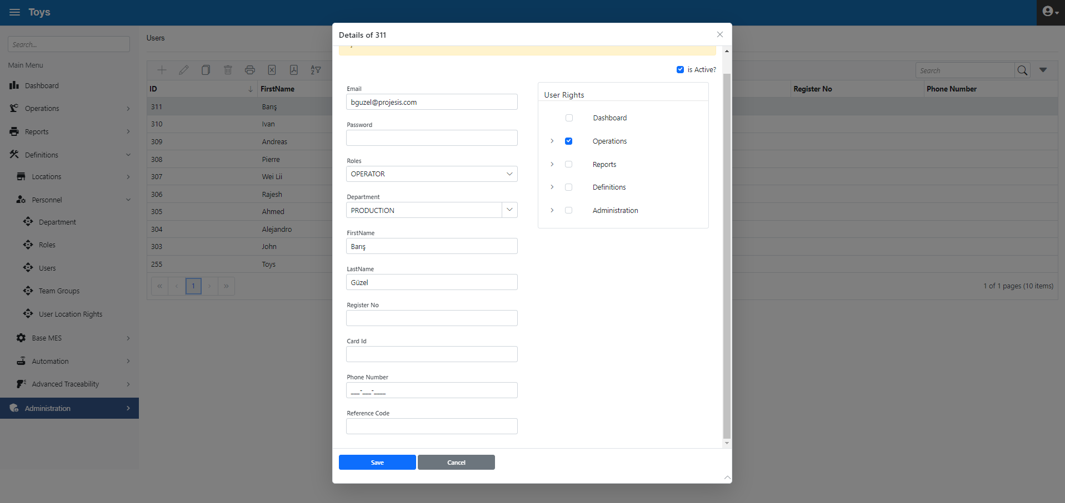
Figure 3.39. User and User Rights
The user list view is given below (figure 3.40)
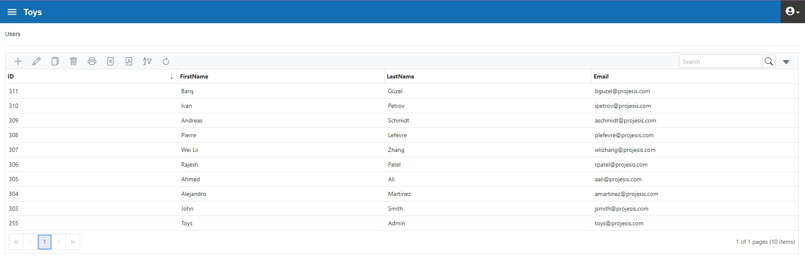
Figure 3.40. User List
"Teams" form, is used to describe groups of users who work together. In the example below, a Team was formed with 2 operators for the "Upper part Bending" operation. In the "Operator Interface" form, instead of selecting the employees one by one, Team can be selected and a quick entry can be made.
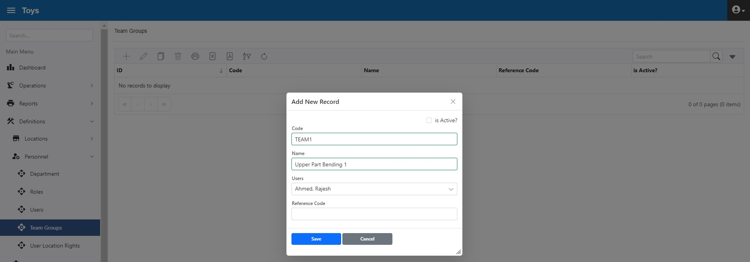
Figure 3.41. Creating Teams

