BM – Base MES – Practical Training Document – Part 2

Contents

5.1.1. BM Sub-Menu 2
5.1.2. MA Sub-Menu 10
5.1.3. AT Sub-Menu 10
5.2. Case Scenario, Production Data 10
5.2.1. “Upper Part Bending 1” Operation Center 12
5.2.2. “Upper Part Bending 2” Operation Center 19
5.2.3. Wheel Operation Centre 24

BM Sub-Menu
It is the form in which the basic parameters are defined, as seen below (figure 3.42) 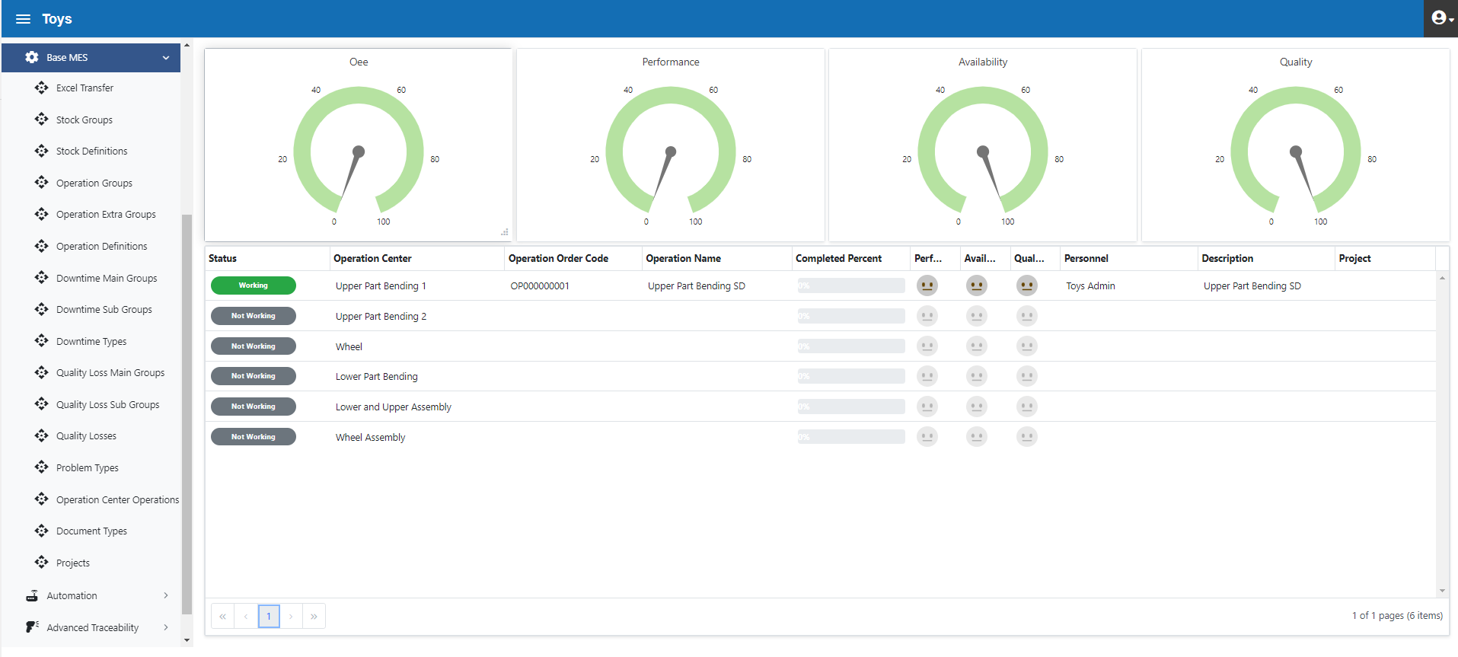
Figure 3.42. BM Sub-menu
Toy Inc. sample inventory items are provided below (Table 3.1)
Inventory Code | Inventory Name | Inventory Group | Inventory Group Code
HB0001 | Hatchback | Finished Goods | SG01
SD0001 | Sedan | Finished Goods | SG01
YM0001 | Lower Part | Work-in-Process | SG02
YM0002 | Upper Part-HB | Work-in-Process | SG02
YM0003 | Upper Part-SD | Work-in-Process | SG02
YM0004 | Wheel | Work-in-Process | SG02
YM0005 | Lower-Upper Part -HB | Work-in-Process | SG02
YM0006 | Lower-Upper Part -SD | Work-in-Process | SG02
HM0001 | Red Cardboard -AP | Raw Material | SG03
HM0002 | Red Cardboard- -UHB | Raw Material | SG03
HM0003 | Red Cardboard -USD | Raw Material | SG03
HM0004 | Black Strip Cardboard | Raw Material | SG03
HM0005 | Tape | Raw Material | SG03
HM0006 | Glue | Raw Material | SG03
Table 3.1. TOY INC. Inventory Information
Below Inventory Groups are defined (figure 3.43)

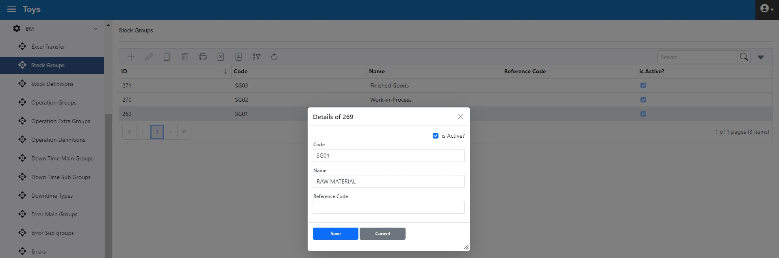
Figure 3.43. Inventory Groups

Below Inventory Groups in list form (figure 3.44)

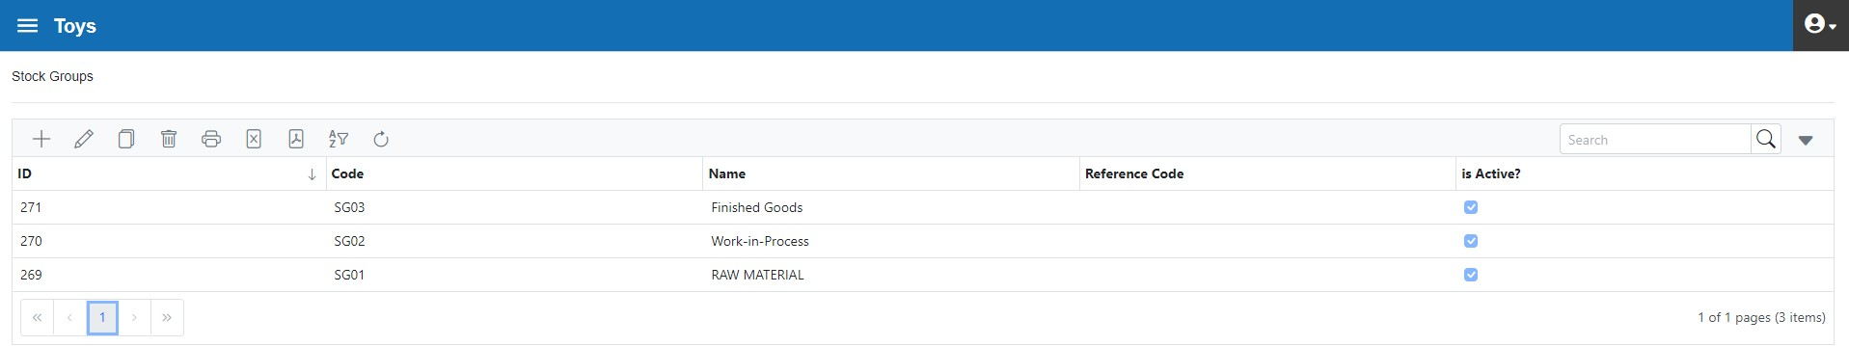
Figure 3.44. Inventory Groups in List Form
The following is a description of Inventory (figure 3.45). "Additional fields" are free fields that can be used for additional information and reporting purposes related to Inventory. 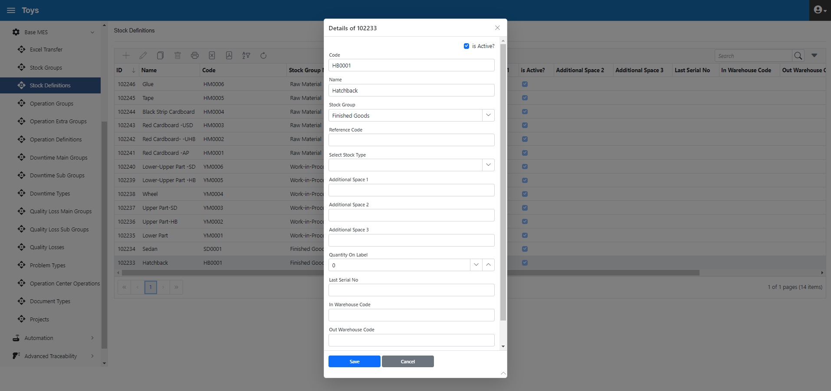
Figure 3.45. Inventory Definition

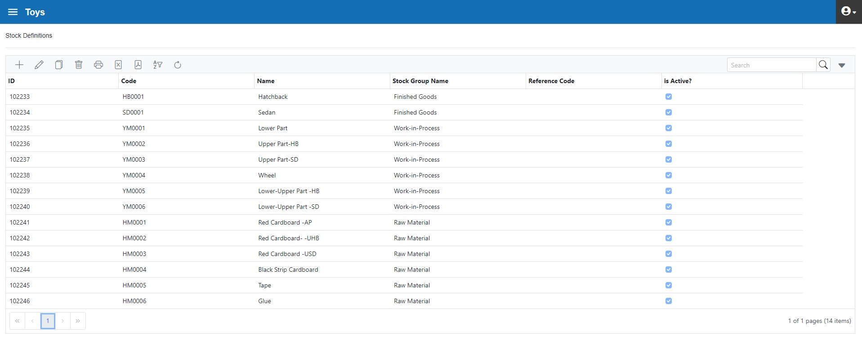
Figure 3.46. Inventories in List Form

Toy Inc. Operation and operation Groups are as follows:
Operation Code | Operation Name | Operation Group | Operation Group Code
OP0001 | Wheel Cutting | Other | OG1
OP0002 | Upper Part Bending HB | Upper Part | OG1
OP0003 | Upper Part Bending SD | Upper Part | OG2
OP0004 | Lower Part Bending | Other | OG2
OP0005 | Upper-Lower Assy | Lower Part | OG3
OP0006 | Wheel Assy | Lower Part | OG3
Table 3.2. Toy Inc. Operation Info

Below is the "Operation Groups" definition form (figure 3.47). This form allows grouping of operations for reporting and easy management 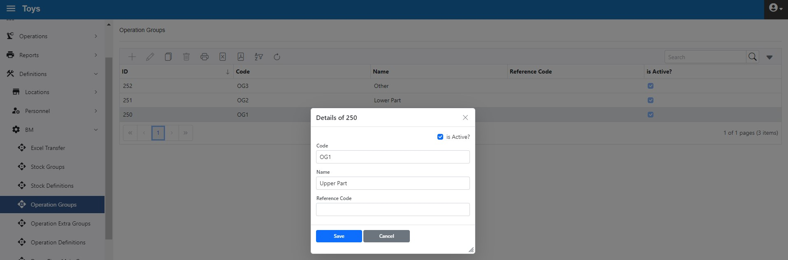
Figure 3.47. Operation Group Form
Below is the "Operation Groups" in list form (Figure 3.48)

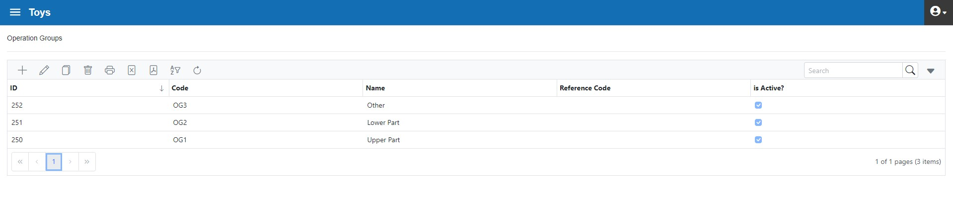
Figure 3.48. Operation Groups in List Form
In cases where the variety of operations is very large, the form "Operation Sub-Groups" is used. In this example, "Operation Sub-Groups" were not used in this application.
The "Operation Definition" form is as follows. Table 3.2 operation records are entered in this form. If the OEE measurement is unnecessary for the relevant operation, the "Exclude from OEE calculation" box should be clicked.
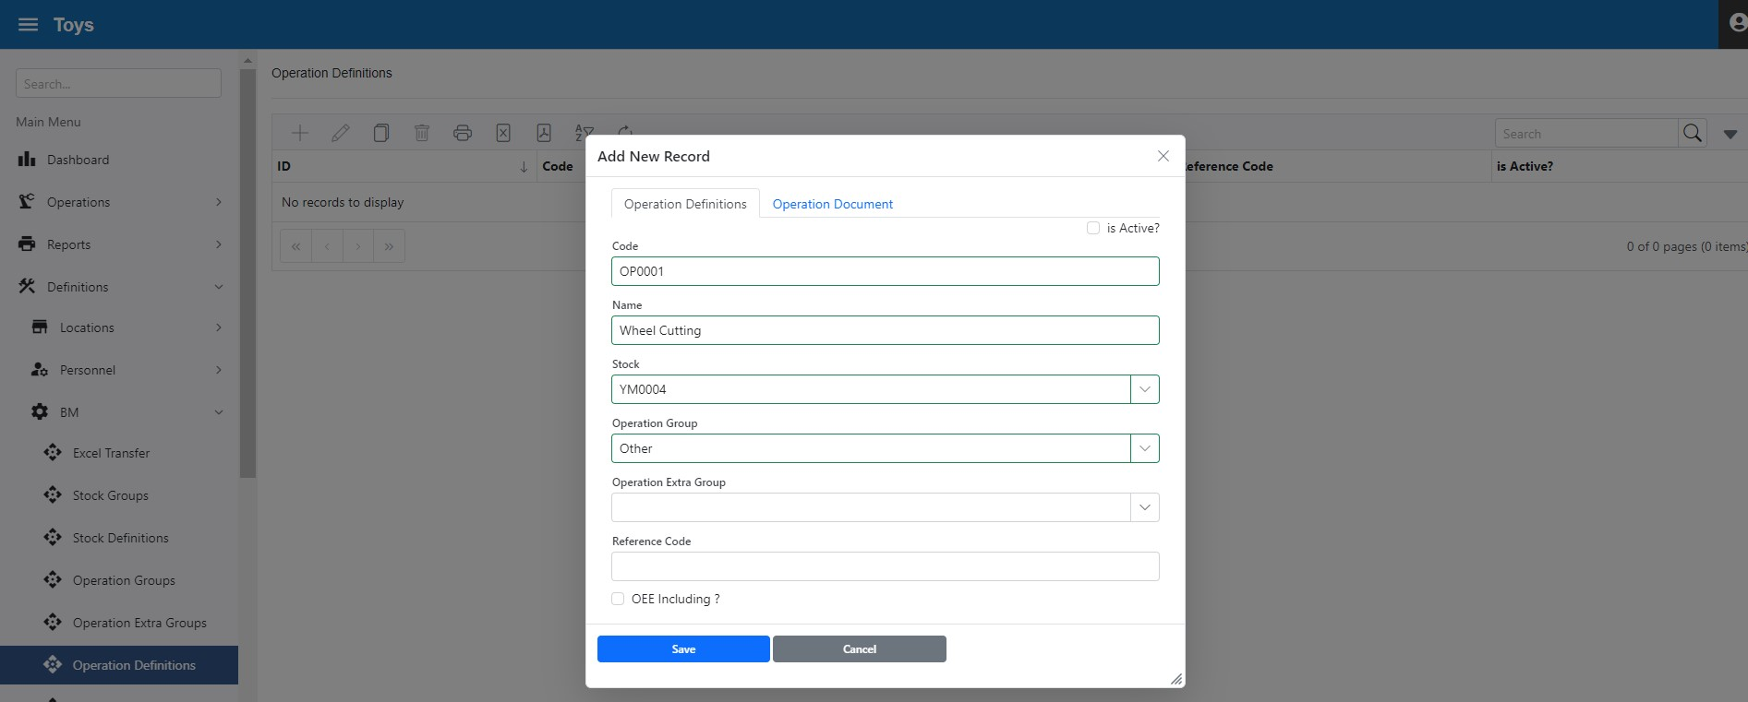
Figure 3.49. Operation Definition Form

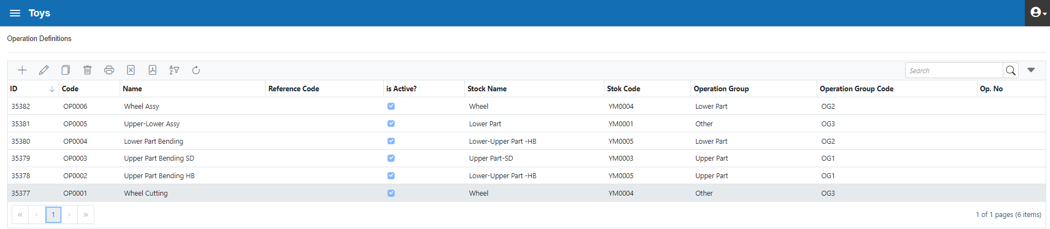
Figure 3.50. Operation Definition in List Form

Based on Downtime Types defined in Figure 2.8, the entry of “Downtime main Groups” is given below (figure 3.51)

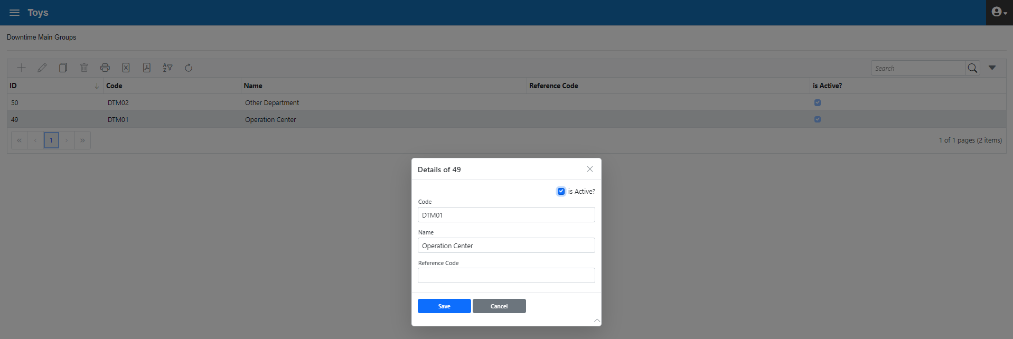
Figure 3.51. Definition of Downtime Main Groups

The "Downtime Sub-Group” is as shown below (Figure 3.52). The "Downtime Sub-Group” is associated with the "Downtime Main Groups"
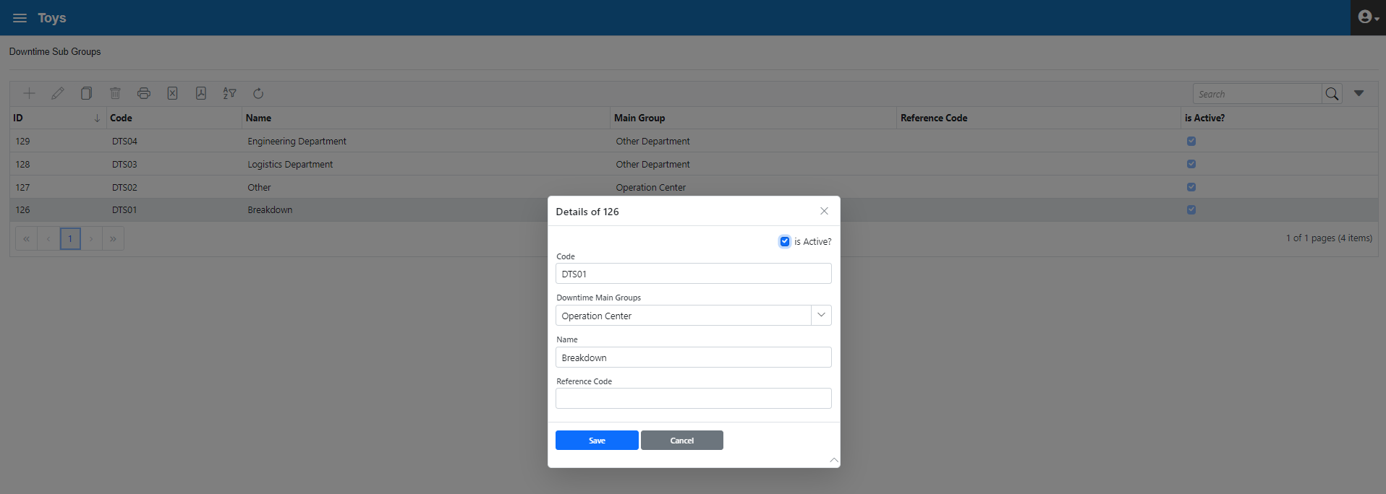
Figure 3.52. Downtime Sub-Group Form

The " Downtime Sub-Group " list form is as follows (figure 3.53). 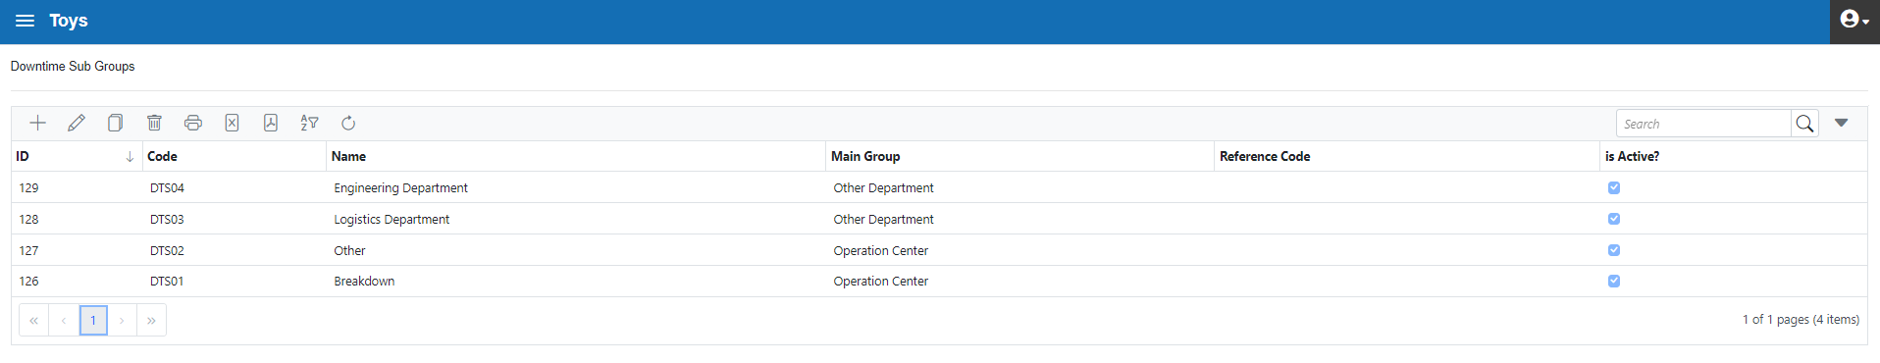
Figure 3.53. Downtime Sub-Group in List Form

The "Downtime Types" form is as follows (figure 3.54). "Downtime Types" are associated with the "Downtime Subgroup". Thus, Downtimes are created in a hierarchical structure
If a downtime has a fixed duration (such as meal break), it is defined in the "Duration" field. Otherwise, it should be left blank.
"Sorting Priority" specifies the sort order in the Downtime drop-down list in the Operator Interface form (the form used by operators). Common stops should be assigned a small order number for easy operator access. If the field is left blank, the corresponding Downtime appears at the bottom part of the list.
"Planned" indicates that the Downtime is planned (such as food, maintenance) and is not taken into account in the calculation of OEE and Availability.
"Starting Info Required" and "Ending Info Required" must be checked if the operator is required to enter description information during the start and end of the downtime.
"User Related" must be marked if the downtime is operator-induced and is for reporting purposes.
"Out of Operation Order" is used to start and end a downtime even though an Operation Order has not been started.
The "Valid for Departments" field identifies the Department, Operations Center Group, and Operations Centers that apply to the selected downtime. Thus, operators can only see the Downtime list that interests them and can quickly select the type of downtime they need. If a downtime is selected at the plant level (Toy Inc.), the downtime appears on all operator screens.

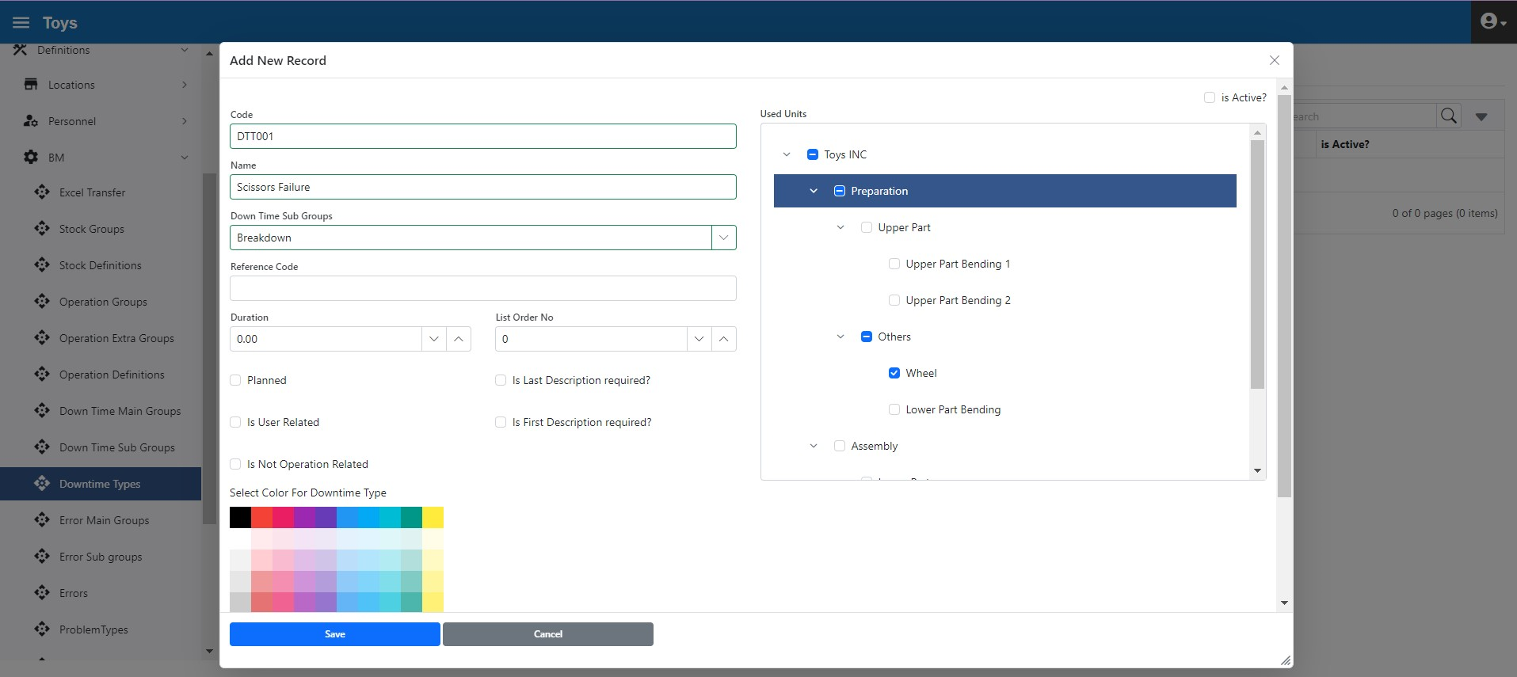
Figure 3.54. Downtime Types Form
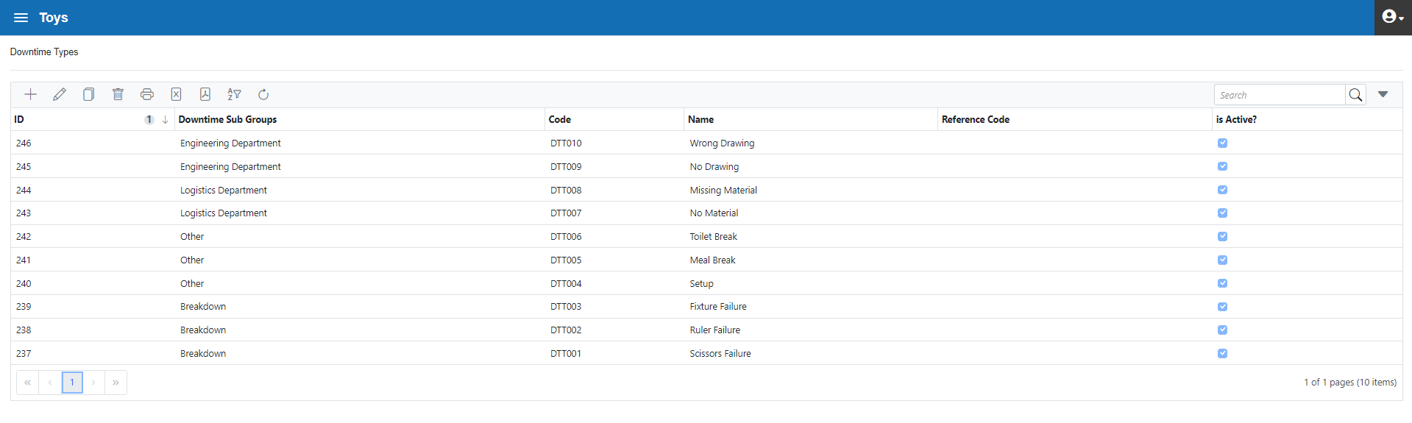
Figure 3.55. Downtime Types in List Form

Based on Quality Loss Types defined in Figure 2.7, the entry of “Quality Loss Main Groups” is given below (figure 3.56)
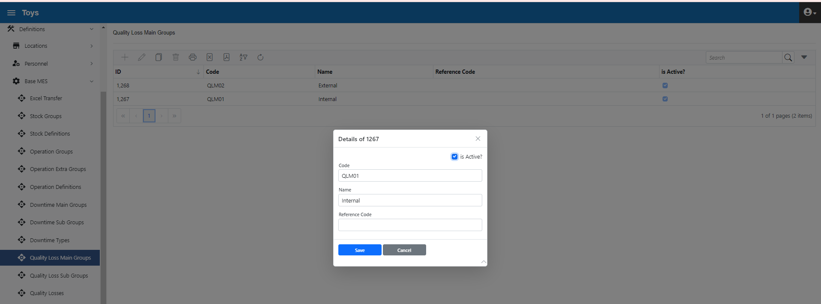
Figure 3.56. Quality Loss Main Groups
The "Quality Loss Sub-Group” is as shown below (Figure 3.57). The " Quality Loss Sub-Group” is associated with the " Quality Loss Main Groups"
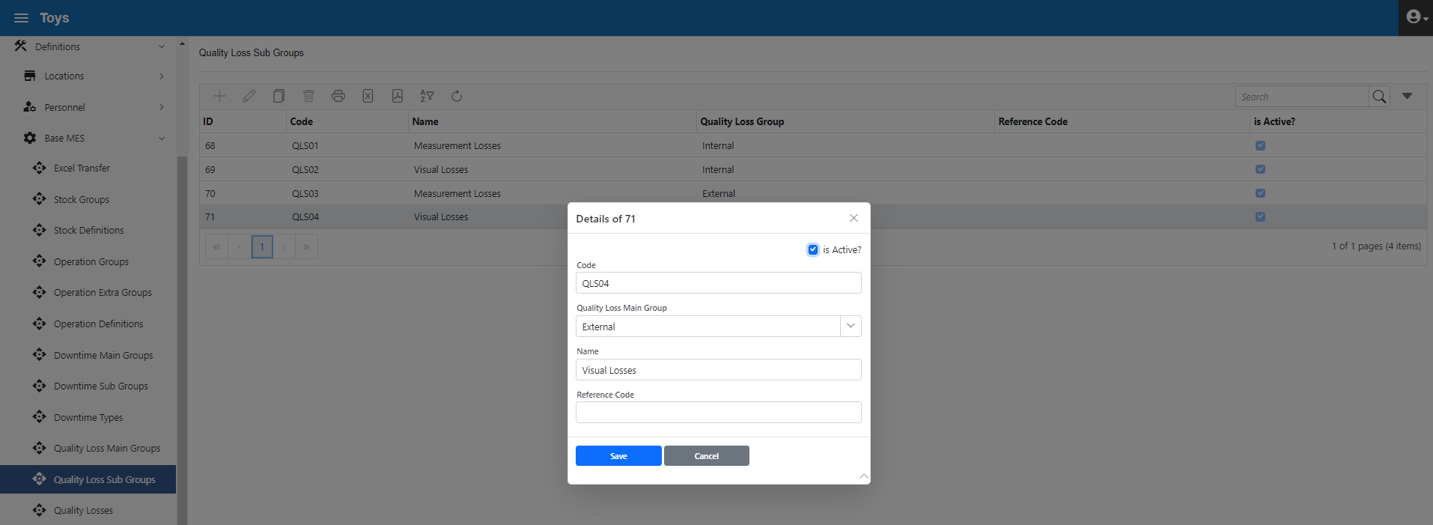
Figure 3.57. Quality Loss Sub-Groups
The " Quality Los Sub-Group" in list form is as follows (figure 3.58).
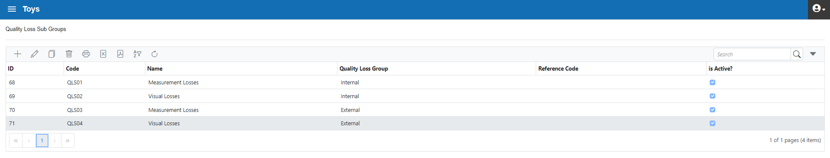
Figure 3.58. Quality Loss Sub-Groups in list form
The "Quality Loss Types" form is as follows (figure 3.59). " Quality Loss Types" are associated with the " Quality Loss Subgroup". Thus, Downtimes are created in a hierarchical structure
The "Valid for Departments" field identifies the Department, Operations Center Group, and Operations Centers that apply to the selected Quality Loss. Thus, operators can only see the Quality Loss list that interests them and can quickly select the type of Quality Loss they need. If a Quality Loss is selected at the plant level (Toy Inc.), the Quality Loss appears on all operator screens.

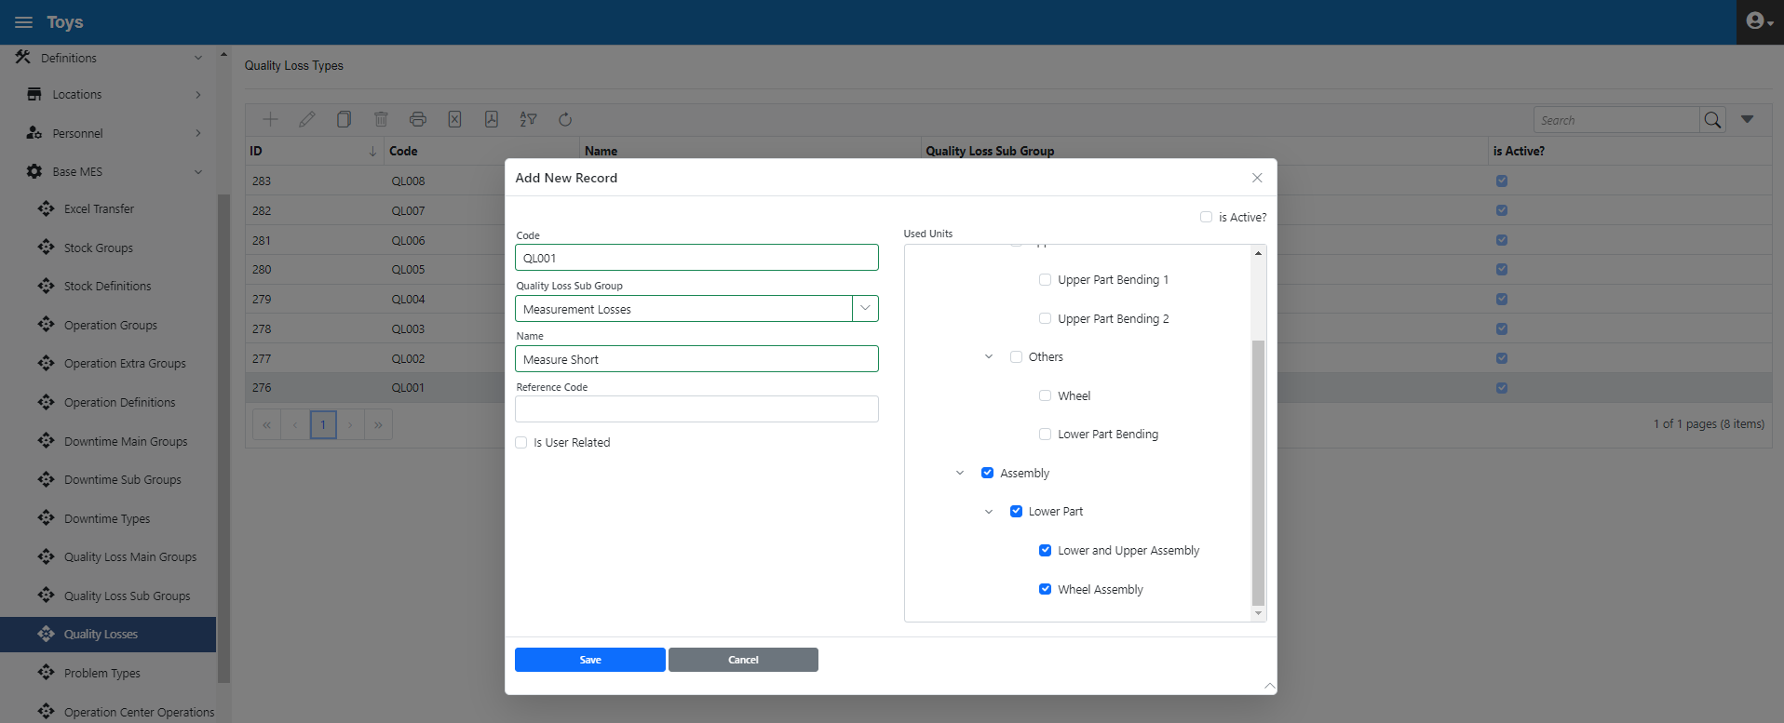
Figure 3.59. Quality Loss Types

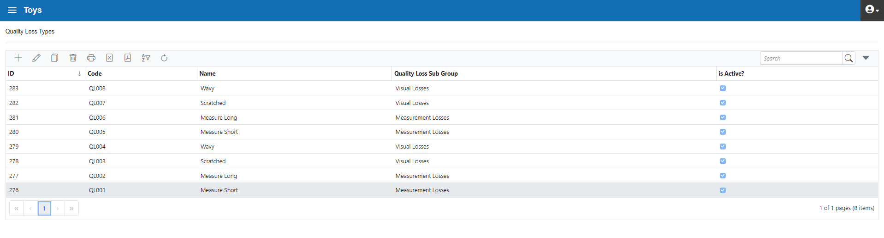
Figure 3.55. Quality Loss Types in List Form
The "Operation Centre-Operation Relationship" form is the form in which the information required to calculate the OEE Performance parameter is entered.
The "Cycle Time" field defines the target time for producing the corresponding selected operation in the selected Operations Center.
An operation can be associated with more than one Operations Centre. In such a case, a value is entered in the "Priority" field to define which Operation Center will be preferred as the priority (used in advanced modules)
Figure 2.6 shows this relationship schematically. An example data can be seen in Figure 3.61.

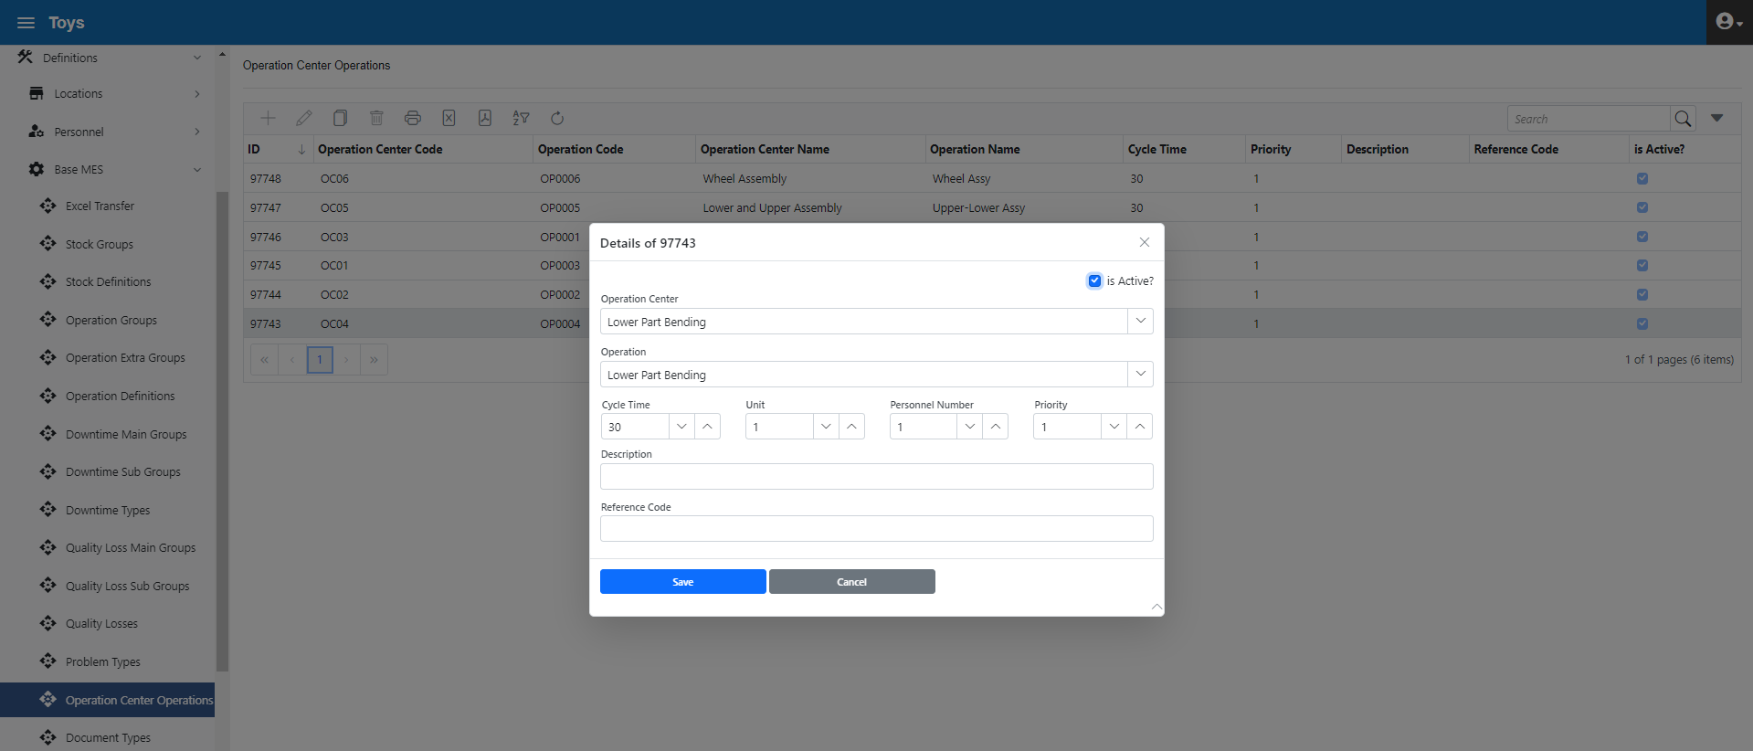

Figure 3.61. Operations Center-Operation Relationship Form
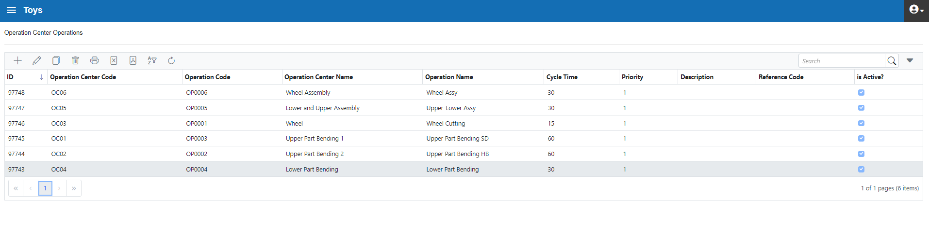

Figure 3.62. Operations Center-Operation Relationship in List form

MA Sub-Menu
To be done

AT Sub-Menu
To be done

Case Scenario, Production Data
In this section, case scenario work with production data will be continued
The "Operation Order" form is the form in which operation orders are created. Shop floor operators can only start by selecting an Operation Order. An operator can perform transactions such as starting, finishing an operation, downtime and quality loss only through Operation Order that he has initiated.
Below is the form in which Operation Orders are created (Figure 3.63). Alternatively, these orders can also be transferred to the system in bulk with Excel transfer.
The "Planned" checkbox is used when the start and end times of the Operation Order are set by the user. When this box is clicked, the "Starting Date" and "End Date" fields are active.

The "Status" section determines the current status of the Operation Order. It can be "Open", "Closed" and "Partly Closed". "Partly Closed" means that the Operation Order has been initiated and temporarily suspended after a certain amount of production. This Operation Order is expected to be put in the "Open" state first and then to the "Closed" state after the operation is completed.
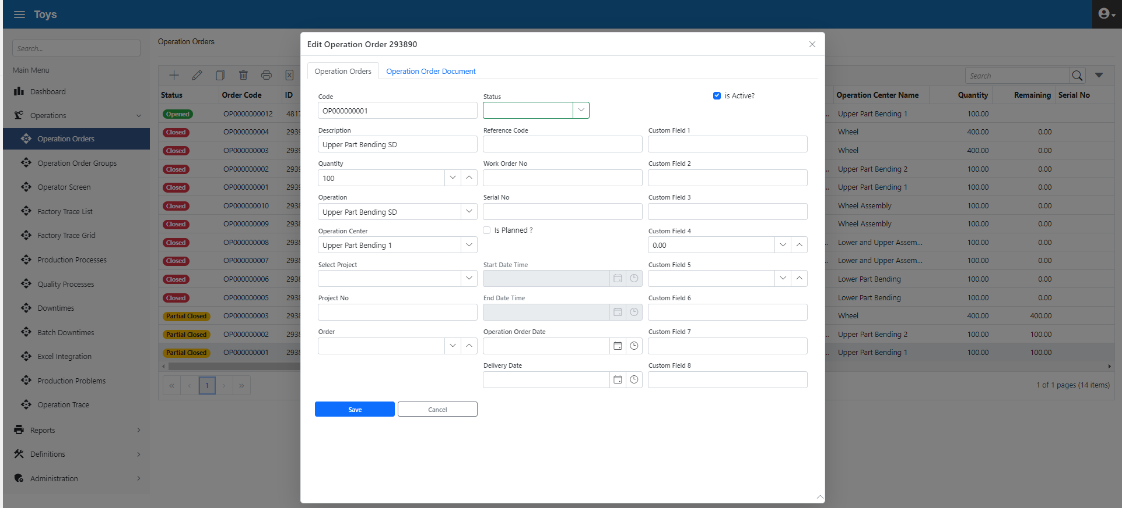
Figure 3.63. Operation Order Form
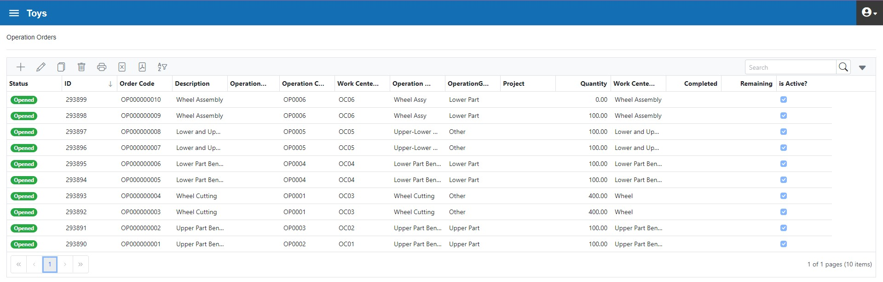

Figure 3.64. Operation Orders in List form

The "Operation Order Groups" form allows more than 1 Operation Order to be grouped and produced at the same time.
For example, 2 different moulds are connected to a press. In this case, the mould will produce 2 different Work-in-Processes with each print. In other words, the press produces 2 different Operation Orders for each cycle. In such a case, the Operation Orders are grouped and become 1 single order. The operator selects the grouped order on the shop floor. Thus, the system receives 2 different WIP production records with each press cycle (figure 3.65)
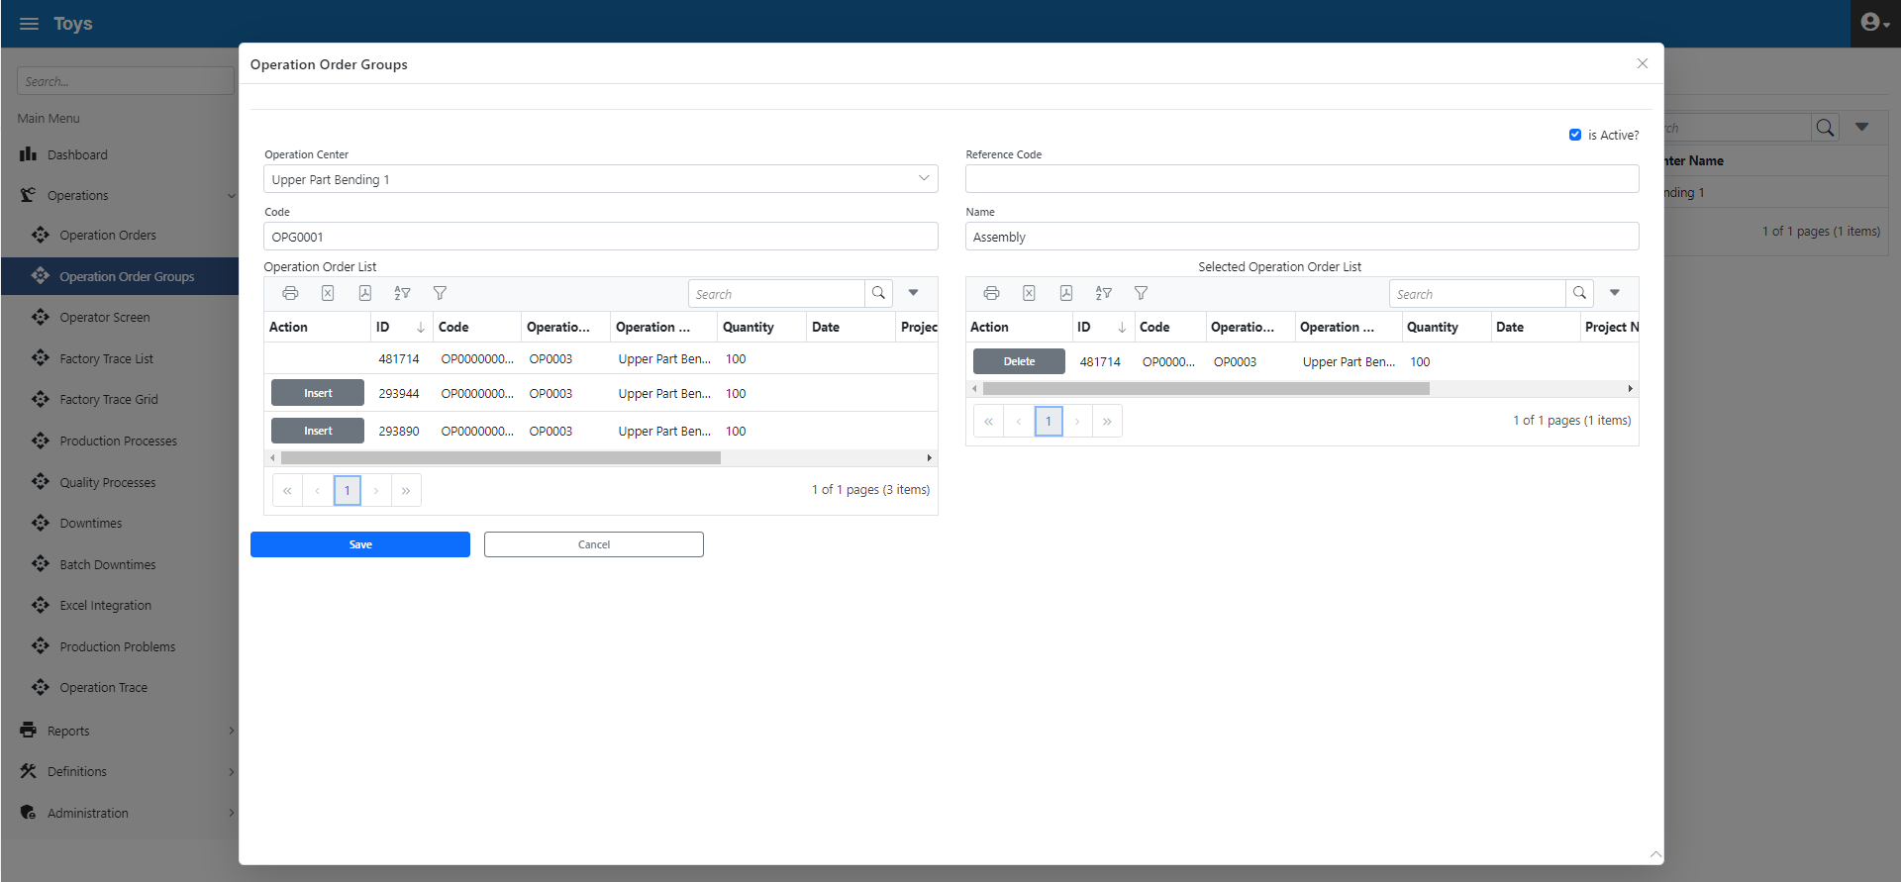
Figure 3.65. Operation Order Group Form
Case shop floor application is as follows.

“Upper Part Bending 1” Operation Center
With the "Terminals" field selection in the "Operator Interface" form, the system automatically determines and implements a) the Operation Center form design, b) which Operation Centres will appear in the form. Please refer to the "Terminals Form" for detailed information
In workstations used for "Operator Interface" purposes on the shop floor (such as PC, tablet or mobile phone), the "Terminals" area is empty on the first use. Once the selection is made, the terminal information is stored in memory and remains the same until it is modified again for this workstation.
In the example below, the terminal named "Upper Part Bending" is selected and 2 Operation Centers appear as described above. (Figure 3.66)
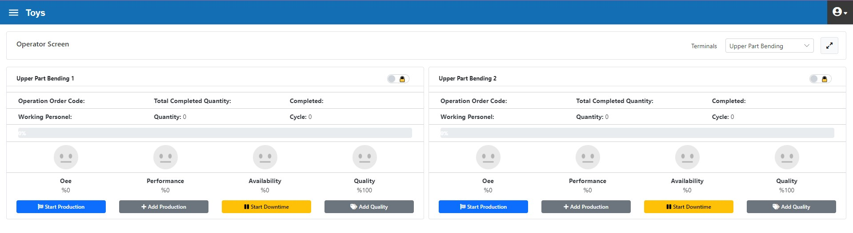
Figure 3.66. Terminal Selection at “Operator Interface”

Each Operation Center form has a "user lock" at the top right (Figure 3.67). If the form is unlocked using this option, all transactions will be available without the need to enter a username and password until the lock is closed again.
"Go for Production" button starts production for an operation order.
The "Add Production" button is to enter the number of parts produced into the system.
"The Start Downtime button is clicked when a downtime starts. When the downtime ends, the "End Downtime" button is clicked.

When quality loss occurs, click "Add Quality Loss" and enter quantity information
Sometimes incomplete or incorrect entry can be made for production, downtime or quality information on the shop floor. In this case, incorrect or missing records can be corrected with the form "Transactions" > "Production Transactions".
Downtime and quality entries can only be made after clicking the "Go for Production" button and starting production. Exceptionally, if the "Out of Operation Order" option is clicked on the "Downtime Types" form, downtime start/end can be done in cases where production is not available.
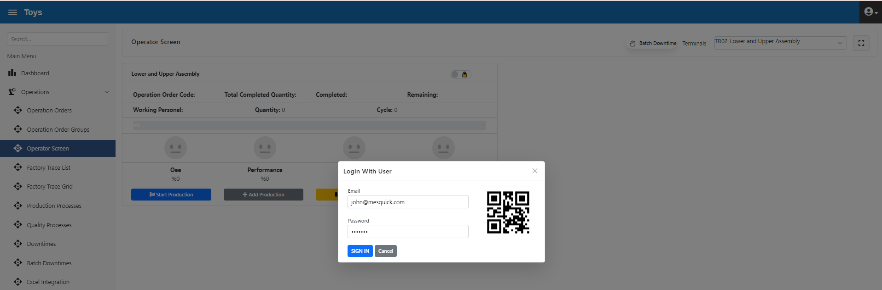
Figure 3.67. Operator Interface “User Lock”

The form that opens when the "Go for Production" button is pressed is below (figure 3.68). In this form, the operation orders assigned to the Operations Centre are displayed.
With the "Employees" dropdown, all employees working in the Operations Center can be added to the list.
Grouped Operation Orders can be seen in the "Operation Order Groups" tab.
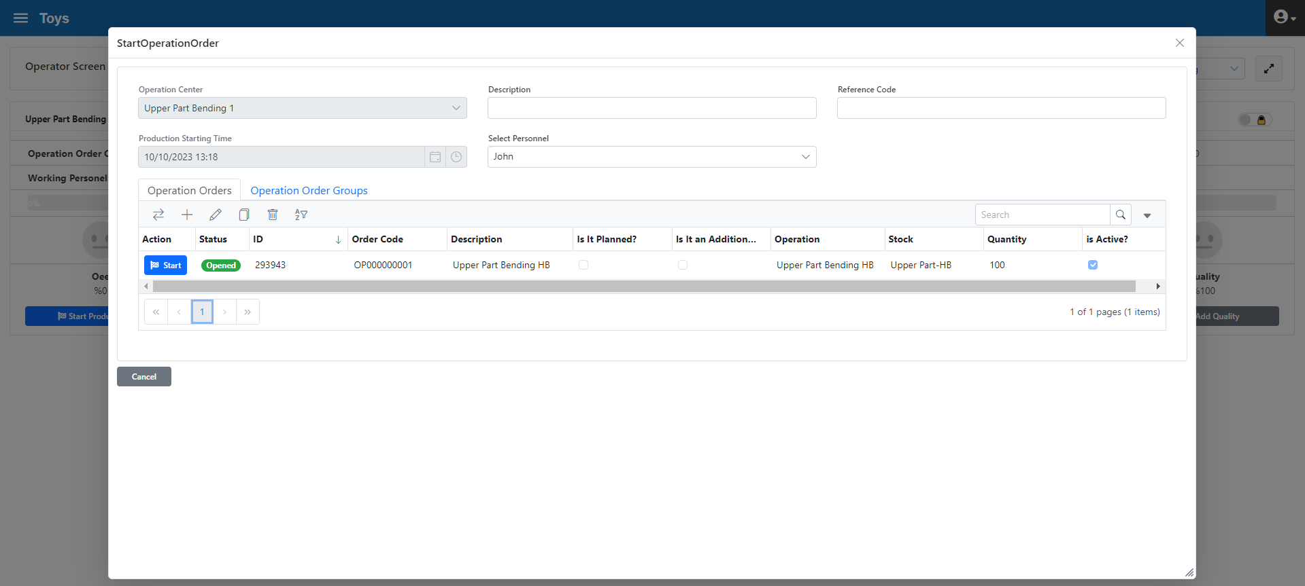
Figure 3.68. Go For Production and select Operation Order

With the "Employees" dropdown, instead of selecting employees one by one, Team selection can be done quickly to register more than 1 employee (figure 3.69)
For detailed information about Teams, see the "Teams Form" section.
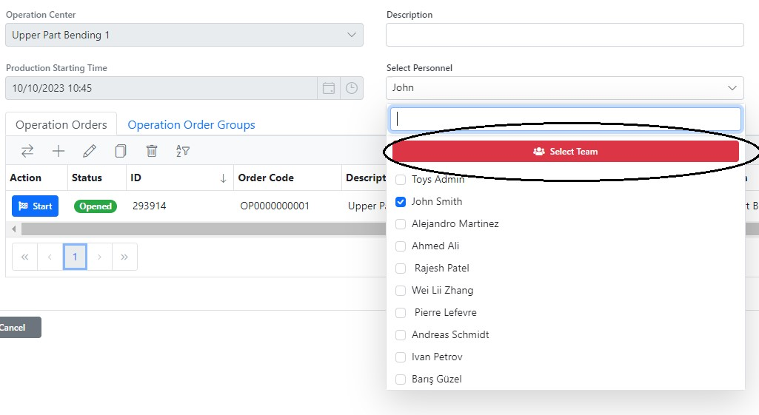
Figure 3.69. Select Team Function

In this operation centre, the following operations were carried out in relation to the operation order OP0000000001:
- 30 min. production

As shown in Figure 3.70, the colour of the operator display changes when production starts. Availability and Quality Rate are shown as 100% at first launch. Production info can be monitored in real time based on the frequency of production data entry.

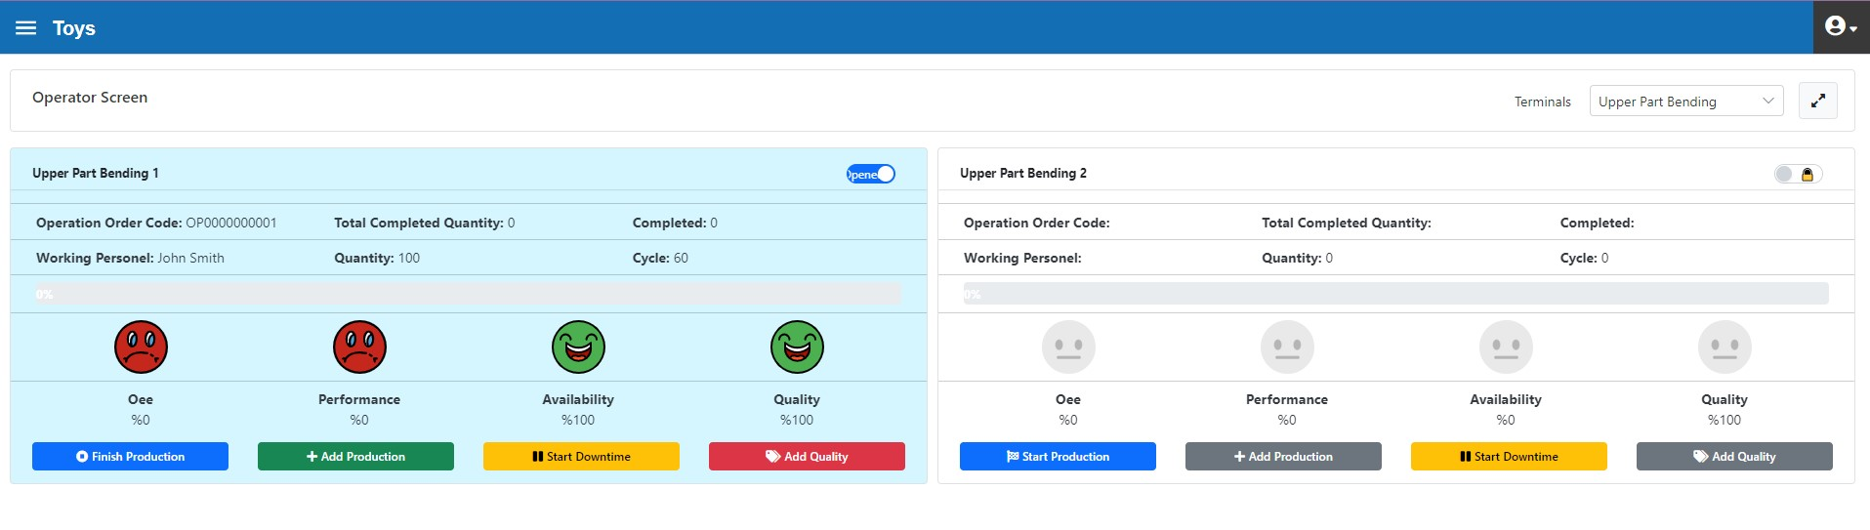

Figure 3.70. “Upper Parts Bending 1” Start of Production in the Operation Center
After the start of production, 30 pieces of Upper Part Bending data were entered into the system as shown in Figure 3.71. 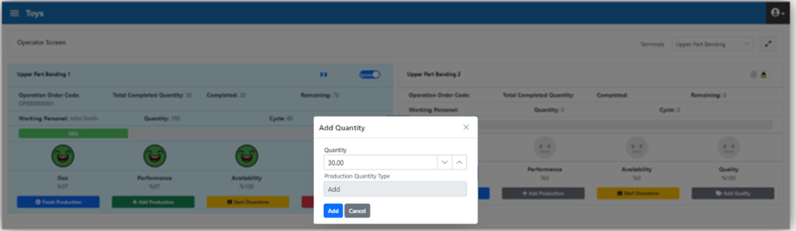
Figure 3.71. Adding Production Quantity

The instant status of the operations centre after adding production is shown in Figure 3.72. It also displays 70 pieces of remaining information for 100 work orders
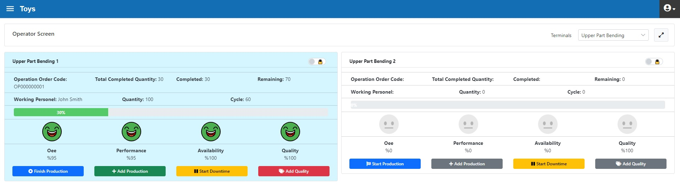
Figure 3.72. Upper Part Bending 1 Operation Center Instant Monitoring
- 10 min. Fixture failure occurred

For this downtime, which occurs 30 minutes after production starts, the Downtime is initiated as shown in Figure 3.73.
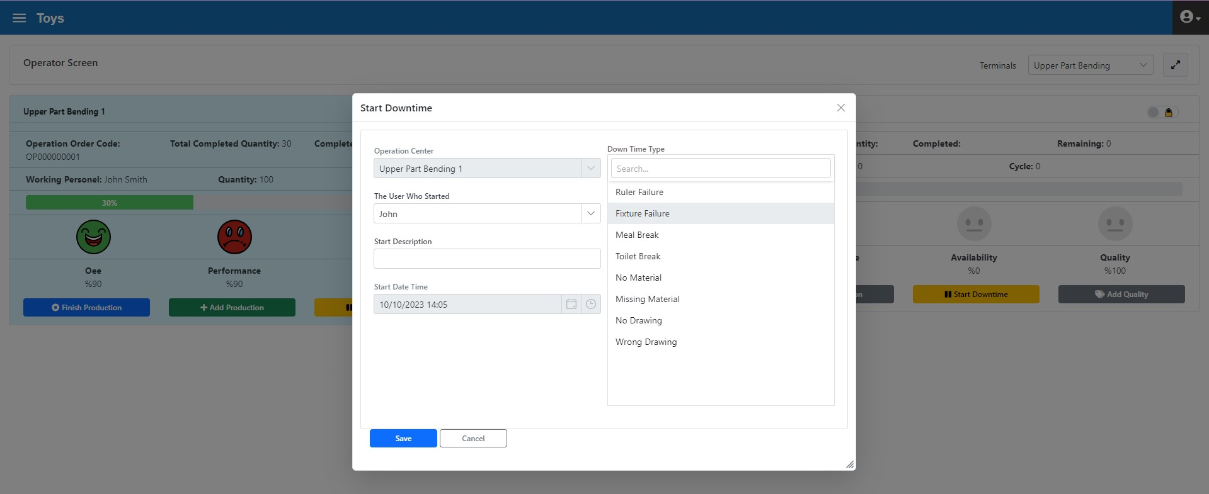
Figure 3.73. Upper Piece Bending 1 Operation Center Downtime Initiation

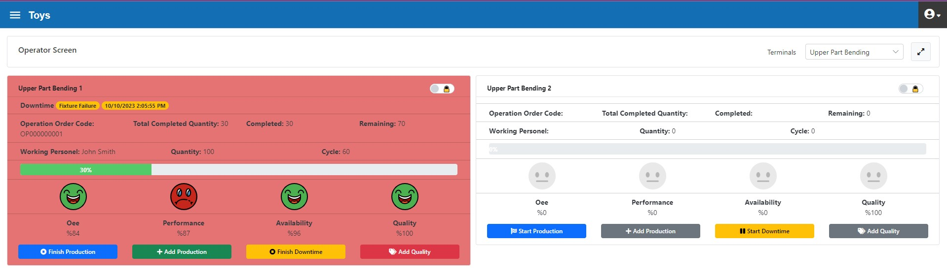
Figure 3.74. Upper Piece Bending Monitoring During Operation Center Downtime

The fixture failure was corrected after 10 minutes and the downtime is ended as shown in figure 3.75.
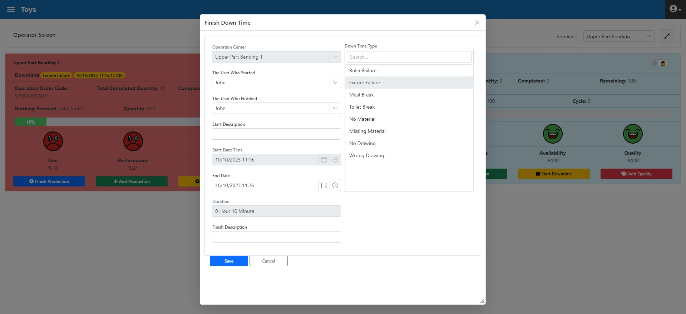
Figure 3.75. Upper Part Bending 1 Operation Center Downtime ending

The current status of the operation centre after the downtime is given in Figure 3.76.
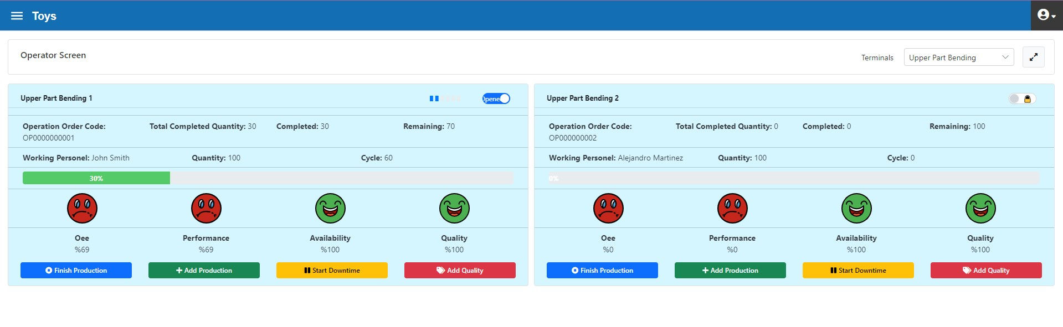
Figure 3.76. End of downtime, Operator Interface form

- 110 min. production

The operation order was completed by making a production entry for the remaining 94 pieces (figure 3.77).

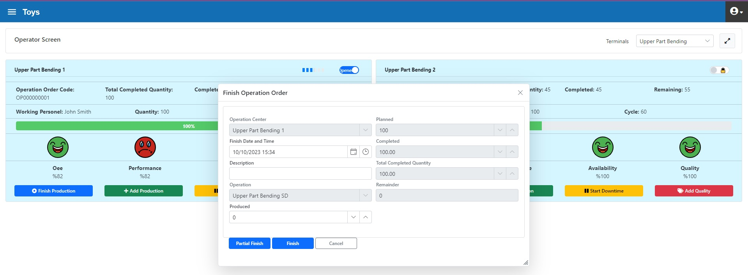
Figure 3.77. Operation Center “Upper Piece Bending 1”, completion of Operation order

Upper Part Bending 1 Operation Center Review
Below is the daily OEE report for the selected operations centre (figure 3.78). The report can be retrieved on Plant/department/operation centre group/operations centre breakdowns.

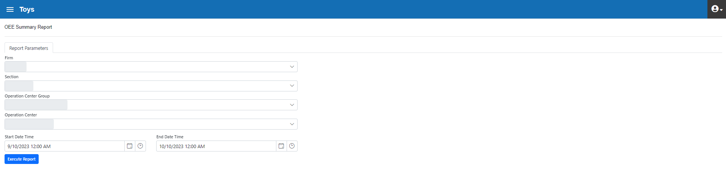
Figure 3.78. OEE Report Filter

OEE report for production as of 11.10.2022 (figure 3.79)
Figure 3.79. “Upper Part Bending 1” OEE Report Running

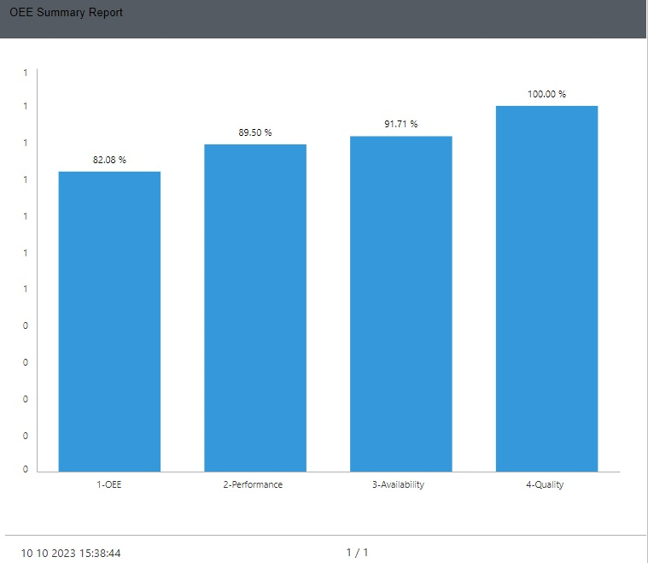
Figure 3.80. “Upper Part Bending 1” OEE Report Result
The target-actualized OEE report can be seen in Figure 3.81. According to the report, the Quality rate parameter has reached the expected performance. Other parameters fell short of the targets. In particular, the availability parameter is well below the target. In this operation centre, downtimes that reduce usability should be analysed in detail and remedial actions should be taken.
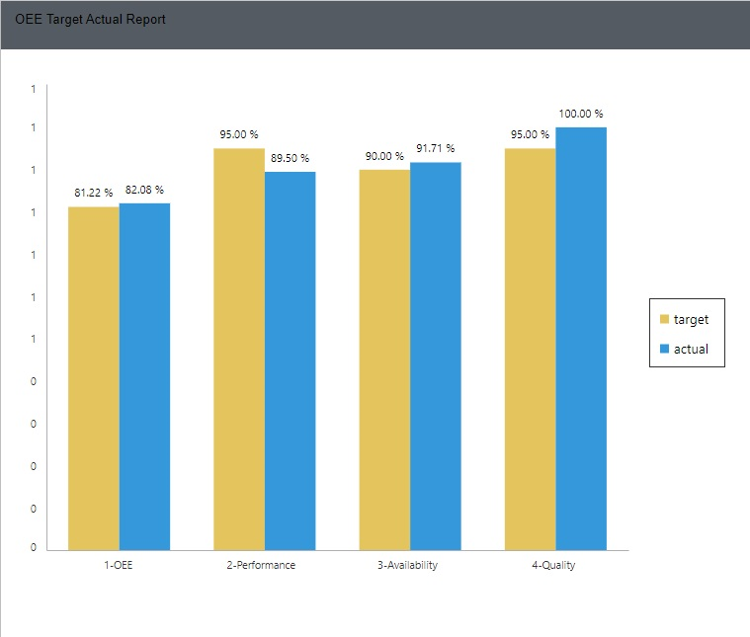
Figure 3.81.” Upper Part Bending 1” OEE Target-Actual Report

“Upper Part Bending 2” Operation Center

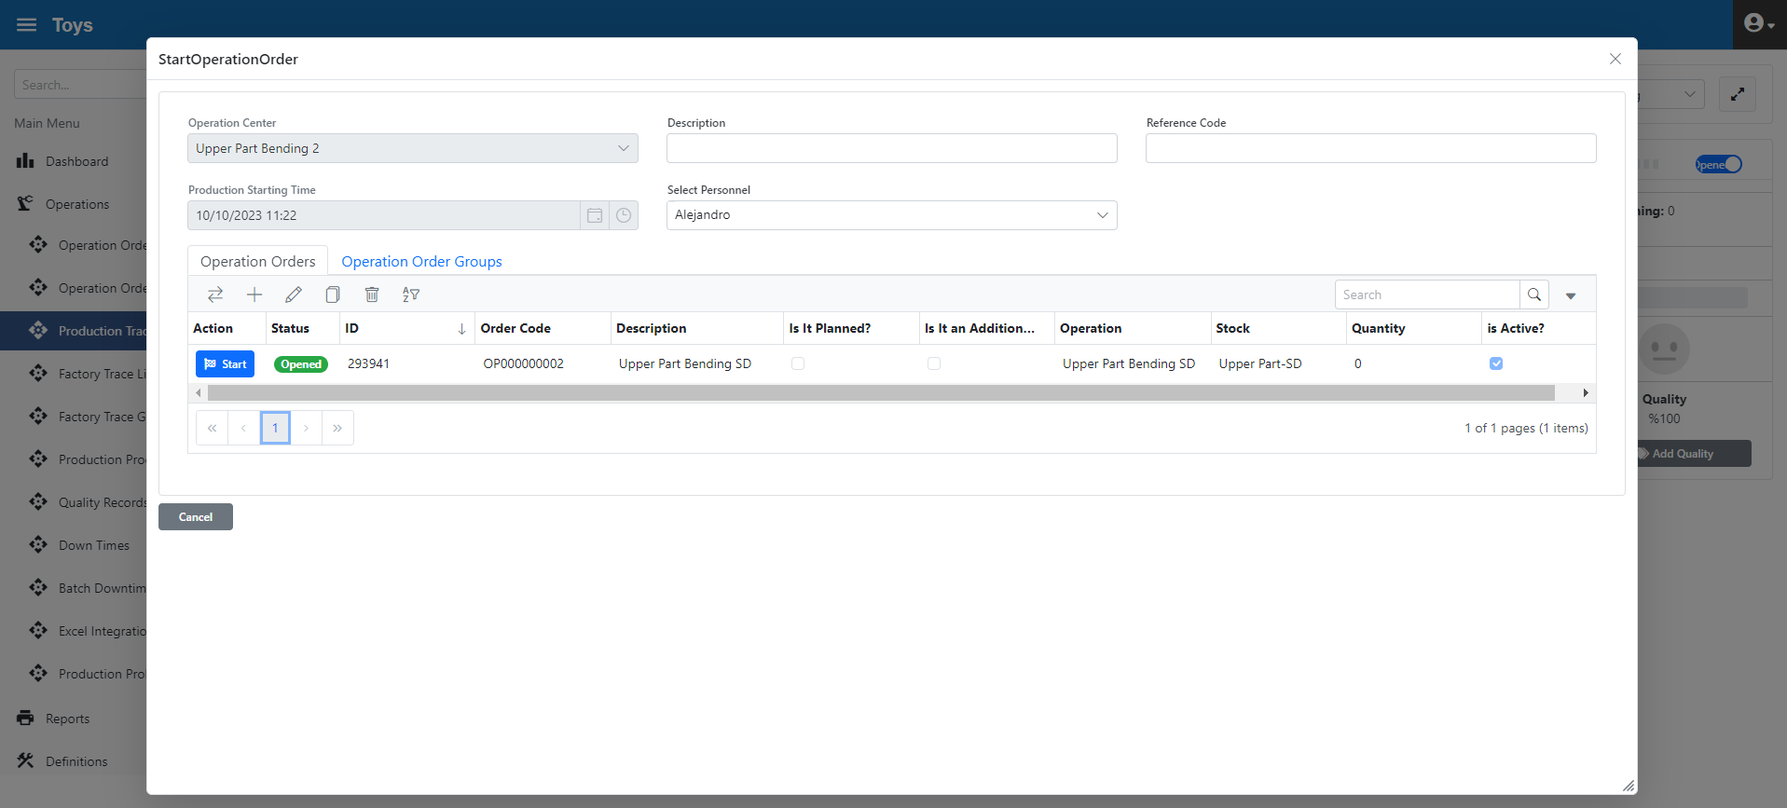
Figure 3.82. “Upper Part Bending 2” Operation Center Production Initiation
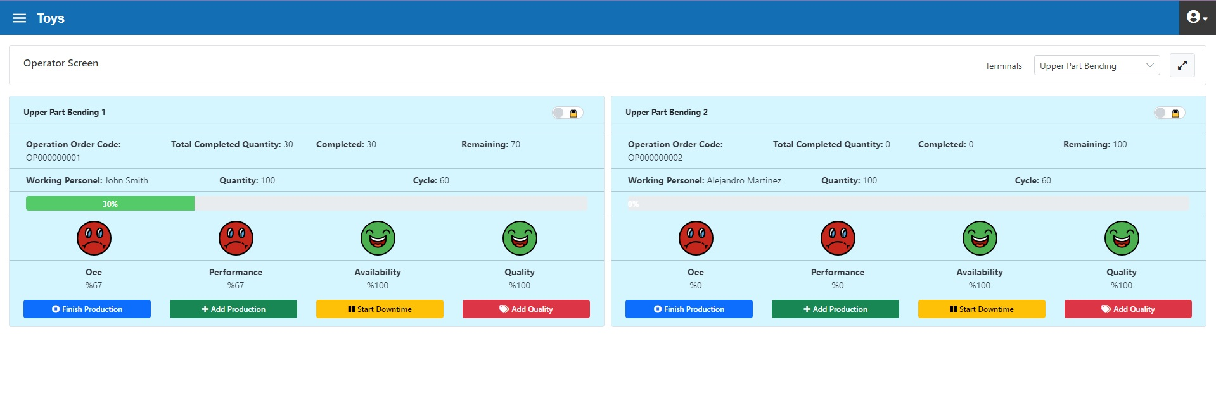
Figure 3.83. “Upper Part Bending 2” Operation Center, Operator Interface During Production
In this operation centre, the operations for operation order OP0000000001 are as follows:
- 5 min. no material downtime

This downtime entry is shown in figure 3.84.

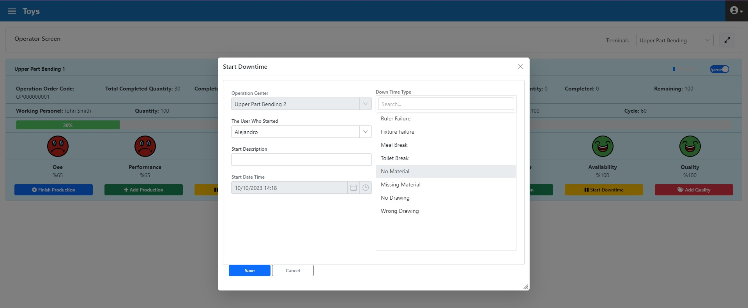
Figure 3.84. “Upper Piece Bending 2” Operation Center Downtime Initiation
As shown in Figure 3.85, the availability before the downtime was 100%, however decreased after the start of the downtime.

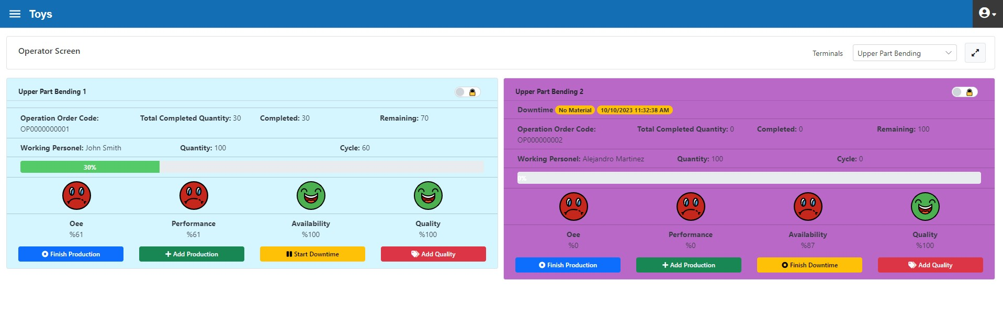
Figure 3.85. Operator Interface form after downtime

This downtime termination is shown in Figure 3.86 below. Since the "Ending Info Required" field is clicked for the "No material" downtime type, it is mandatory to enter information in this field during the "end downtime" operation. See the "Downtime Types" form for detailed information.
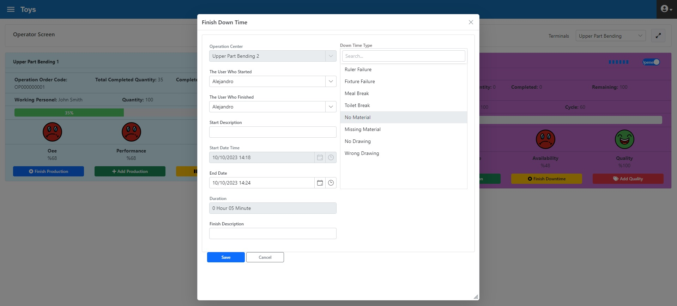
Figure 3.86. “Upper Part Bending 2” Operation Center, End Downtime

- 40 min. production

While production was in progress, 30 parts were entered as shown in Figure 3.87.
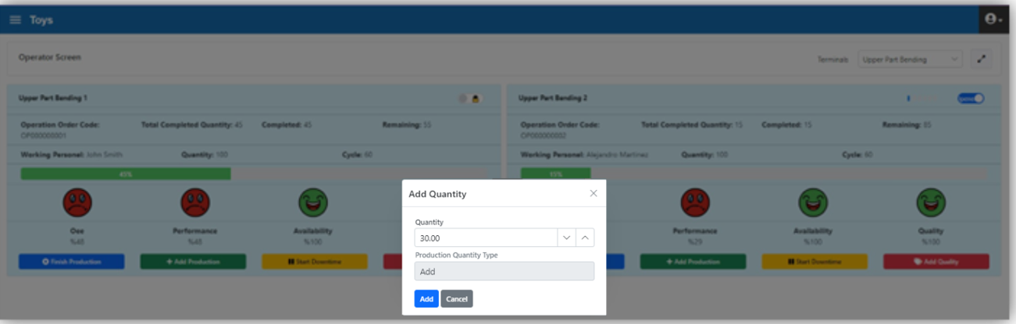
Figure 3.87. “Upper Part Bending 2” Operation Center, "Add Production" option

After the production quantity of 30 pieces, the operator interface form is given in Figure 3.88.
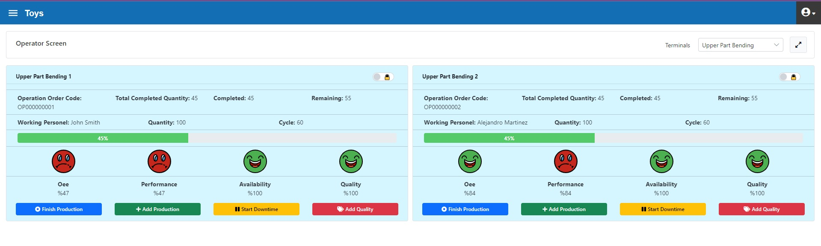
Figure 3.88. “Upper Part Bending 2” Operation Center after “Add production”

- 2 "measure short” quality loss encountered

Quality loss information can be entered from the "operator interface" form during production and from the "Transactions > Quality Transactions" tab after production.
Below (figure 3.89) there are 2 "measure short" input via “Operator Interface” form 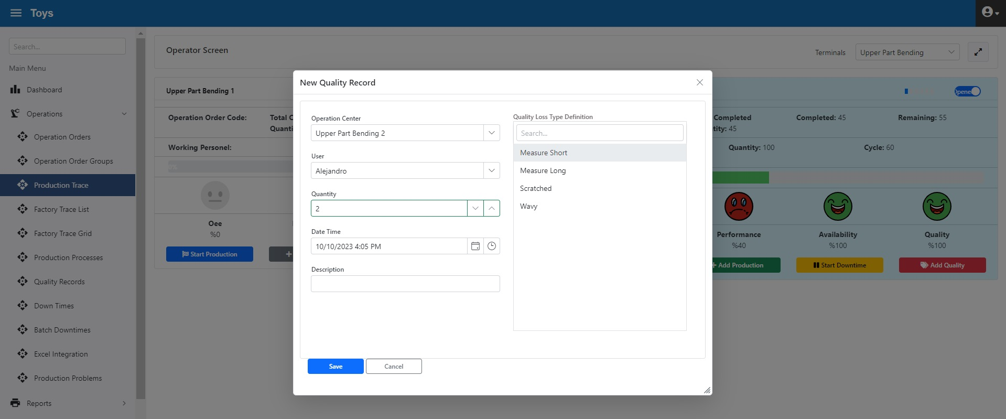
Figure 3.89. “Upper Part Bending 2” Operation Center, Quality Loss input
- 100 pieces of YM0003 coded work-in-process production

Entering the remaining production quantity (figure 3.90) and completing the operation order
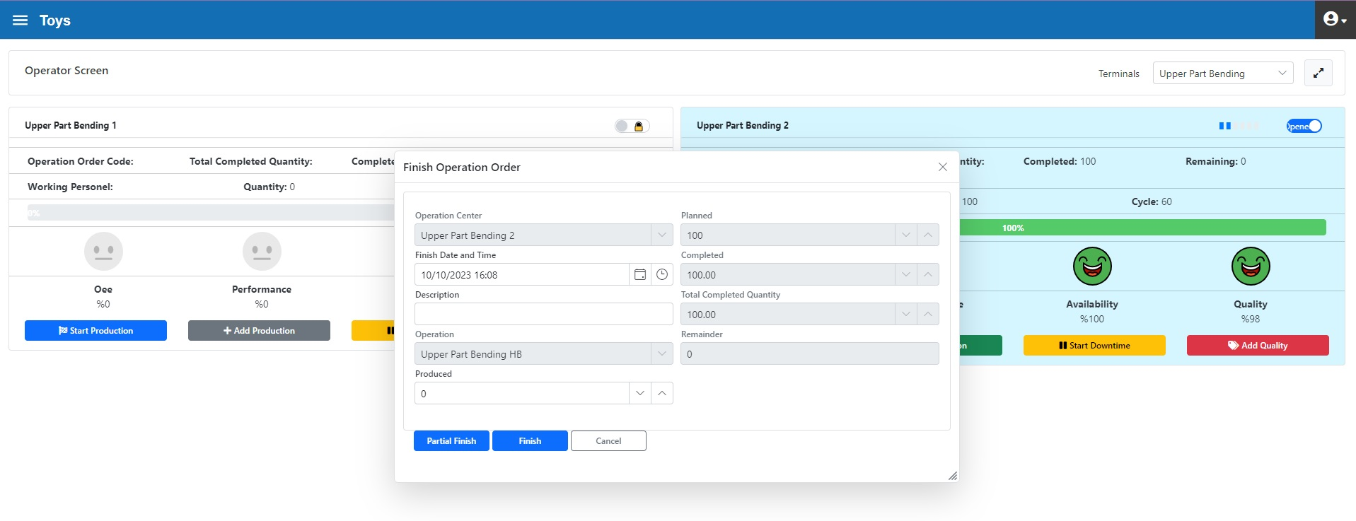
Figure 3.90. “Upper Part Bending 2” Operation Center, end of Operation Order

“Upper Part Bending 2” Operation Center Review

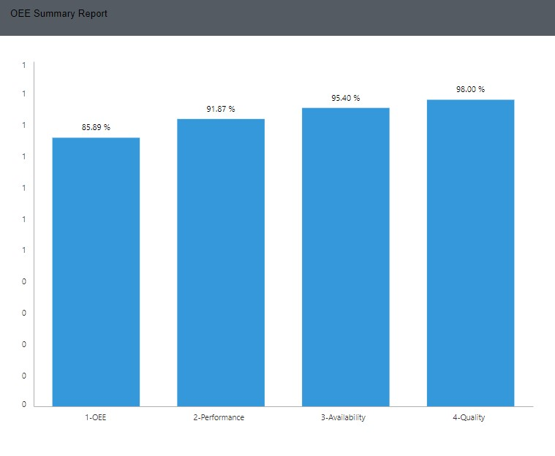
Figure 3.91. “Upper Part Bending 2” OEE Report Result

The target-actualized OEE report can be seen in Figure 3.92. According to the report, the OEE has reached the expected value. However, the availability parameter is well below the target. In this operation centre, downtimes that reduce availability should be analysed in detail and remedial actions should be taken.

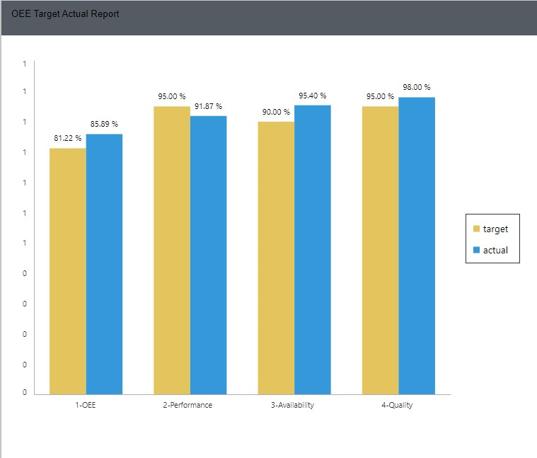
Figure 3.92.” Upper Part Bending 2” OEE Target-Actual Report

Wheel Operation Centre
The transactions with the operation orders OP000000003 and OP000000004 assigned to this operations centre are as follows:
- Operation order OP000000003 has been started.

By clicking the "Go for Production" button in the "Operator Interface" form (figure 3.93), all the operation orders assigned to this operation centre are visible. Production started by selecting the operation order OP000000003.
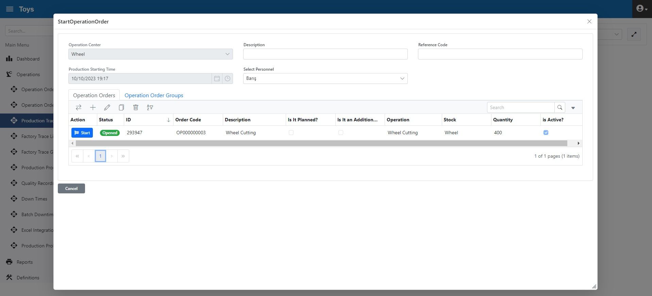
Figure 3.93. Wheel Operation Center Production Initiation
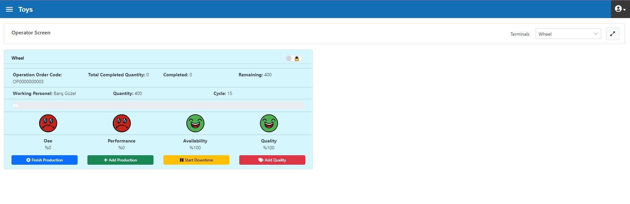
Figure 3.94. Operator Interface form for Wheel Operation Center after Operation Order started

- 30 min. production
- Production of 120 wheels

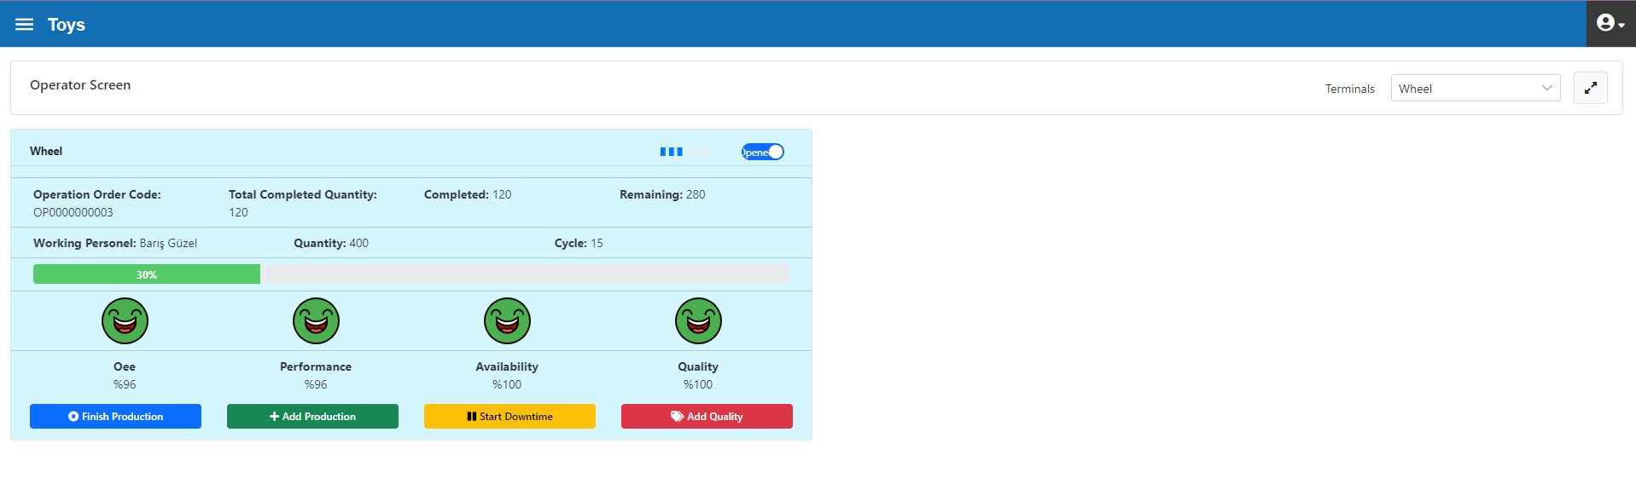
Figure 3.95. Wheel Operation Center after “Add production”
- 10 min. scissor failure stop
- Scissor failure stop initiated (figure 3.96) 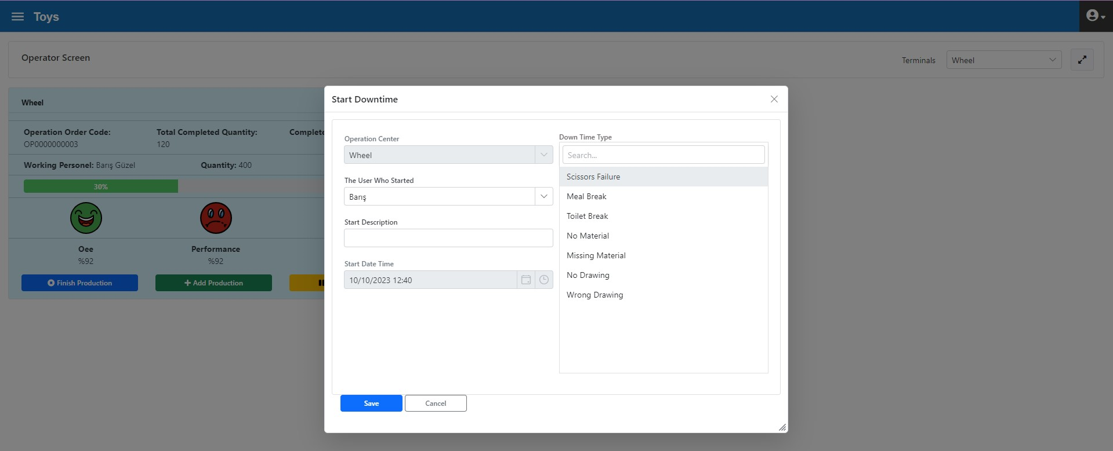
Figure 3.96. Wheel Operation Center, Scissor Failure Downtime Initiation
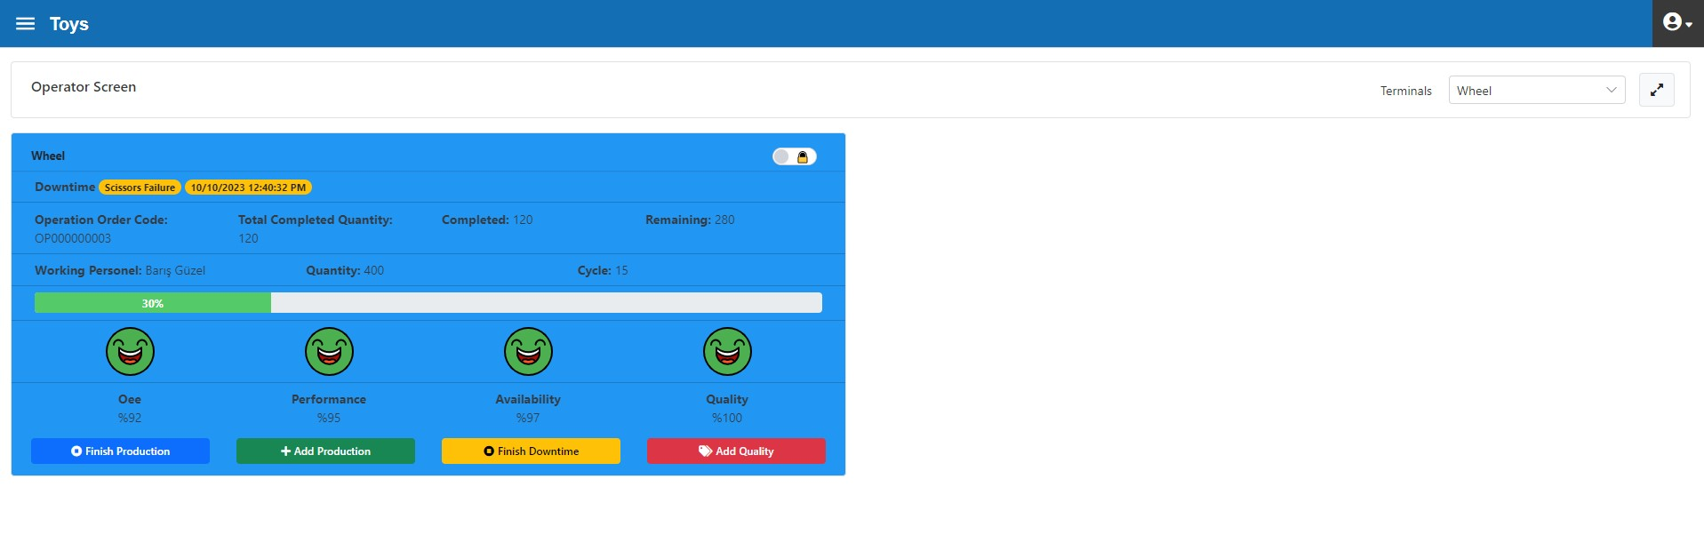
Figure 3.97. Wheel Operation Center, “Operator Interface” form During Downtime

End of "Scissor failure" downtime with "Ending Info" definition (figure 3.98)
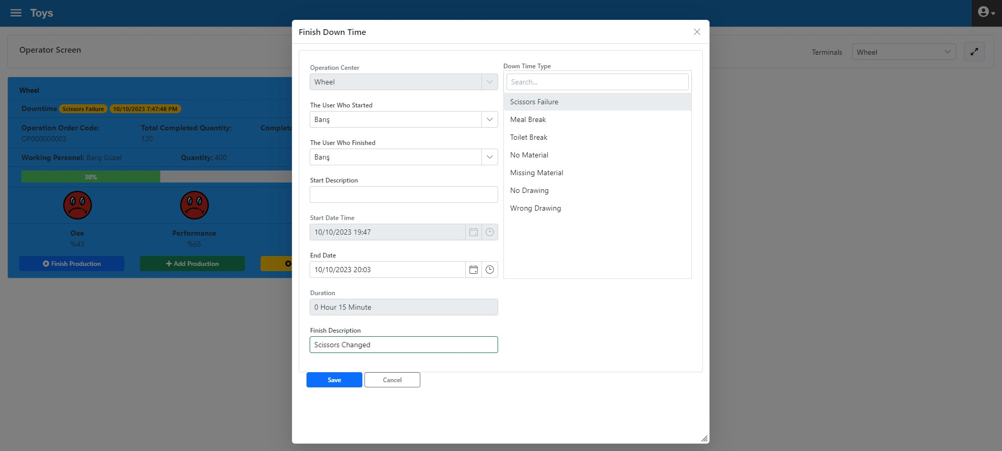
Figure 3.98. Wheel Operation Centre, End of Downtime

- 20 min. production
- 5 min. toilet break
Production was performed for 20 minutes and the toilet break was started as shown in Figure 3.99.

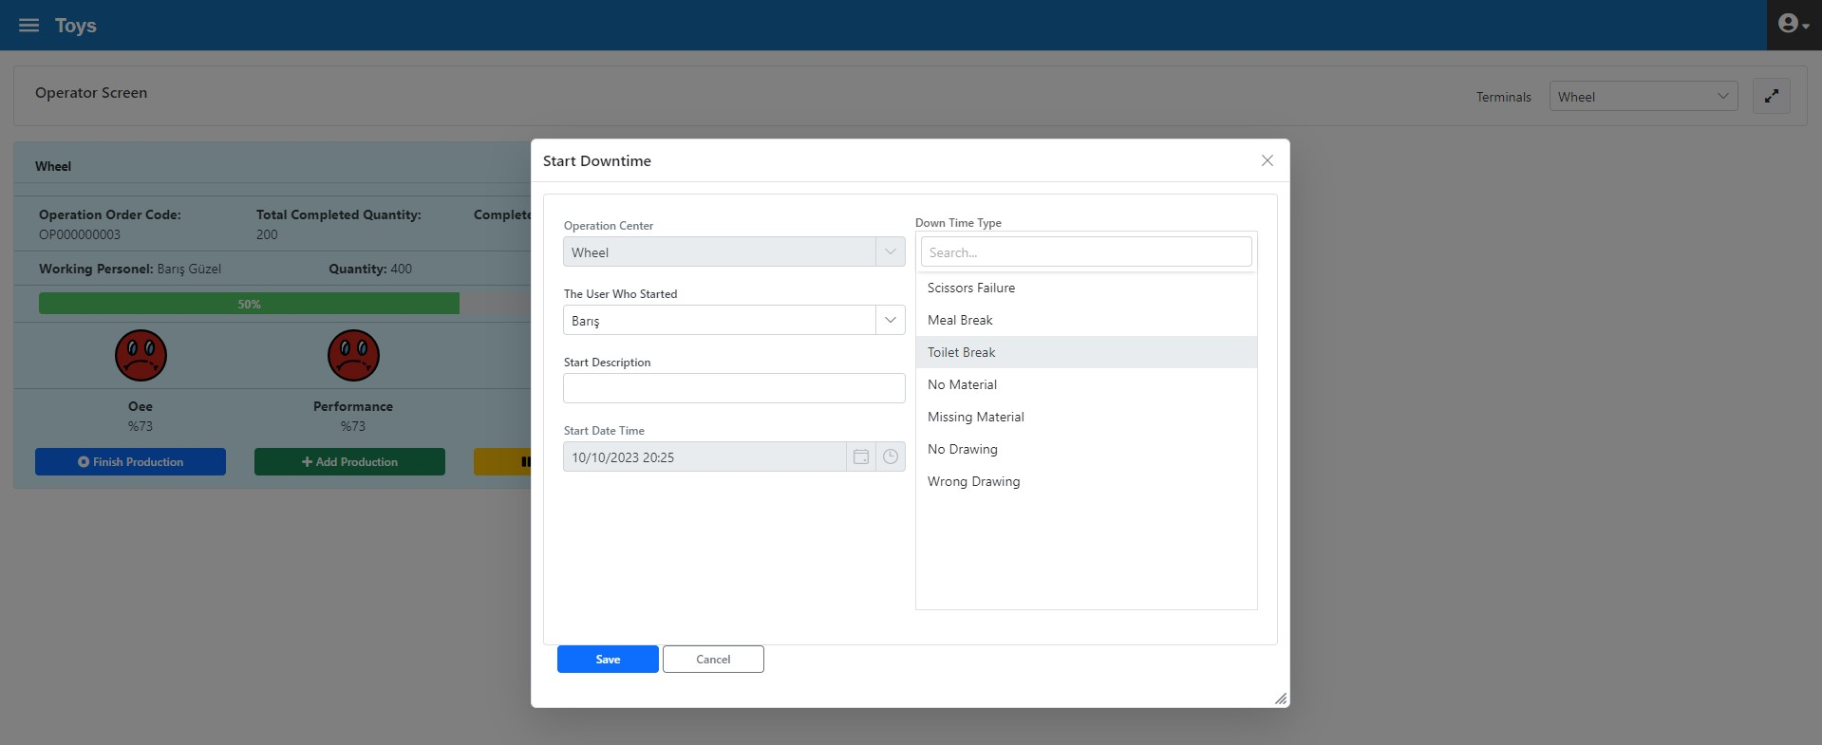
Figure 3.99. Wheel Operation Center Toilet Break Initiation
The toilet break is ended as shown in Figure 3.100

Figure 3.100. Wheel Operation Center End of Toilet Break
- 60 min. production
- 400 YM0004 coded work-in-processes were produced
Remaining 200 wheels were cut and the Operation Order was completed (Figure 3.101) 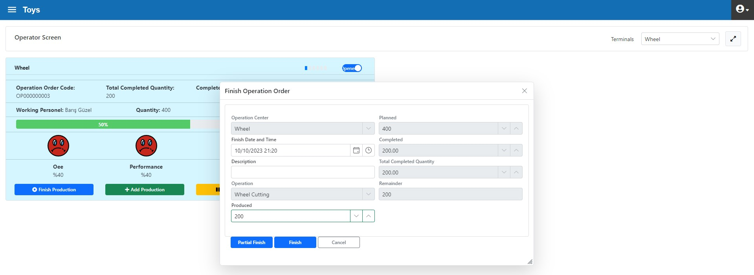
Figure 3.101. Wheel Operation Center Ending Operation Order

- Operation order OP000000004 has been started.

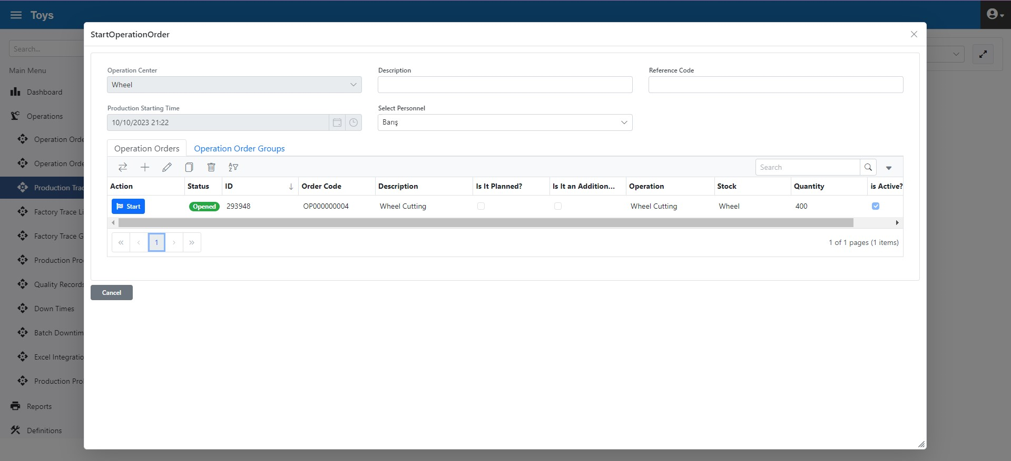
Figure 3.102. Wheel Operation Center OP000000004 Operation Order Initiation
- 5 min. no material downtime

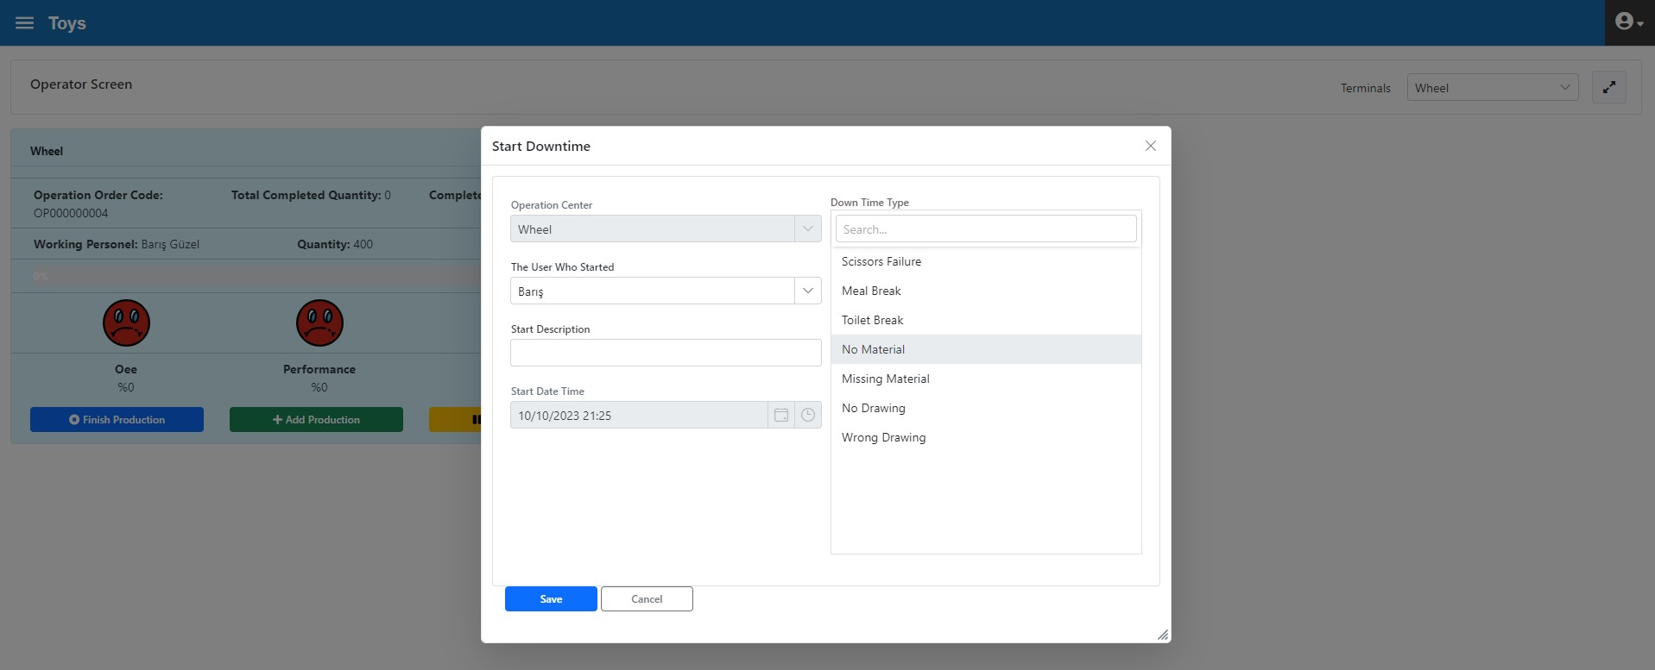
Figure 3.103. Wheel Operation Center No Material Downtime Initiation

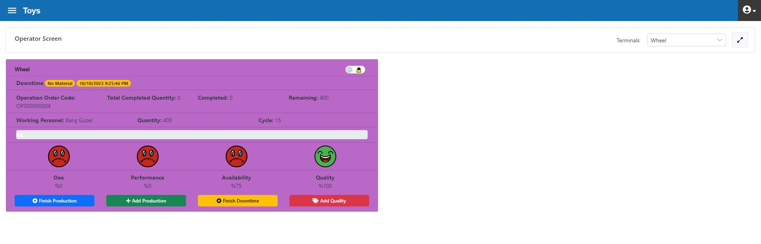
Figure 3.104. Operator Interface Form during “No Material” downtime
End of "No material" downtime and entering information in the "Ending Info" field

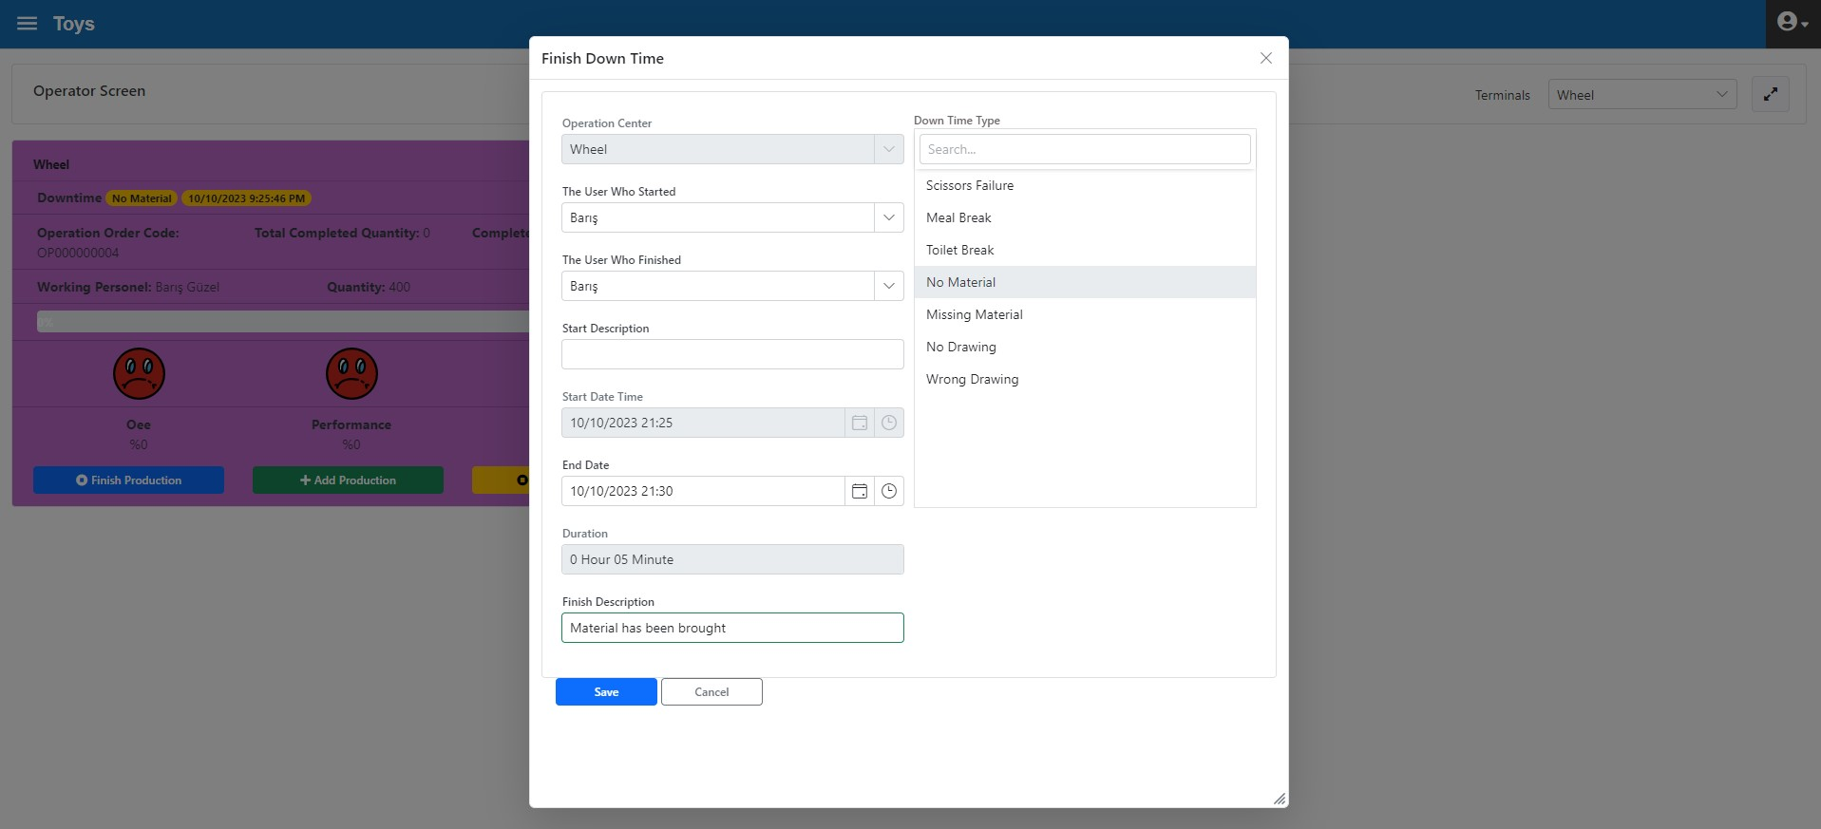
Figure 3.105. End of "No material" downtime and entering information in the "Ending Info" field
- 30 min. production
- 100 wheels were produced and system input was made (Figure 3.106)
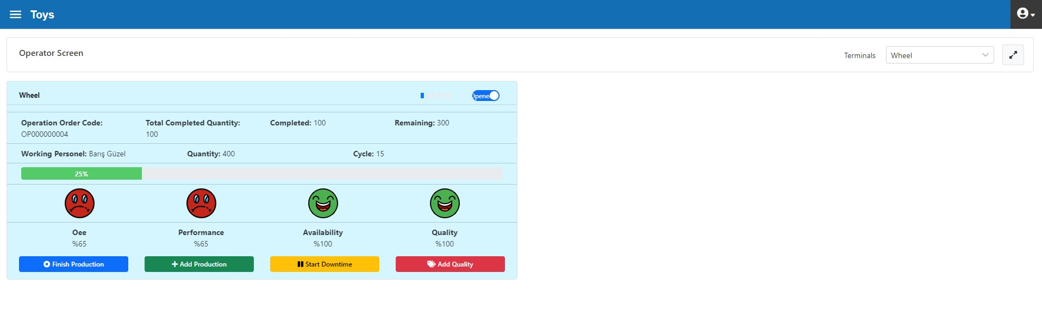
Figure 3.106. Wheel Operation Center, after 100 Pieces Production Input
- 10 min. scissor failure

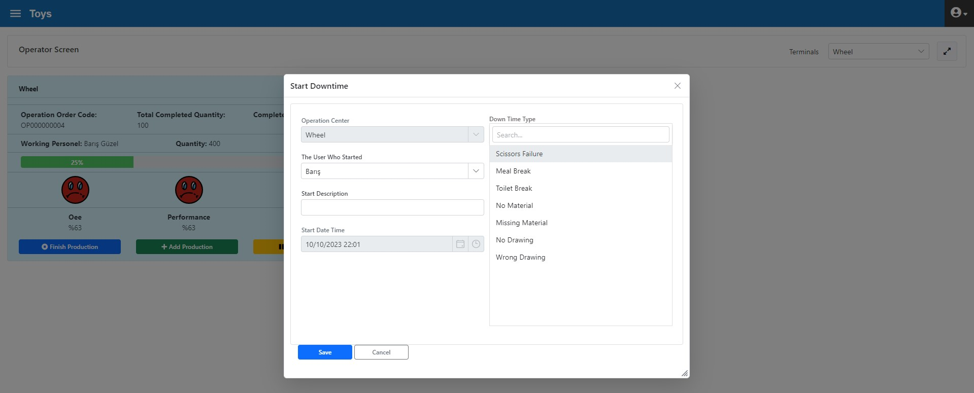
Figure 3.107. Wheel Operation Center Scissor Failure Downtime Initiation

Downtime was terminated (Figure 3.108) and "Ending info" was entered

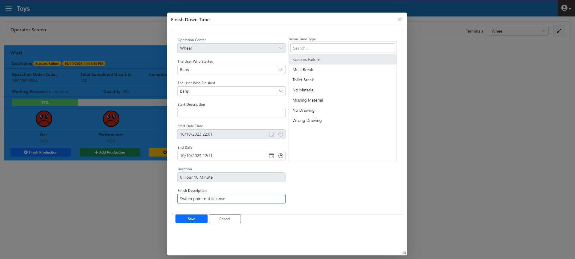
Figure 3.108. Wheel Operation Center, end of Scissor Failure Downtime

- 40 wheels were produced and system input was made (Figure 3.109)
- 75 min. production

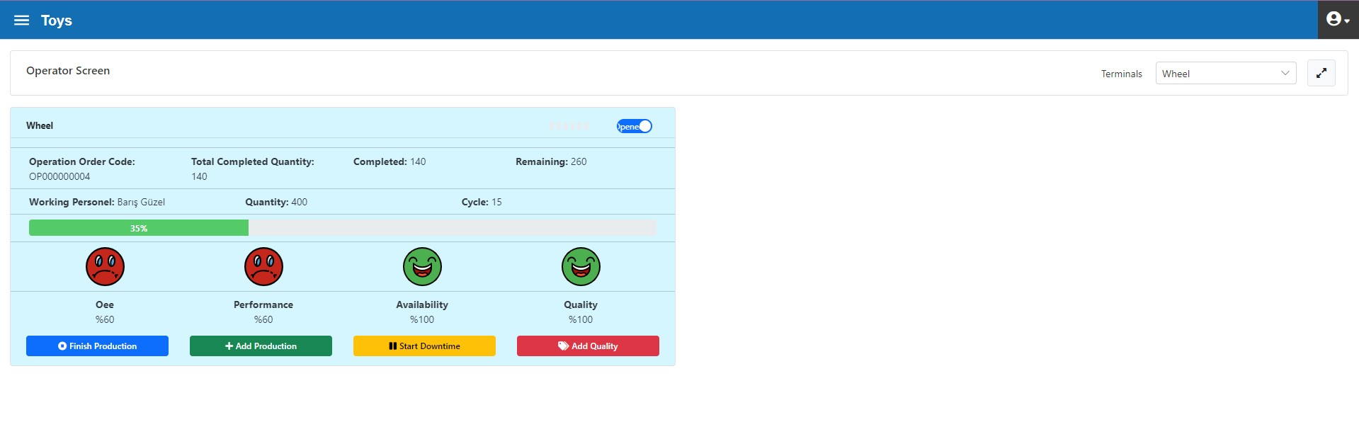
Figure 3.109. Wheel Operation Center, after 40 Pieces Production Input

- 400 YM0004 coded work-in-processes were produced
- 260 wheels were produced and system input was made and operation order completed (Figure 3.110)

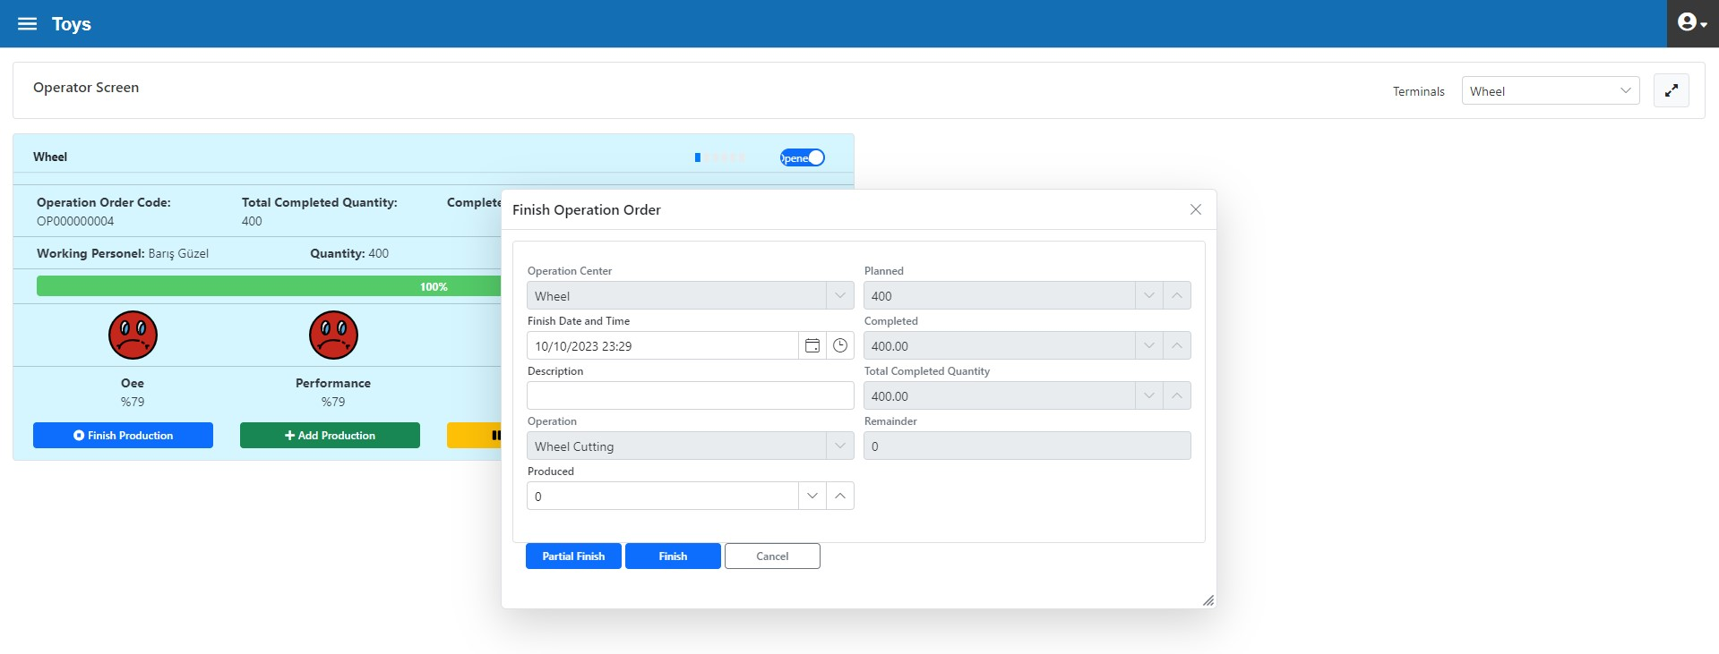
Figure 3.110. Wheel Operation Center end of Operation Order

Wheel Operation Center Reviews
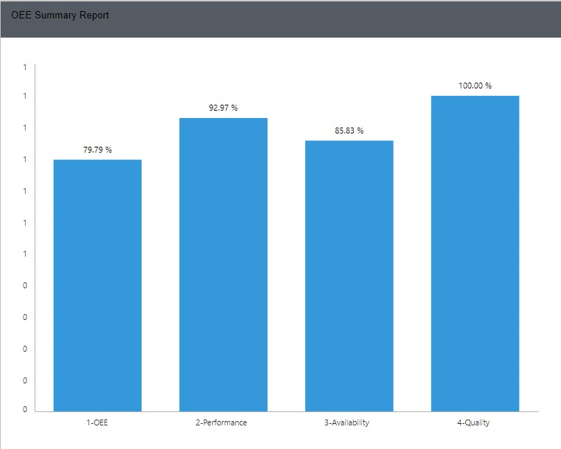
Figure 3.111. Wheel Operation Center, Daily OEE Report

The target-actualized OEE report can be seen in Figure 3.112. According to the report, the Quality Rate and Performance has reached the expected value. However, the availability parameter is well below the target. In this operation centre, downtimes that reduce availability should be analysed in detail and remedial actions should be taken.

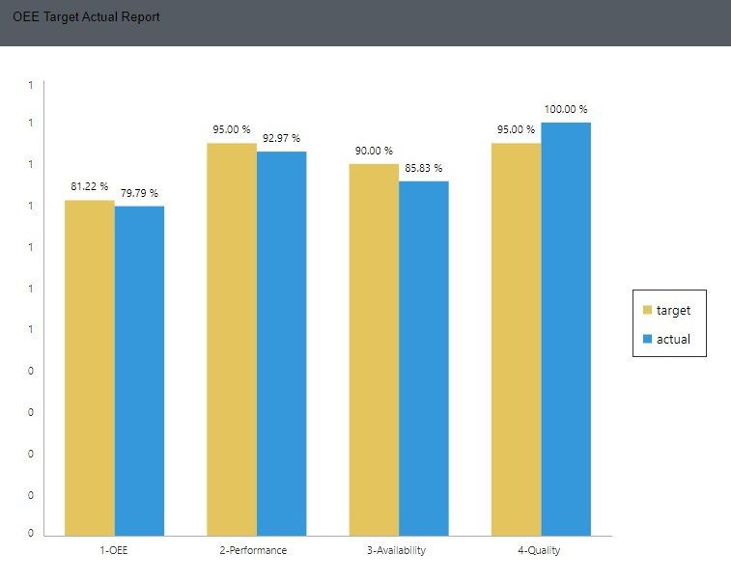
Figure 3.112. Wheel Operation Center OEE Target-Actual Report

