BM – Base MES – Practical Training Document – Part 3

Contents

5.2.4. Lower Part Bending Operation Center 2
5.2.5. Lower-Upper Part Assembly Operation Center 7
5.2.6. Wheel Assembly Operation Centre 15
5.2.7. General Review of Operation Centers 25
5.3. Factory Monitoring 25
5.4. Operation Orders 26
5.5. Production Transactions 26
5.6. Quality Transactions 27
5.7. Downtime Transactions 27
5.8. Excel Integration 28
5.9. Reports 28
5.9.1. Production Reports 28
5.9.2. OEE Reports 29
5.9.3. Downtime Reports 30
5.9.4. Quality Loss Reports 33
5.10. Dashboard 36

Lower Part Bending Operation Center
The production information for operation orders OP000000005 and OP000000006 is as follows:
- Operation order I000000000000467 was started and production was last for 45 minutes (figure 3.113)

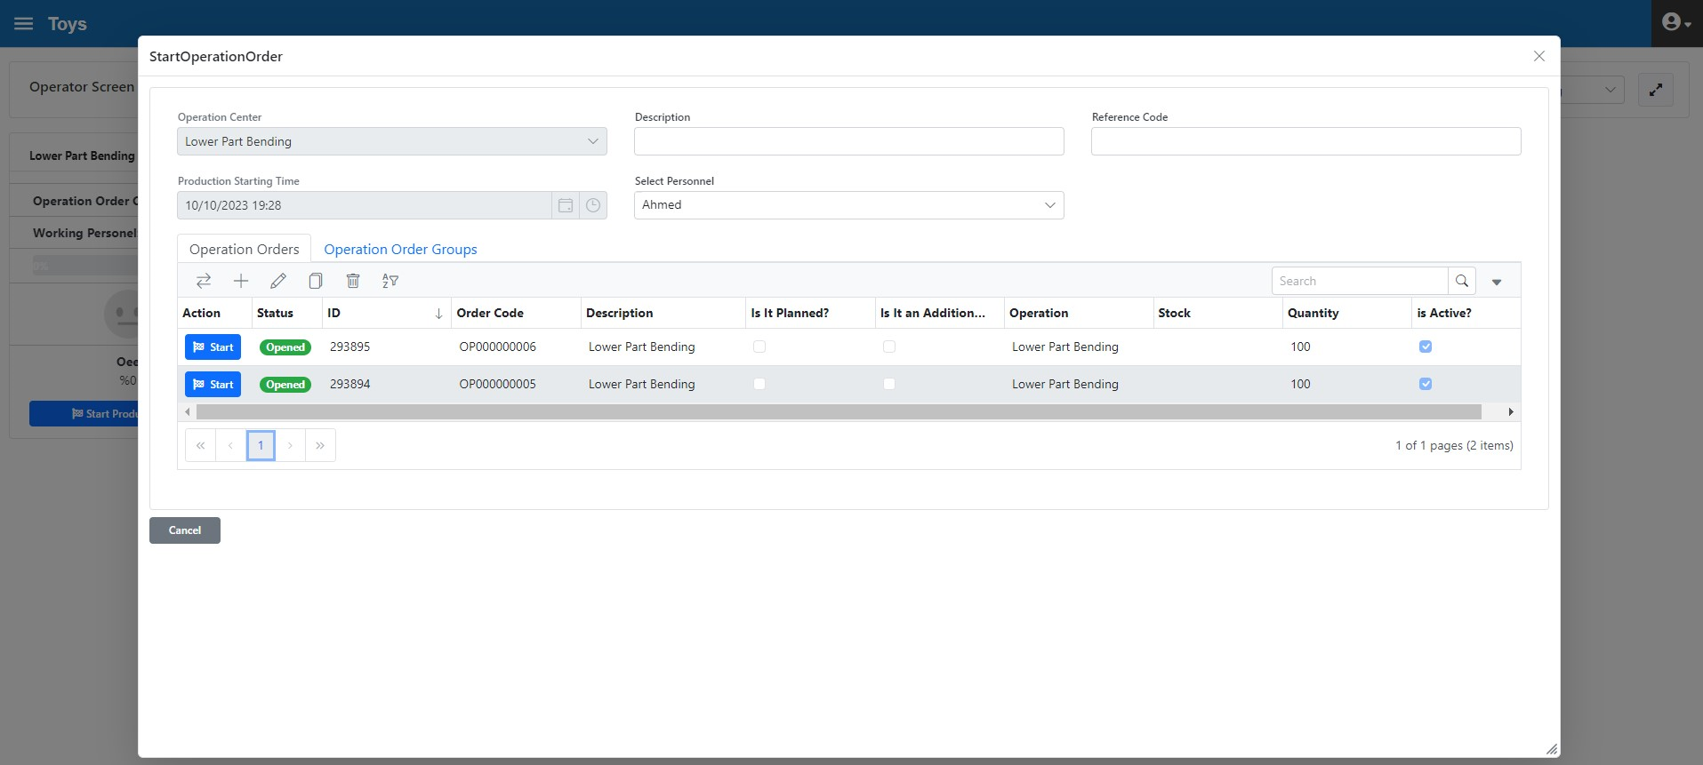
Figure 3.113. Lower Parts Bending Operation Center, OP000000005 Operation Order Initiation
"The Operation Interface (Figure 3.114) is as follows. It appears to be 100% because there is no downtime and quality loss yet.
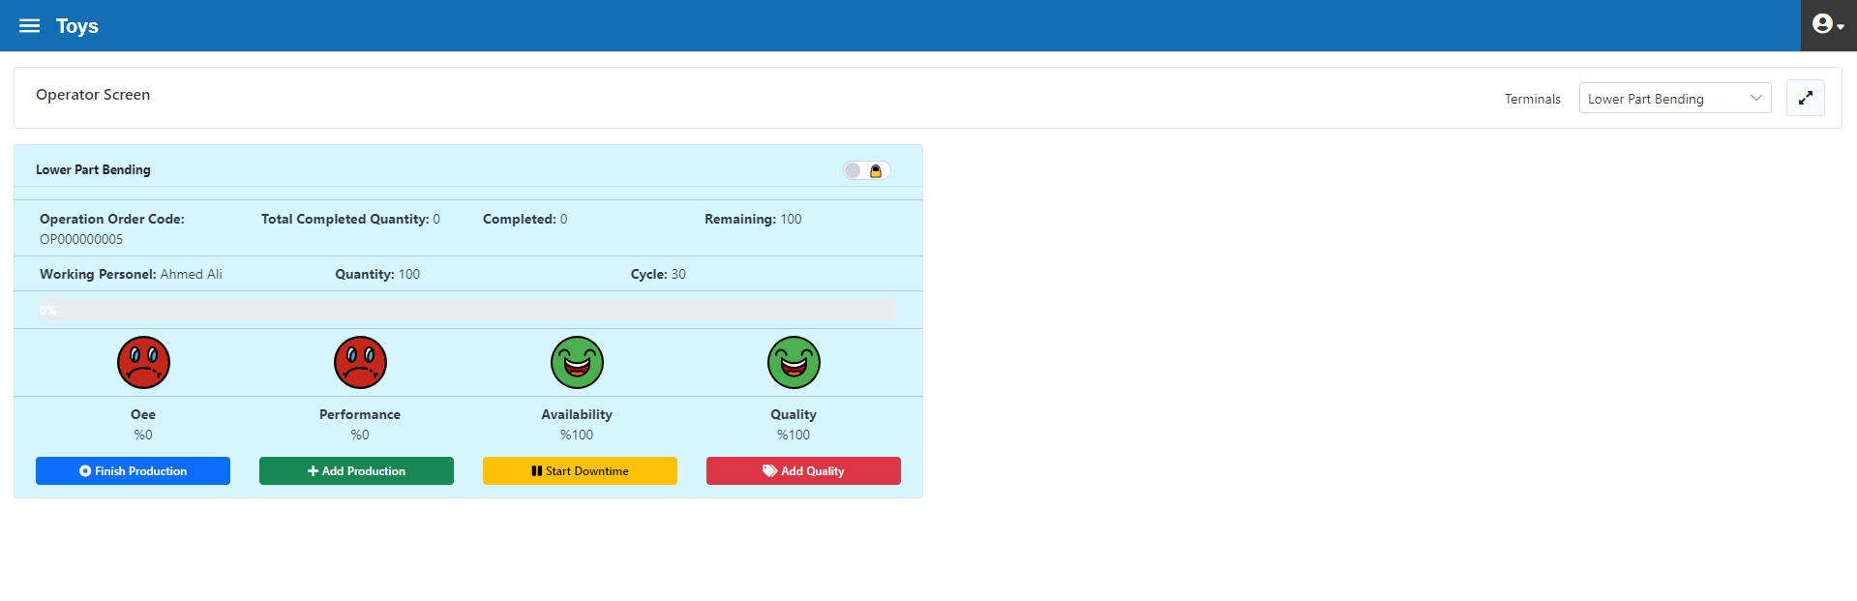
Figure 3.114. Lower Part Bending Operation Centre, Operator Interface

- 24 min. production
- 48 pieces were produced and system input was made (figure 3.115)
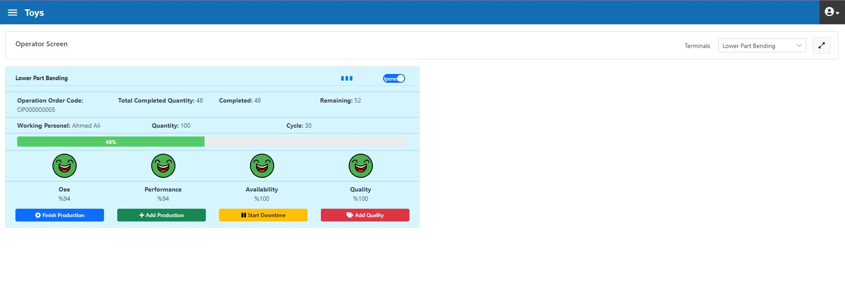
Şekil 3.115. Lower Part Bending Operation Center, after 48 Pieces Production Input
- 10 min. toilet break

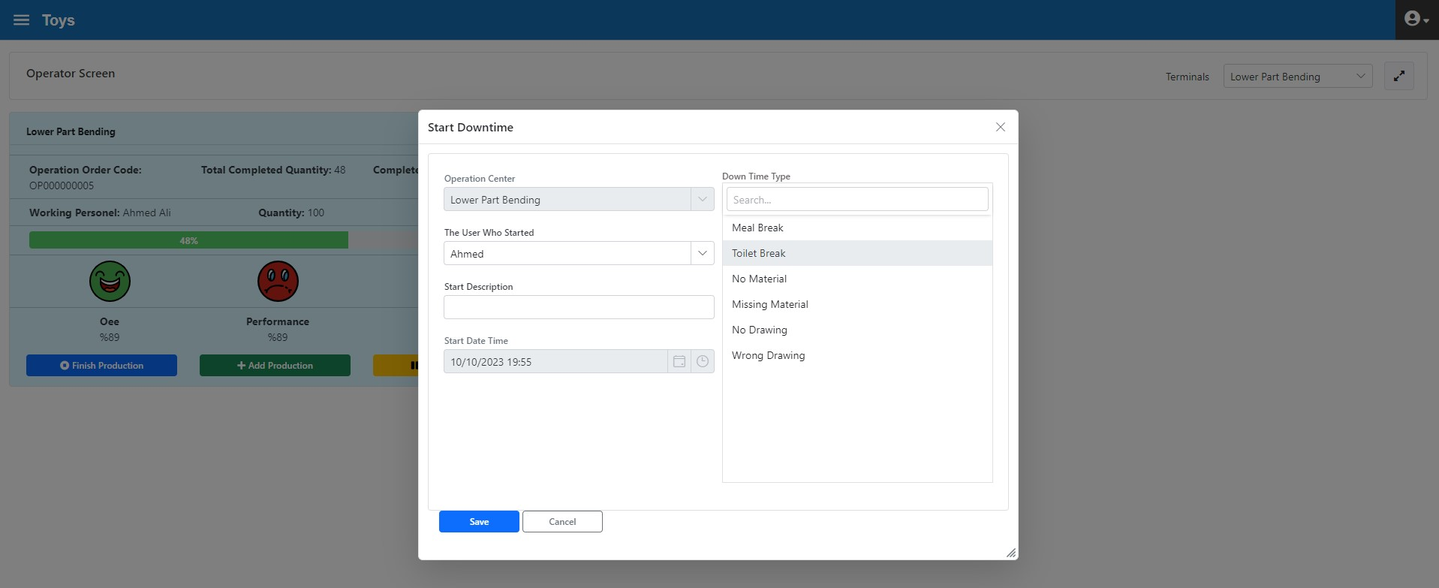
Figure 3.115. Lower Part Bending Operation Center Toilet Break Initiation
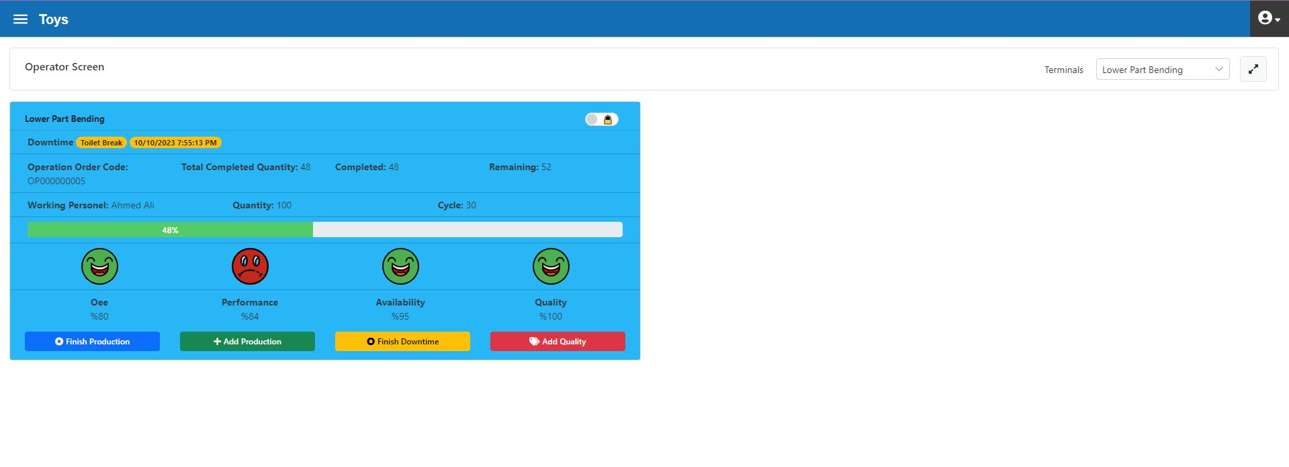
Figure 3.116. Lower Part Bending Operations Center, at Toilet Break Downtime
End of toilet break after 10 minutes (figure 3.117)

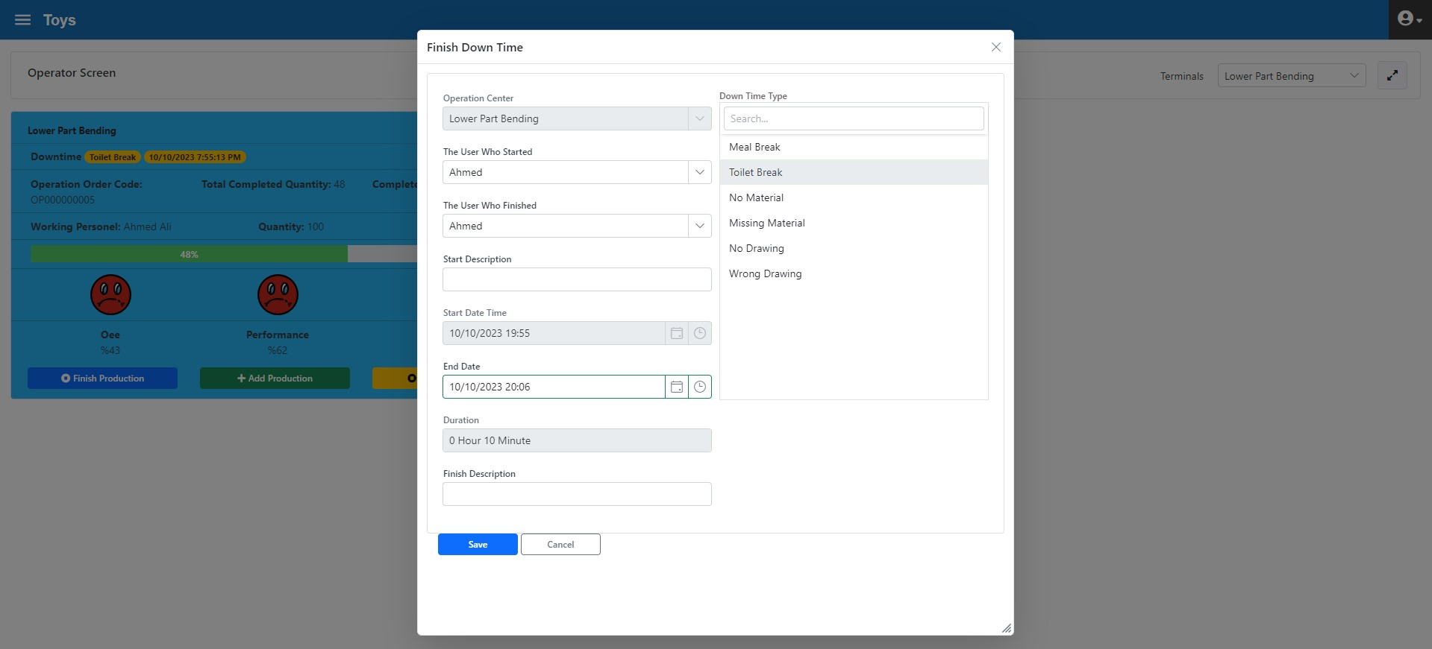
Figure 3.117. Lower Part Bending Operations Center, end of Toilet Break Downtime

- 100 YM0004 coded work-in-processes were produced
- Remaining 52 pieces were produced and system input was made and operation order completed (figure 3.119)

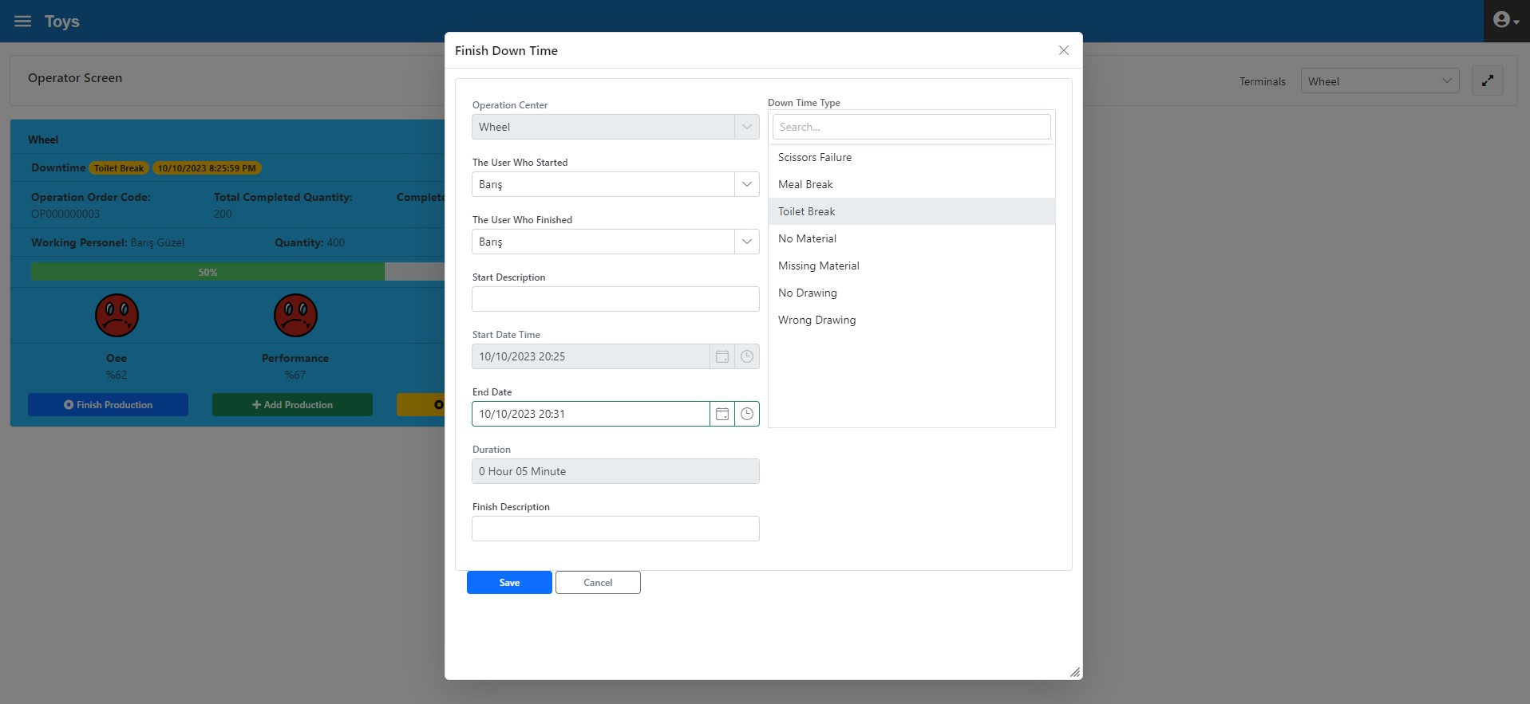
Figure 3.119. Lower Part Bending Operation Center, end of Operation Order
- Production was made for 60 minutes with the operation order numbered OP000000006 (şekil 120)

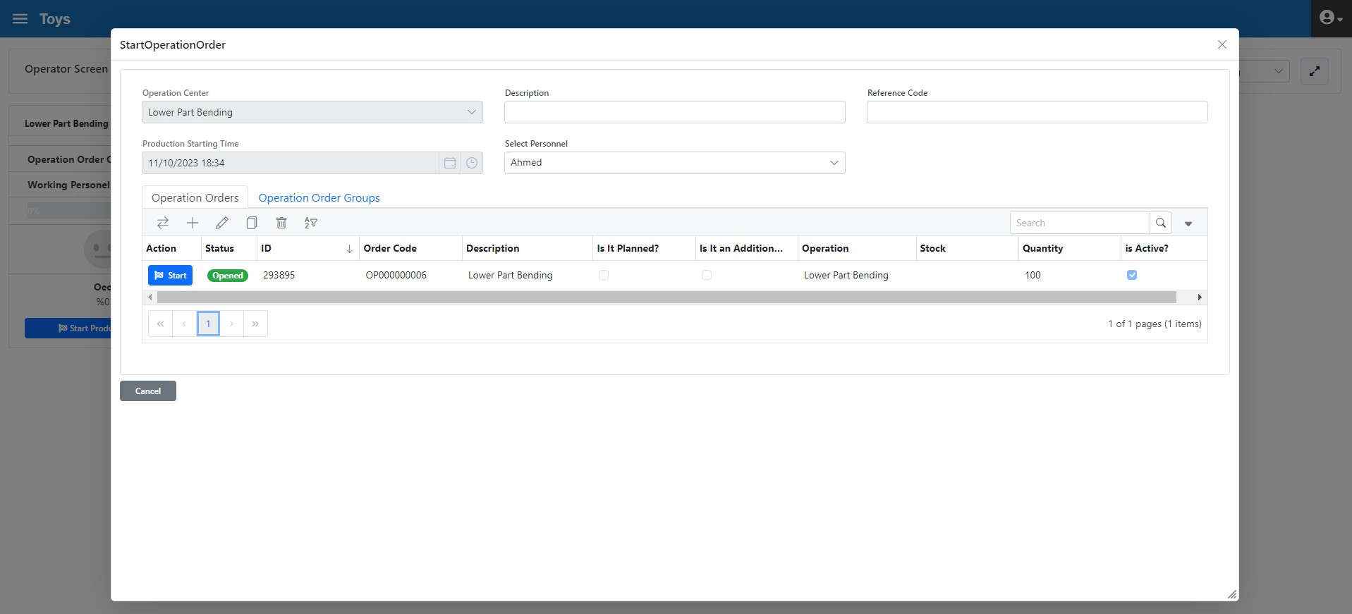
Figure 3.120. Lower Part Bending Operation Center, Operation Order Initiation
- 4 "scratched" quality losses (figure 3.121)

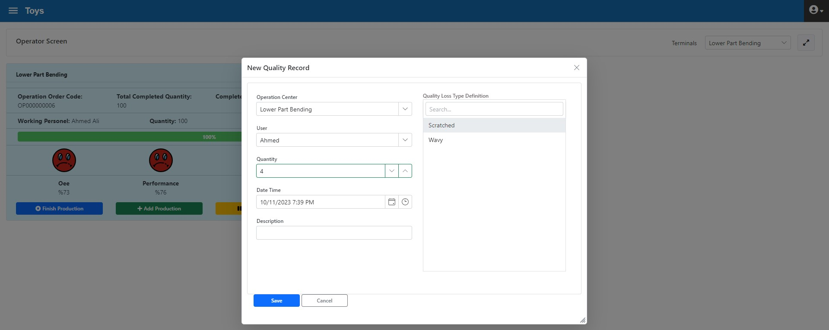
Figure 3.121. Lower Part Bending Operation Center Quality Loss Input
- 100 YM0001 coded work-in-processes were produced and operation order completed (figure 3.112)

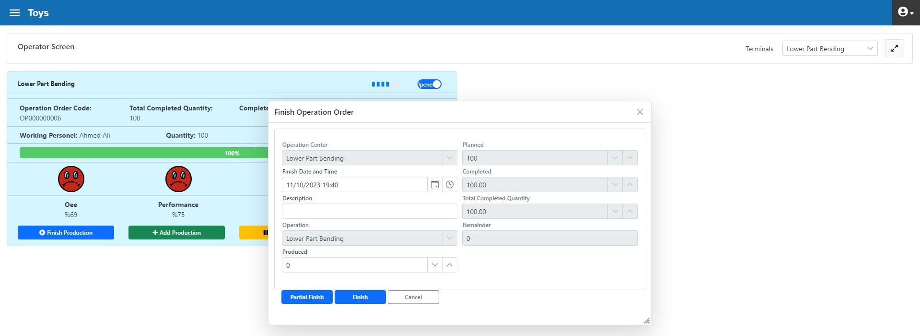
Figure 3.122. Lower Part Bending Operation Center, Ending Operation Order

Lower Part Bending Operation Center Review

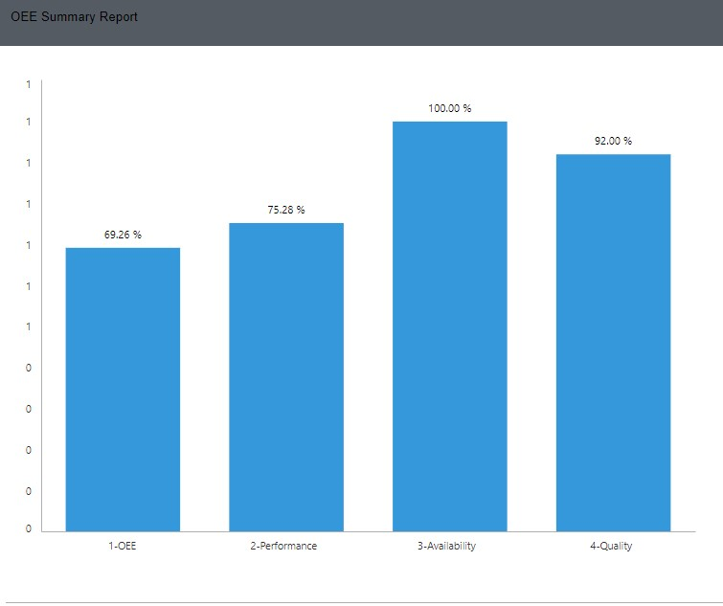
Figure 3.123. Bottom Parts Bending Operations Center Daily OEE Report
The target-actualized OEE report can be seen in Figure 3.114. In the report, we see that the Performance parameter is low. This is because the target cycle time is 30 seconds, but the actual cycle time is 36 seconds. In other words, the operations centre ran 20% slower. In this operation centre, Performance that reduce OEE should be analysed in detail and remedial actions should be taken.

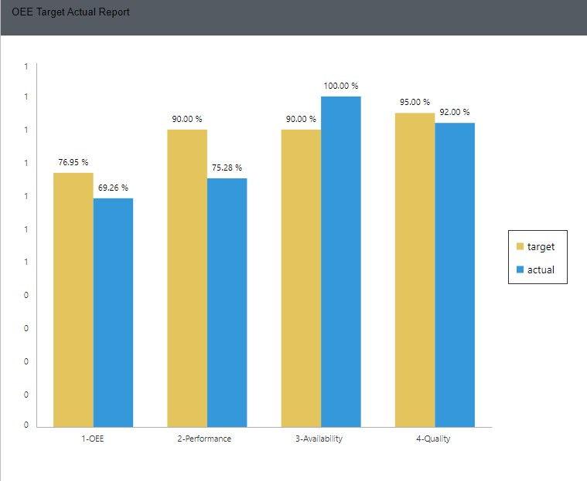
Figure 3.124. Bottom Parts Bending Operation Center, OEE Target-Actual Report

Lower-Upper Part Assembly Operation Center
The following transactions have been performed regarding the operation orders OP000000007 and OP000000008:
- Operation order OP000000007 has been initiated (Figure 3.125)

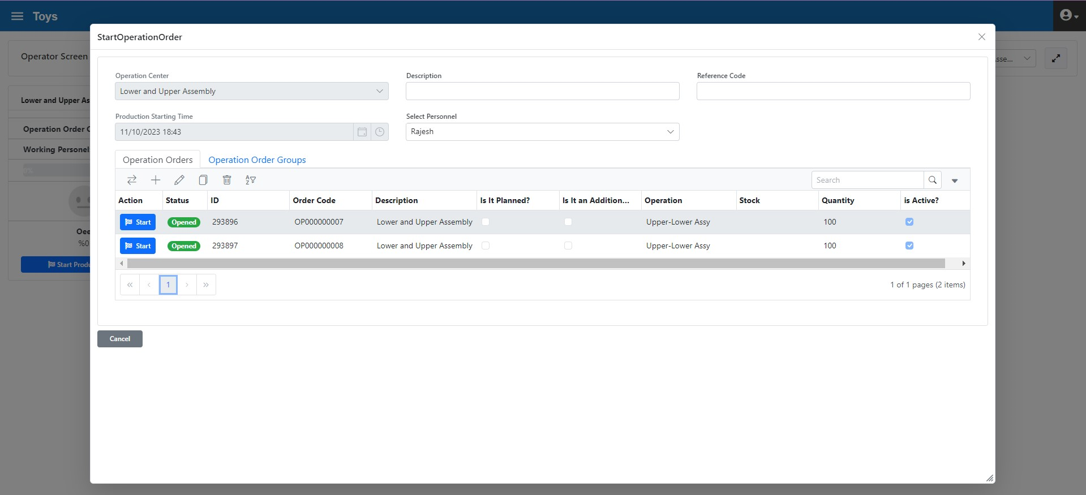
Figure 3.125. Lower-Upper Assembly Operations Center, Operation Order Initiation
- 85 min. no drawing downtime (figure 3.126)

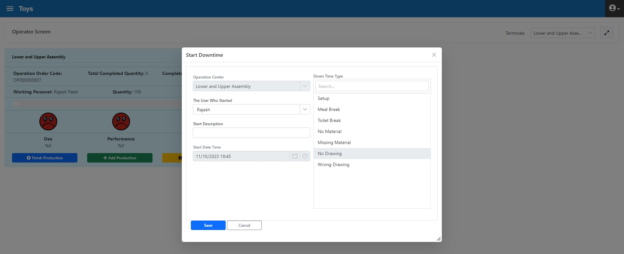
Figure 3.126. Lower-Upper Assembly Operation Center, Downtime Initiation

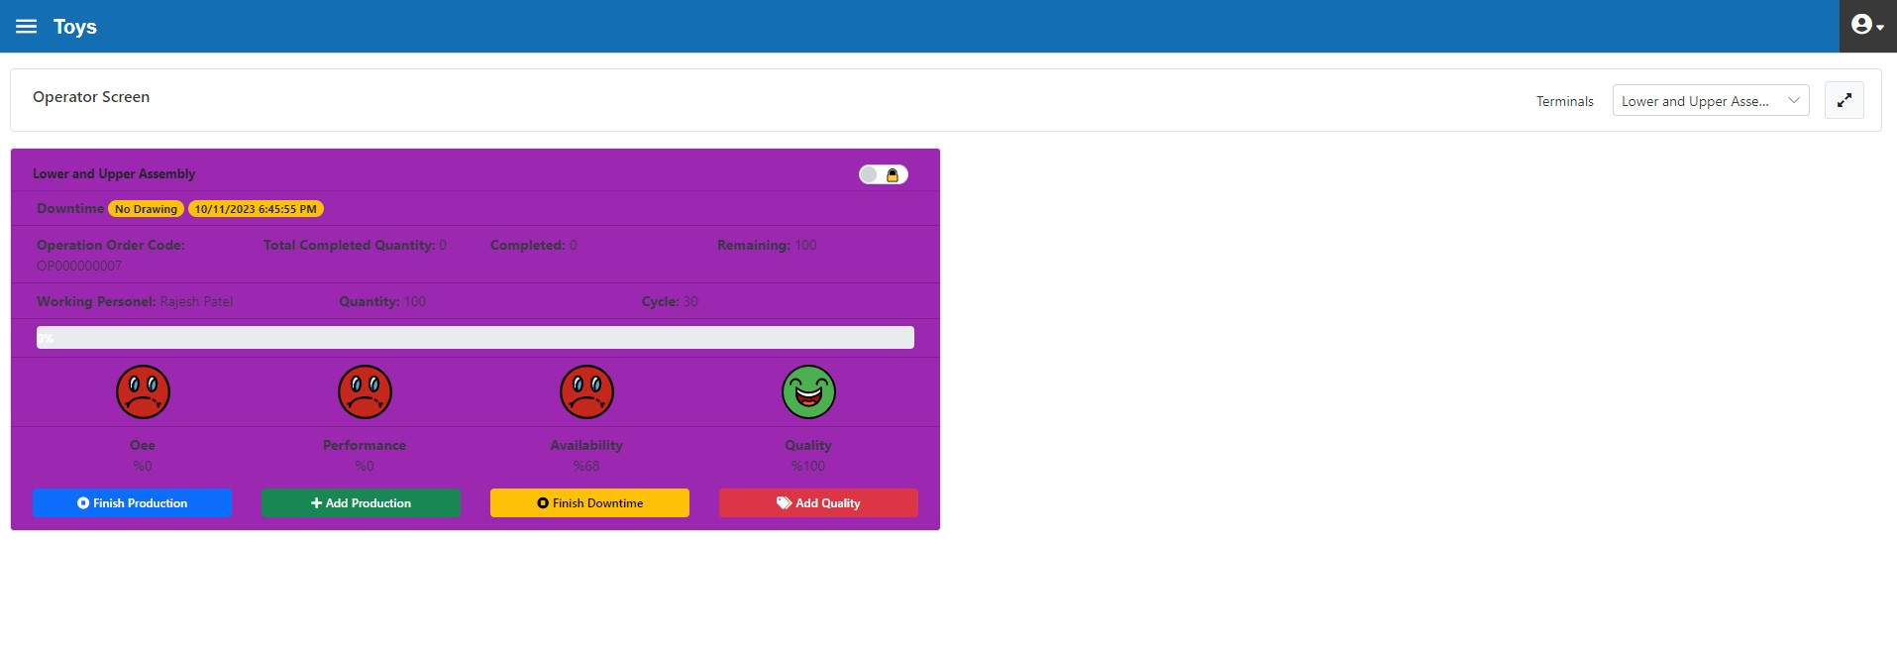
Figure3.127. Lower-Upper Assembly Operation Center, Operator Interface during Downtime

The downtime ended in 85 minutes and "ending info" information entered (figure 3.128).
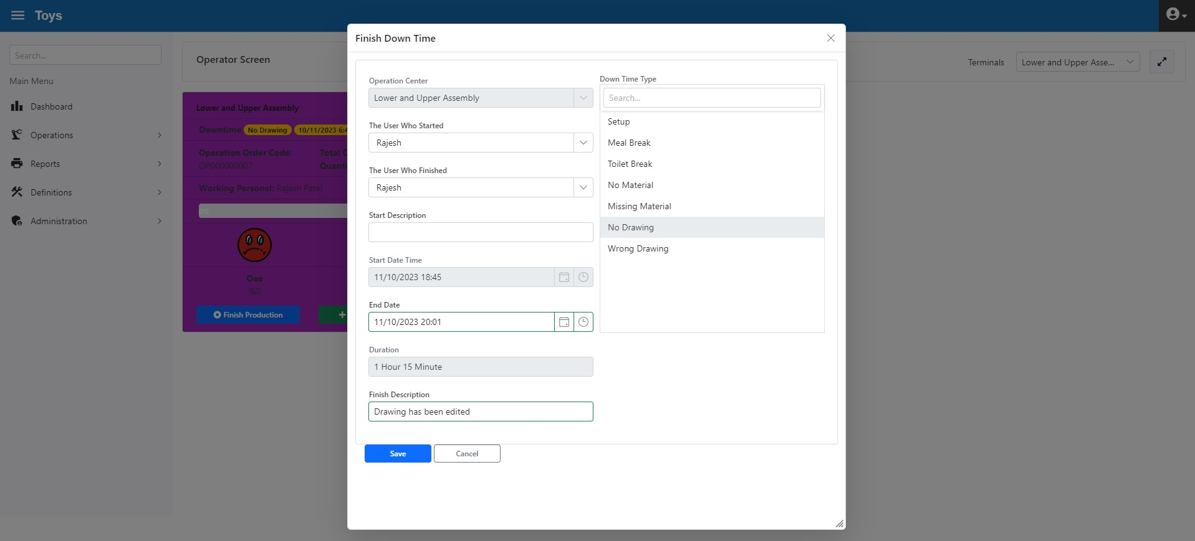
Figure 3.128. Lower-Upper Assembly Operation Center, end of Downtime

- 50 min. production
- 30 pieces were produced and system input was made (figure 3.129)

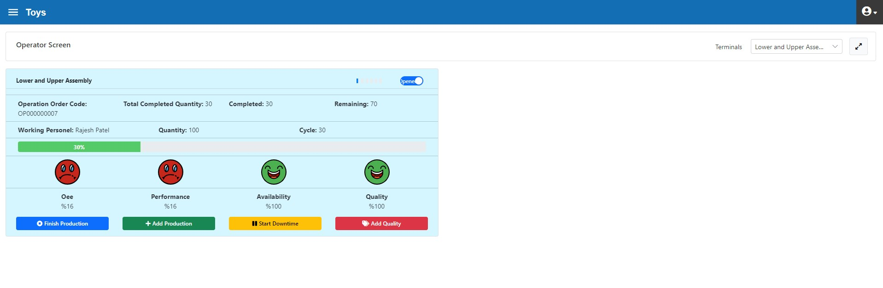
Figure 3.129. Lower-Upper Assembly Operation Center, Adding Production

- Production of 100 YM005 coded lower-upper parts HB has been completed.
- Remaining 80 pieces of YM005 were produced and system input was made and operation order completed (figure 3.130)

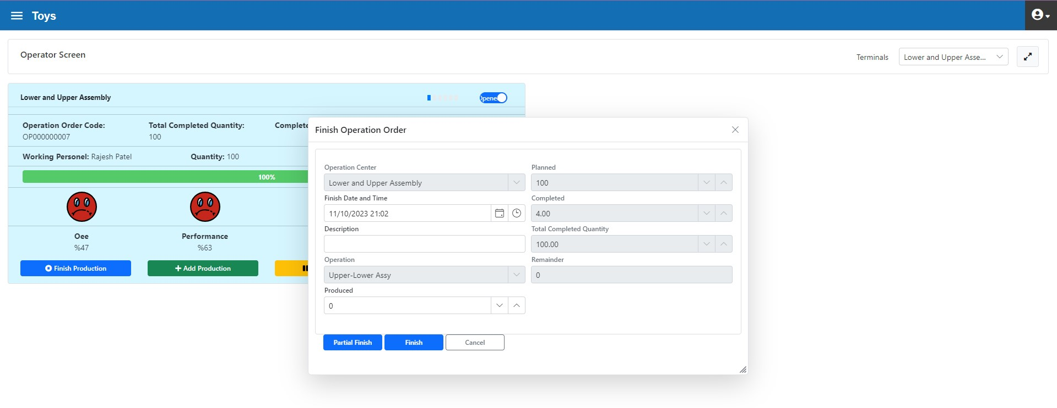
Figure 3.130. Lower-Upper Assembly Operation Center, end of Operation Order

Sometime after the closing of the Operation Order, the Quality Division provided Quality Loss information for 1 product
- 1 “short measure” quality loss has occurred

Since this quality loss is detected after the Operation Order is closed, it is not possible to enter loss info with the "Operator Interface" form. Instead, it should be entered in the "Transactions > Quality Transactions" tab (figure 3.131).
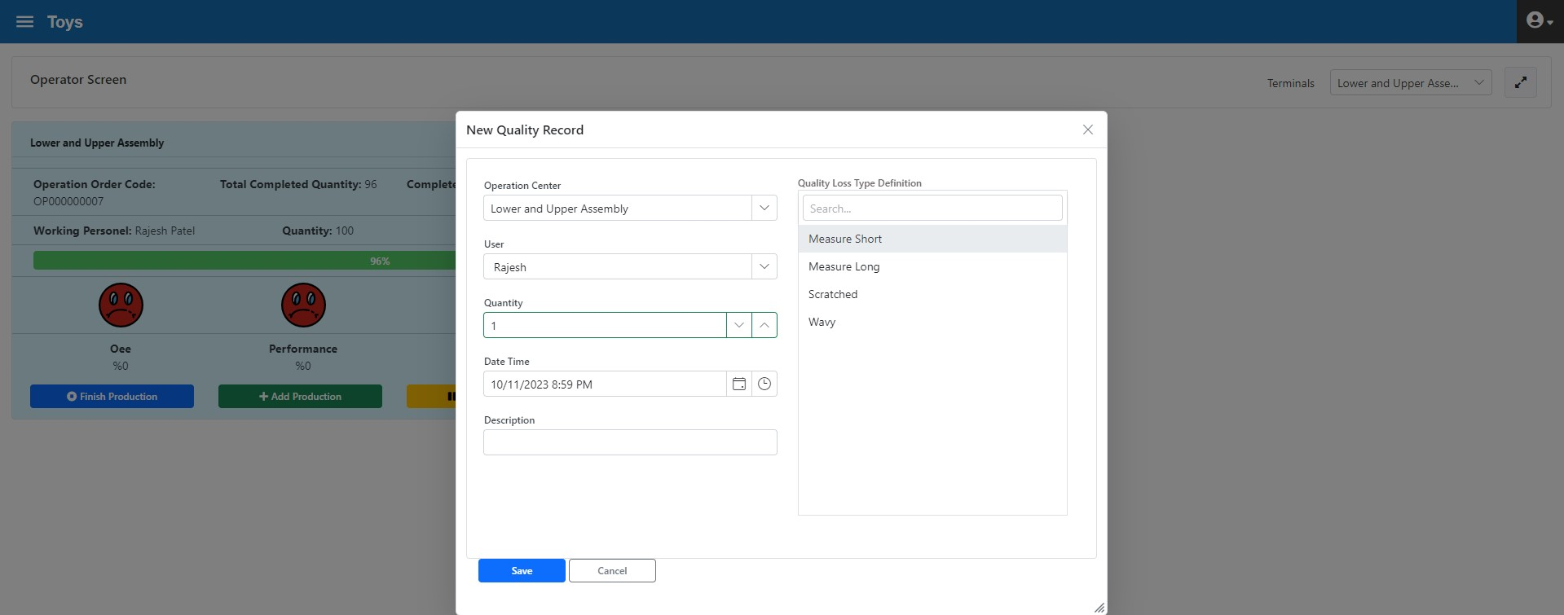
Figure 3.131. Lower-Upper Assembly Operation Center, Quality Loss Input while Operation Order is Ended

- Following the above work order, the operation order OP000000008 was started.
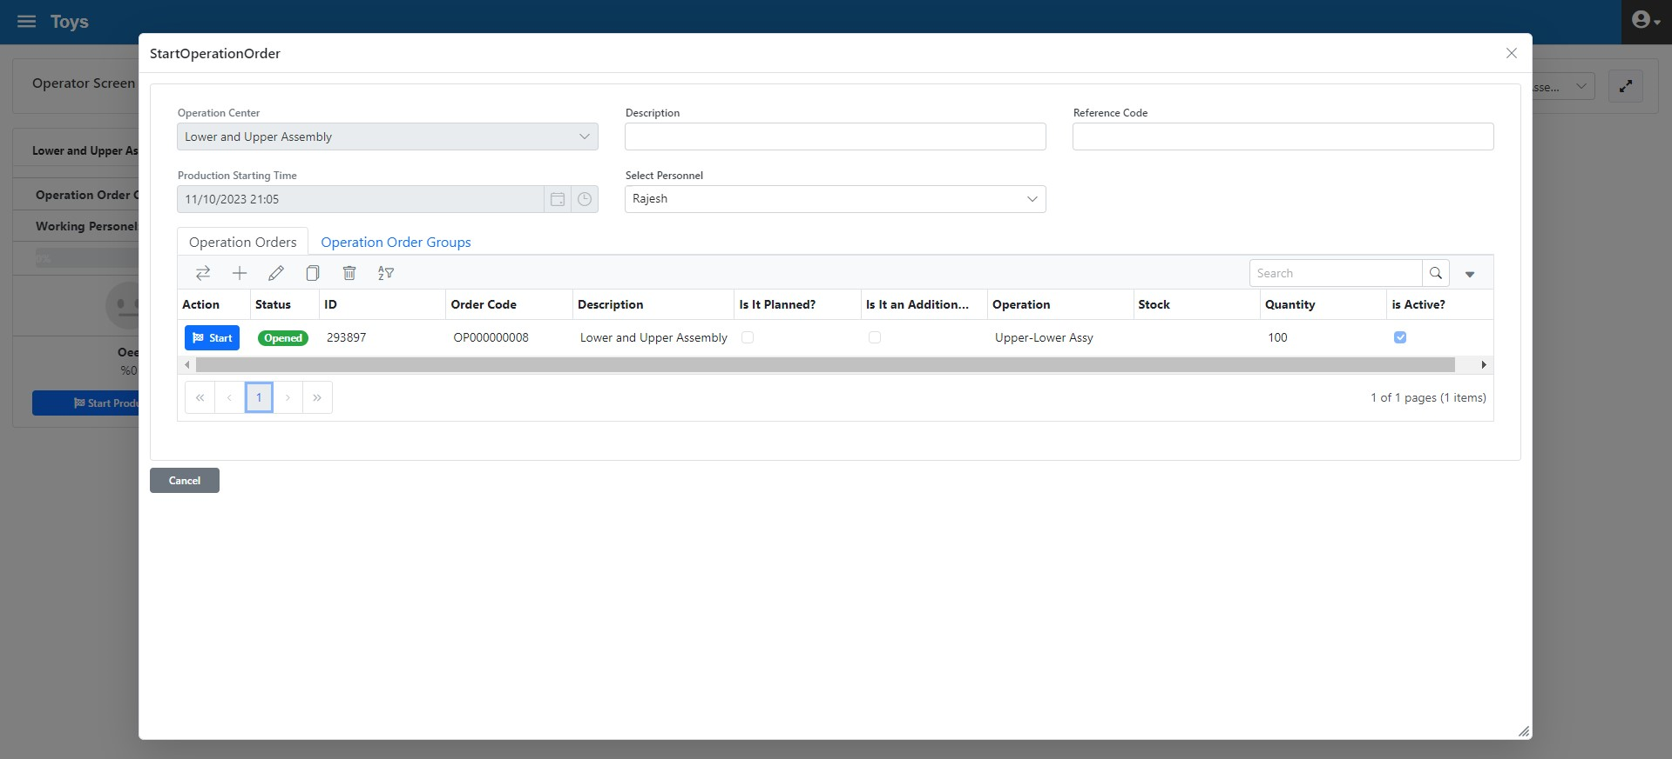
Figure 3.132. Lower-Upper Assembly Operations Center, Operation Order Initiation

- 20 min. production
- 40 pieces were produced and system input was made (figure 3.129)

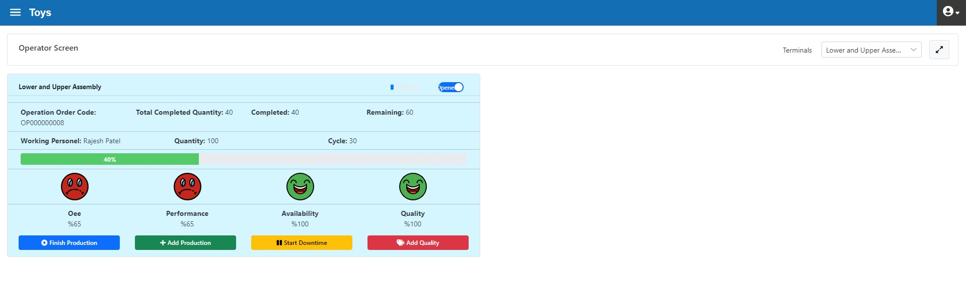
Figure 3.136. Lower-Upper Assembly Operation Center, Adding Production

- 5 min. Setup downtime

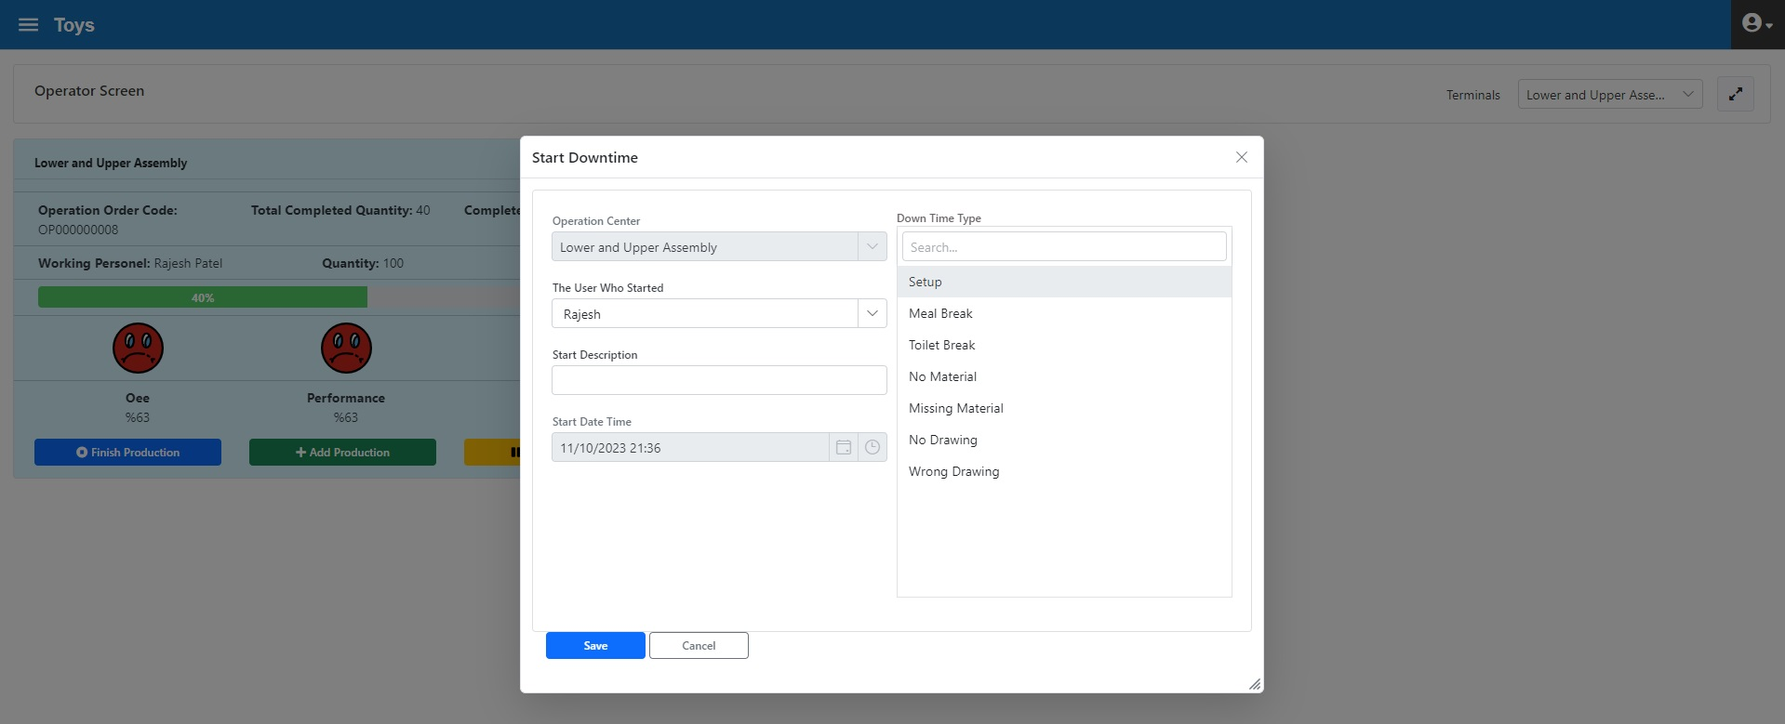
Figure 3.133. Lower-Upper Assembly Operation Center, Downtime Initiation

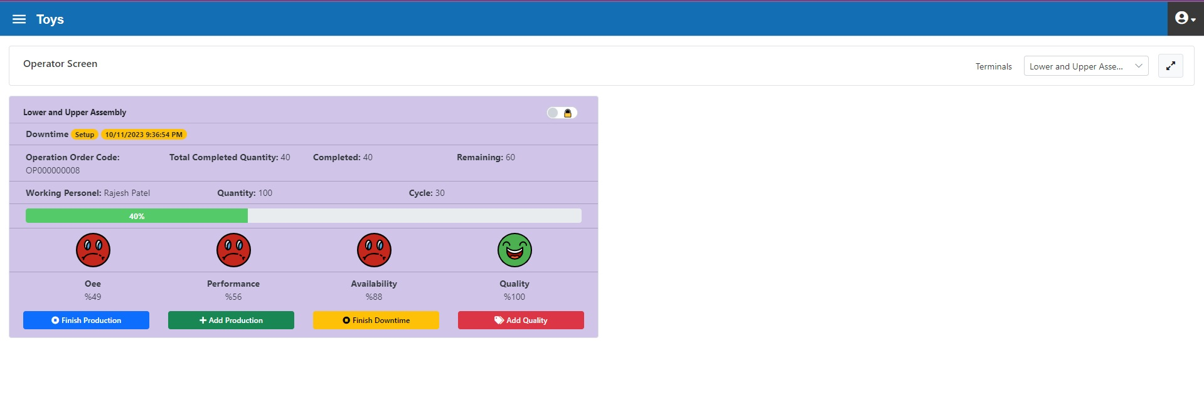
Figure3.134. Lower-Upper Assembly Operation Center, Operator Interface during Downtime

The downtime ended in 5 minutes and "ending info" information entered (figure 3.134).
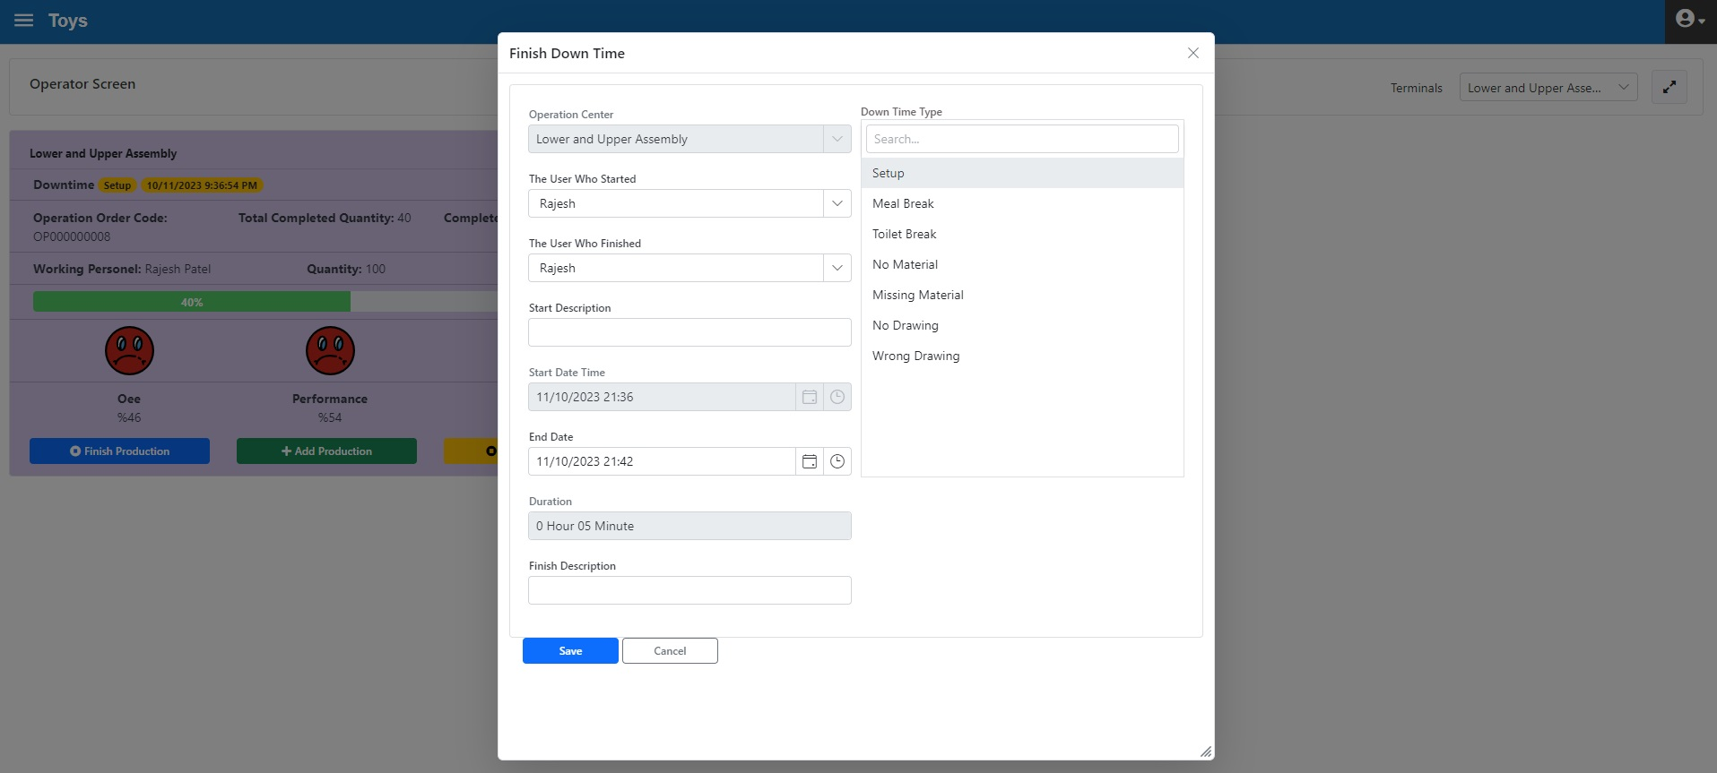
Figure 3.135. Lower-Upper Assembly Operation Center, end of Downtime

- Production was made in 50 minutes
- 100 YM006 upper and lower parts SD were produced

Remaining 60 pieces were produced and system input was made and operation order completed (figure 3.137)

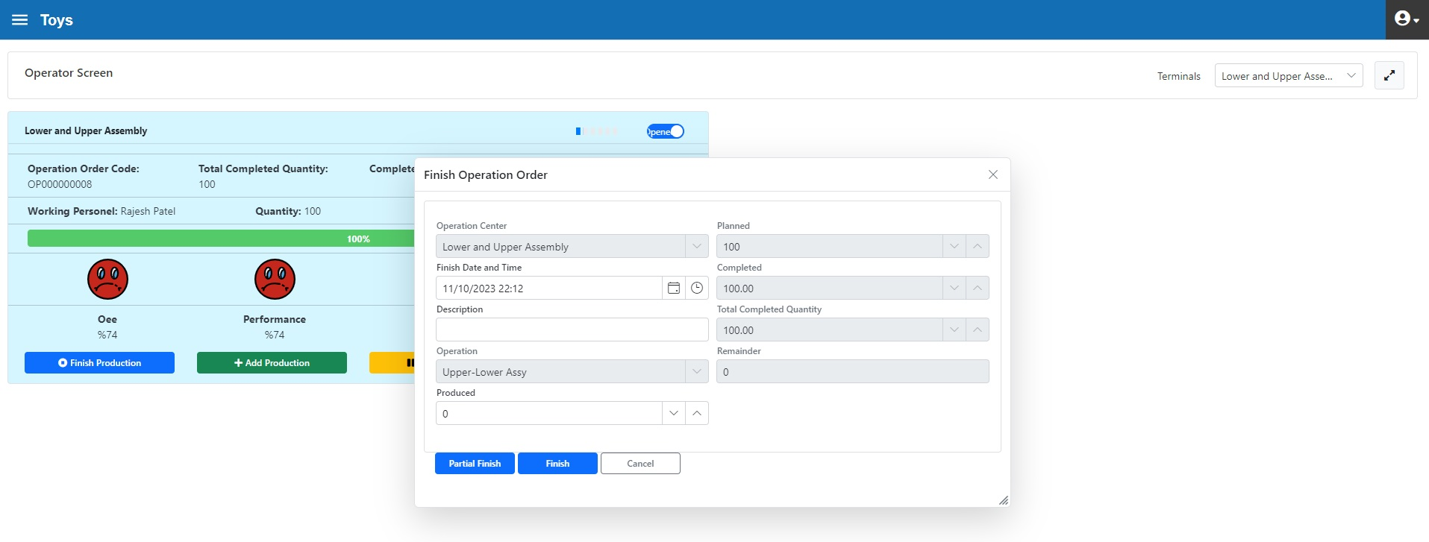
Figure 3.137. Lower-Upper Assembly Operation Center, end of Operation Order

Lower-Upper Assembly Operation Centre Review
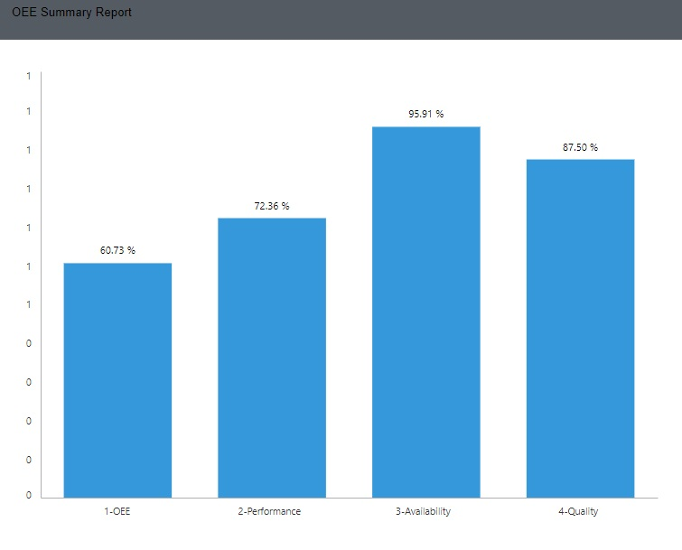
Figure 3.138. Lower-Upper Assembly Operation Center, Daily OEE Report

The target-actualized OEE report can be seen in Figure 3.139. According to the report, the Quality Rate and Performance has reached the expected value. However, the availability parameter is slightly below the target. In this operation centre, downtimes that reduce availability should be analysed in detail and remedial actions should be taken.

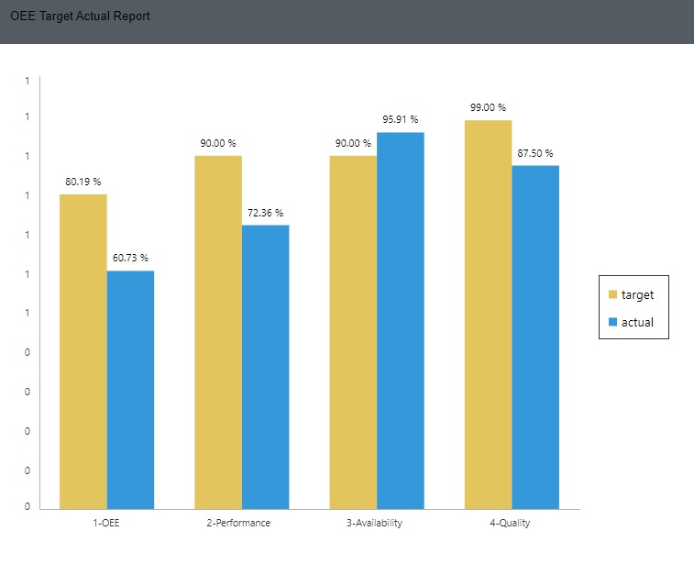
Figure 3.139. Lower-Upper Assembly Operation Centre, OEE Target-Actual Report

Wheel Assembly Operation Centre
The transactions with the operation orders OP000000009 and OP000000010 assigned to this operations centre are as follows:
- Operation order OP000000009 has been started.
- 20 minutes production

By clicking the "Go for Production" button in the "Operator Interface" form (figure 3.140), all the operation orders assigned to this operation centre are visible. Production started by selecting the operation order OP000000009 for 100 pieces.
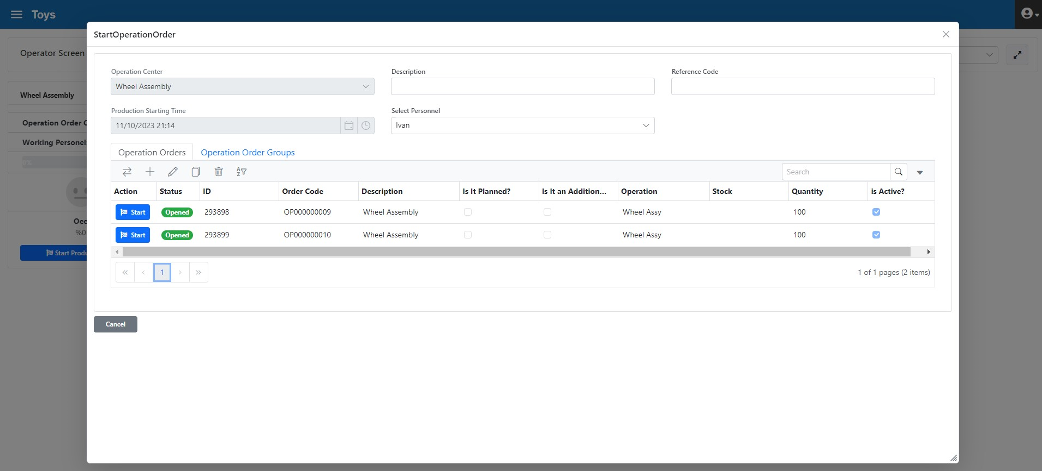
Figure 3.140. Wheel Assembly Operation Center Production Initiation

- Production of 100 wheels, production of 27 pieces entered (şekil 3.141)

“Performance” value calculation is as follows:
Production duration = 13,5 minutes = 810 seconds
Quantity produced= 27 pieces
Target cycle time= 30 seconds
Actual cycle time= 810/27 = 30 second
Performance= 100 %
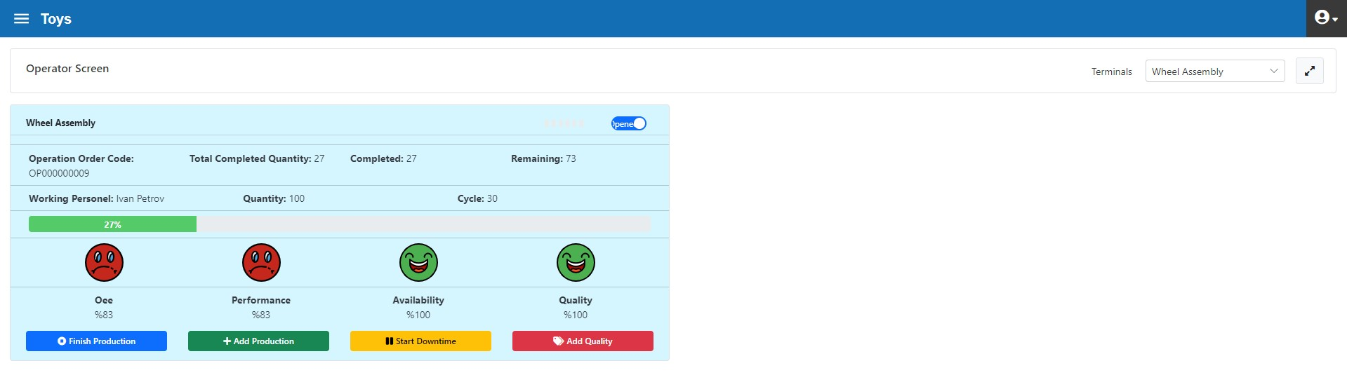

Figure 3.141. Wheel Assembly Operation Center after “Add production”

- “Missing Material” downtime for 20 min.

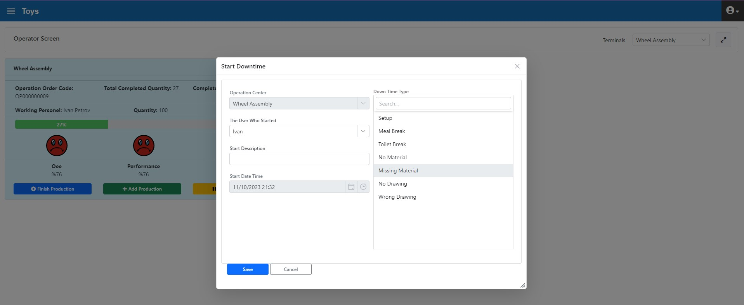
Şekil 3.142. Wheel Assembly Operation Center, Missing Material Downtime Initiation

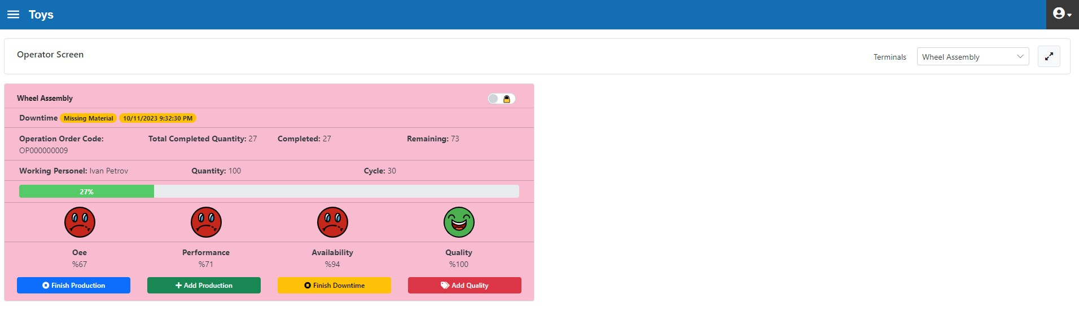
Figure 3.143. Wheel Assembly Operation Center, “Operator Interface” form During Downtime

End of "Missing Material" downtime with "Ending Info" definition (figure 3.144)

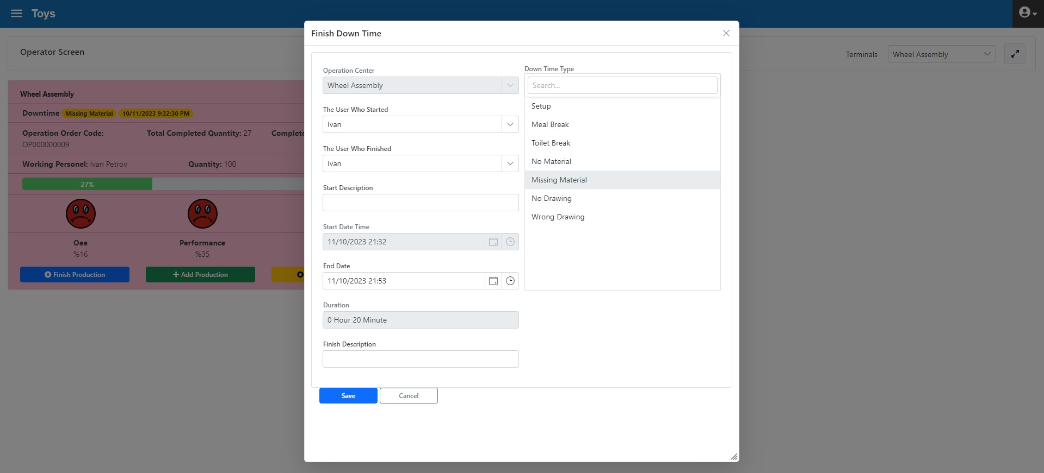
Figure 3.144. Wheel Assembly Operation Centre, End of Downtime

- 20 min. production
- 10 pieces of additional production (figure 145)

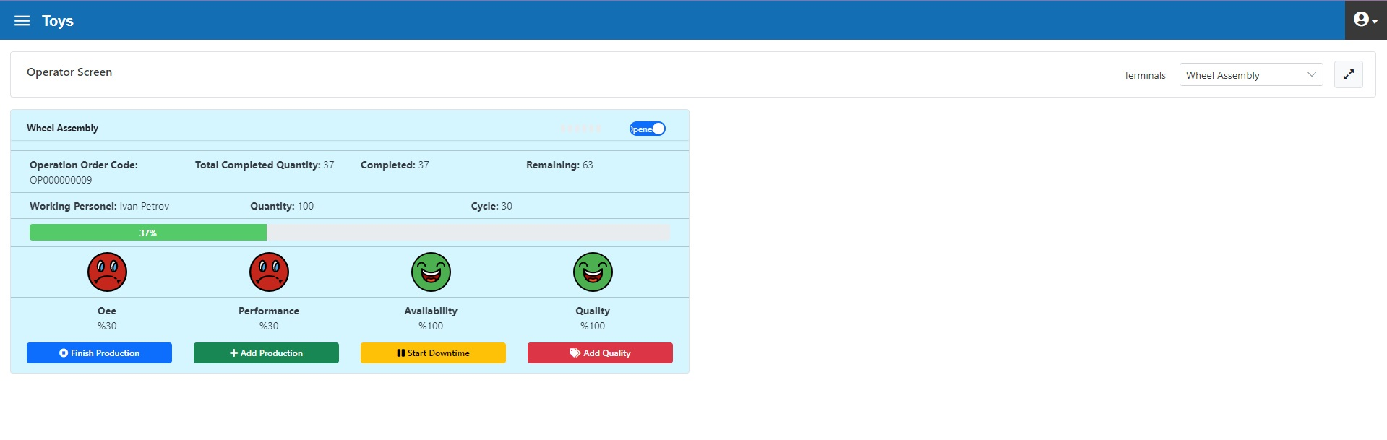
Figure 3.145. Wheel Operation Center, after 10 Pieces Production Input

- 10 min. toilet break

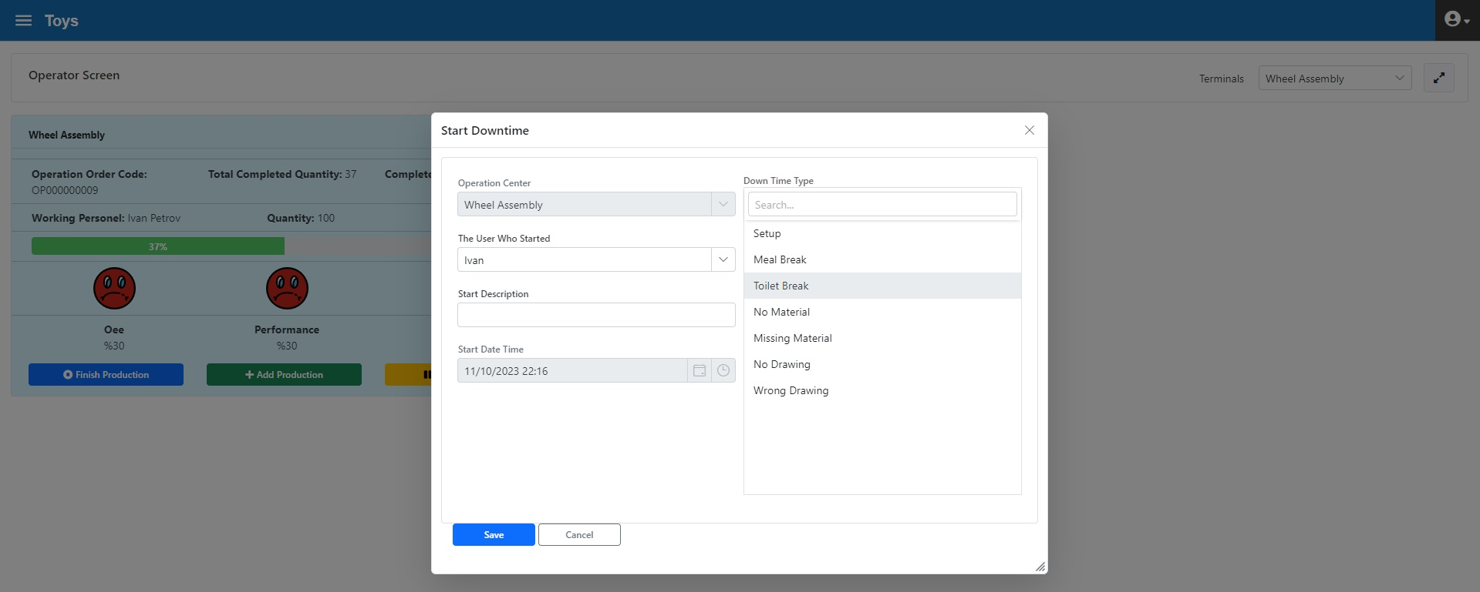
Figure 3.146. Wheel Assembly Operation Center Toilet Break Initiation

The toilet break is ended as shown in Figure 3.147

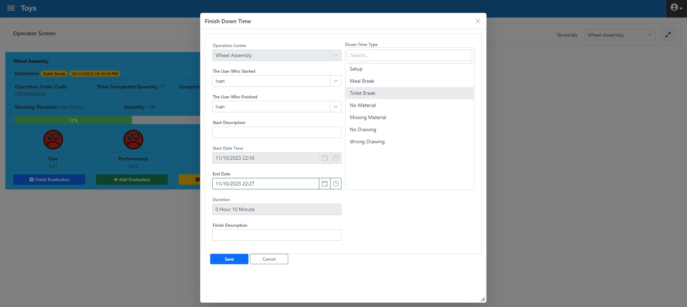
Figure 3.147. Wheel Assembly Operation Center End of Toilet Break

- 40 min. production
- 10 pieces “Wavy” quality loss (Fig. 3.148

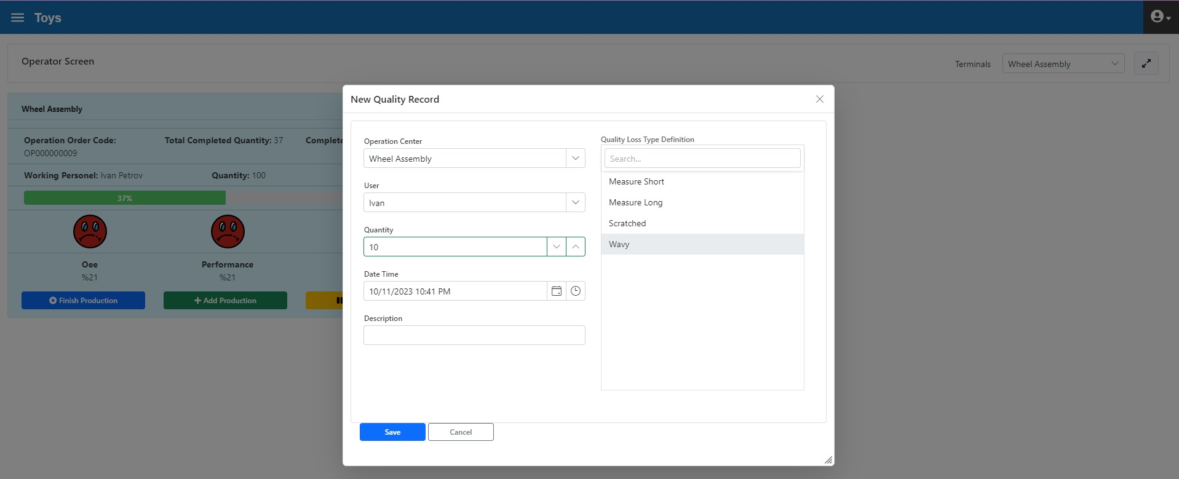
Figure 3.148. Wheel Assembly Operation Center, Quality Loss Input

Calculation of “Quality Rate” value is as follows (Figure 3.149):
Total Produced = 37
Quality Loss=10
Quality Rate= (37-10)/37 = 73 %

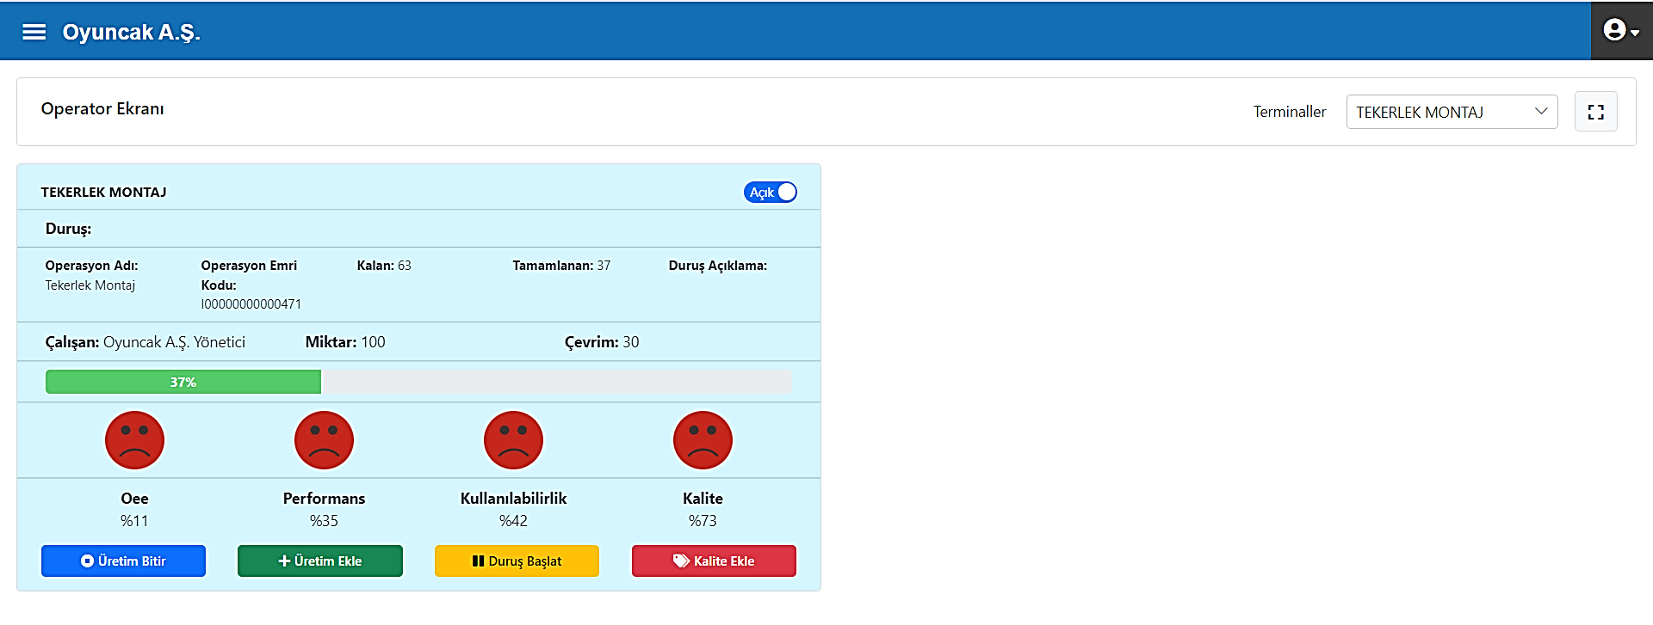
Figure 3.149. Wheel Assembly Operation Center, Operator Interface after Quality Loss Input

- Production of 100 pcs
- End of Operation Order

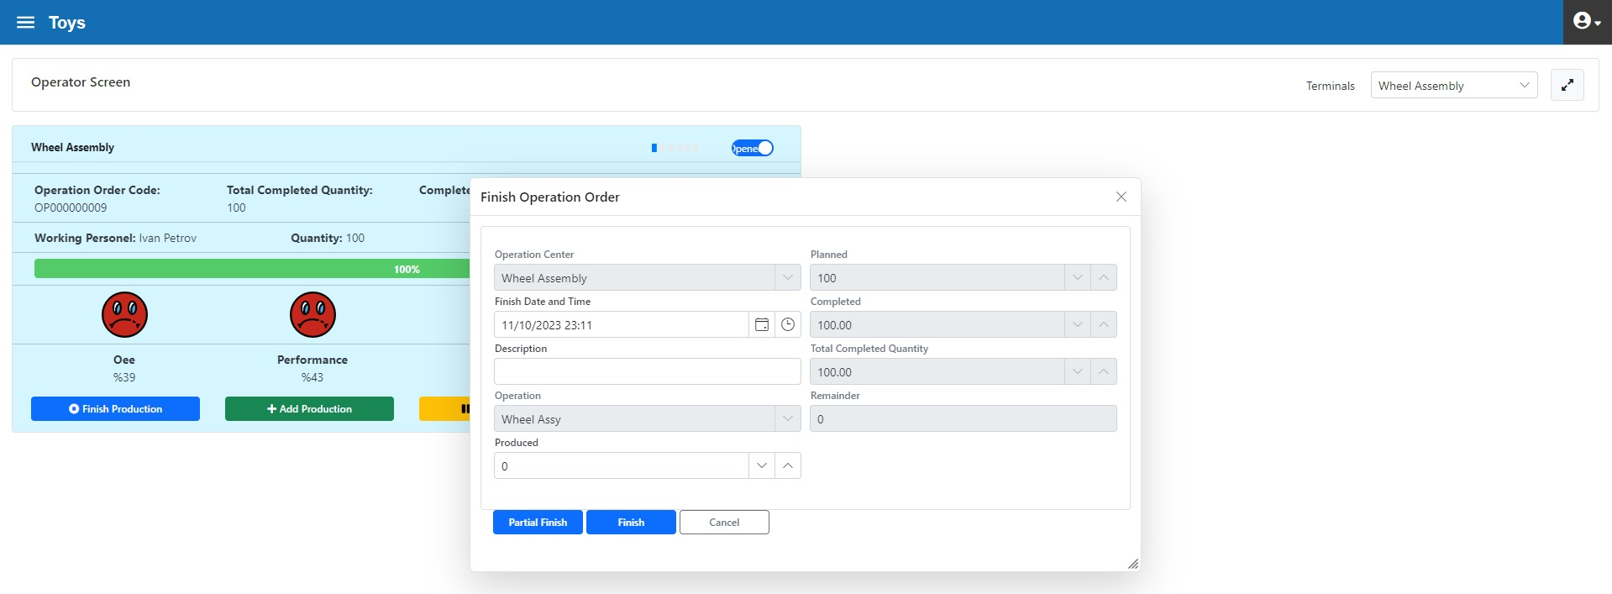
Figure 3.150. Wheel Assembly Operation Center, end of Operation Order

- Operation order OP000000010 has been initiated (figure 3.151
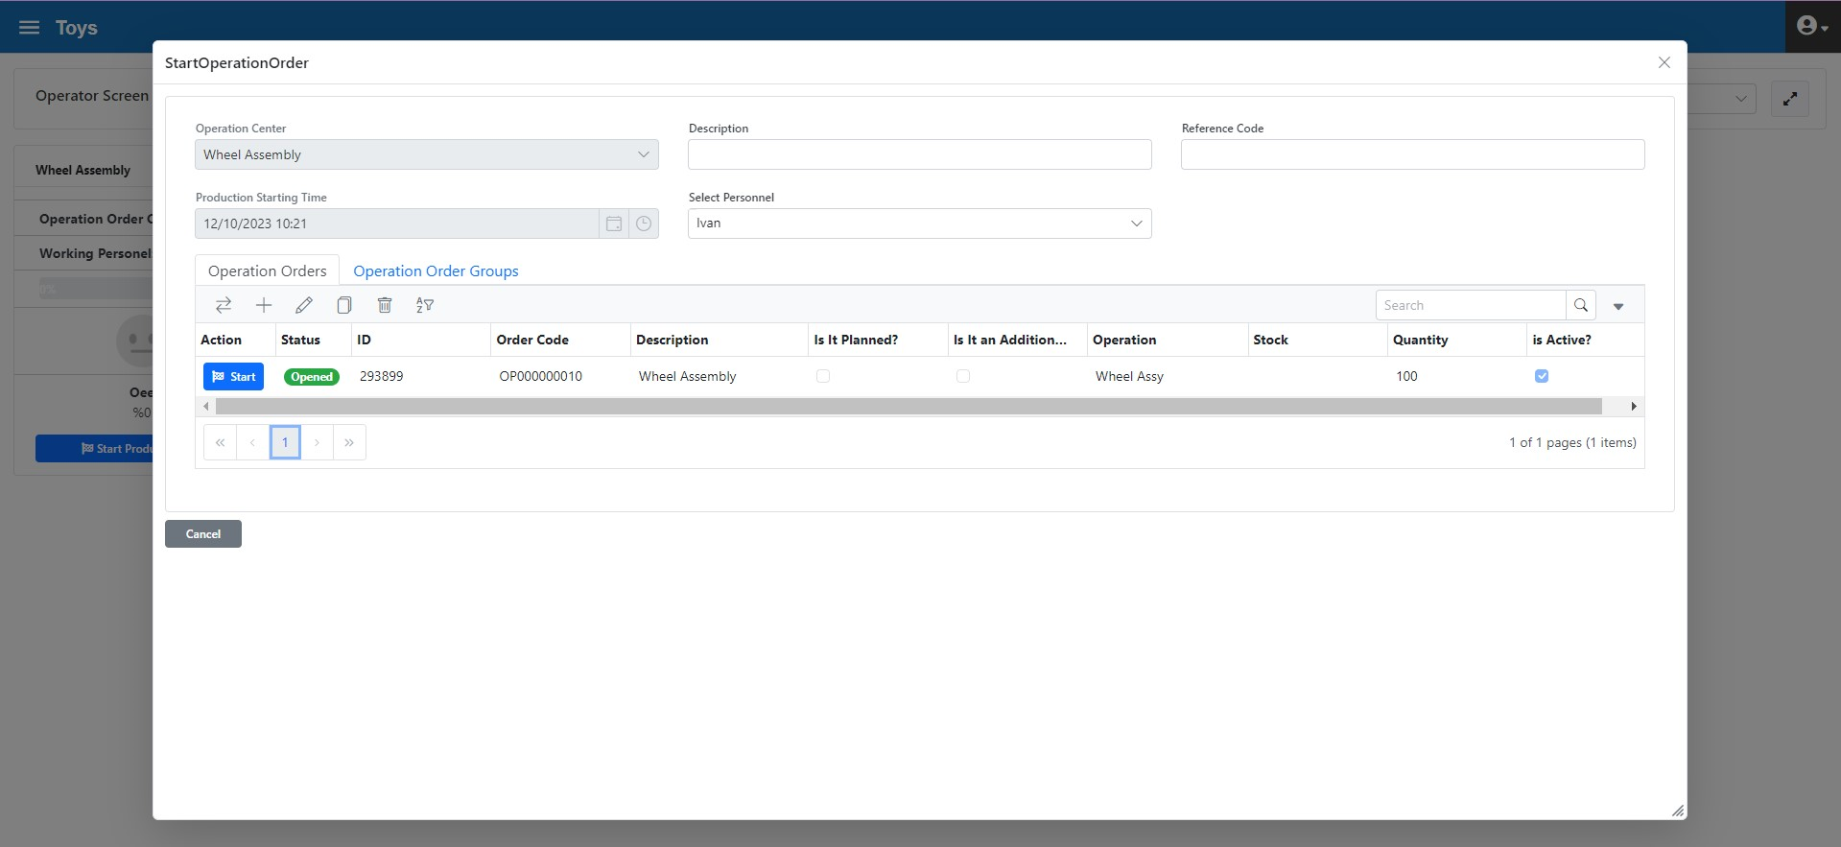
Figure 3.151. Wheel Assembly Operation Center Production Initiation

- Production of 23 sedans in 12 minutes
“Performance” value calculation is as follows:
Production duration = 12 minutes = 720 seconds
Quantity produced= 23 pieces
Target cycle time= 30 seconds
Actual cycle time= 720/23 = 30 second
Performance= 96 %

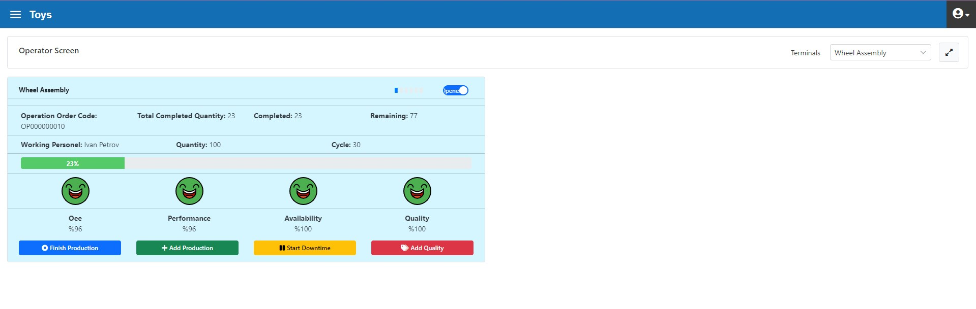
Figure 3.152. Wheel Assembly Operation Center after “Add production”

- “Missing material” downtime for 20 min. (Figure 3.153)

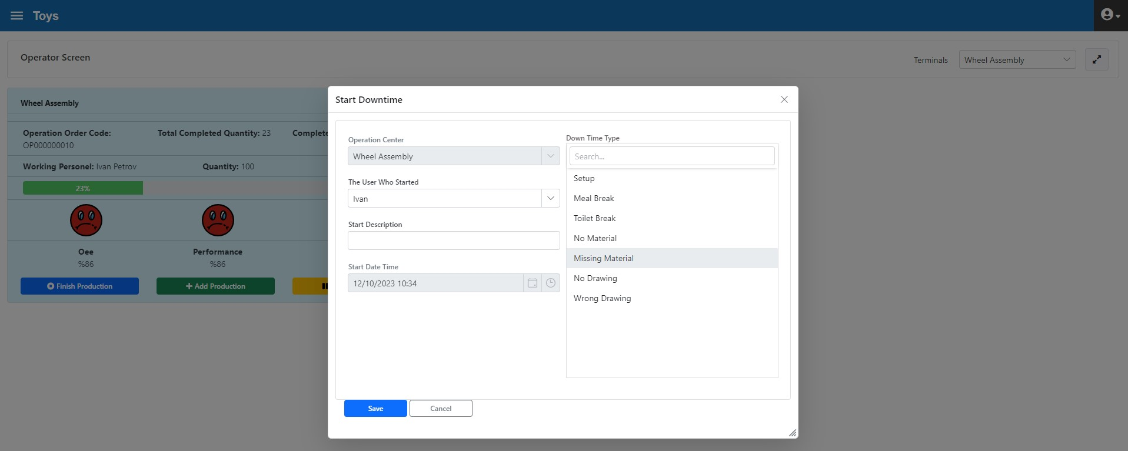
Figure 3.153. Wheel Assembly Operation Center, No Material Downtime Initiation

Availability decreased from 100% to 52% after Downtime (figure 3.154)
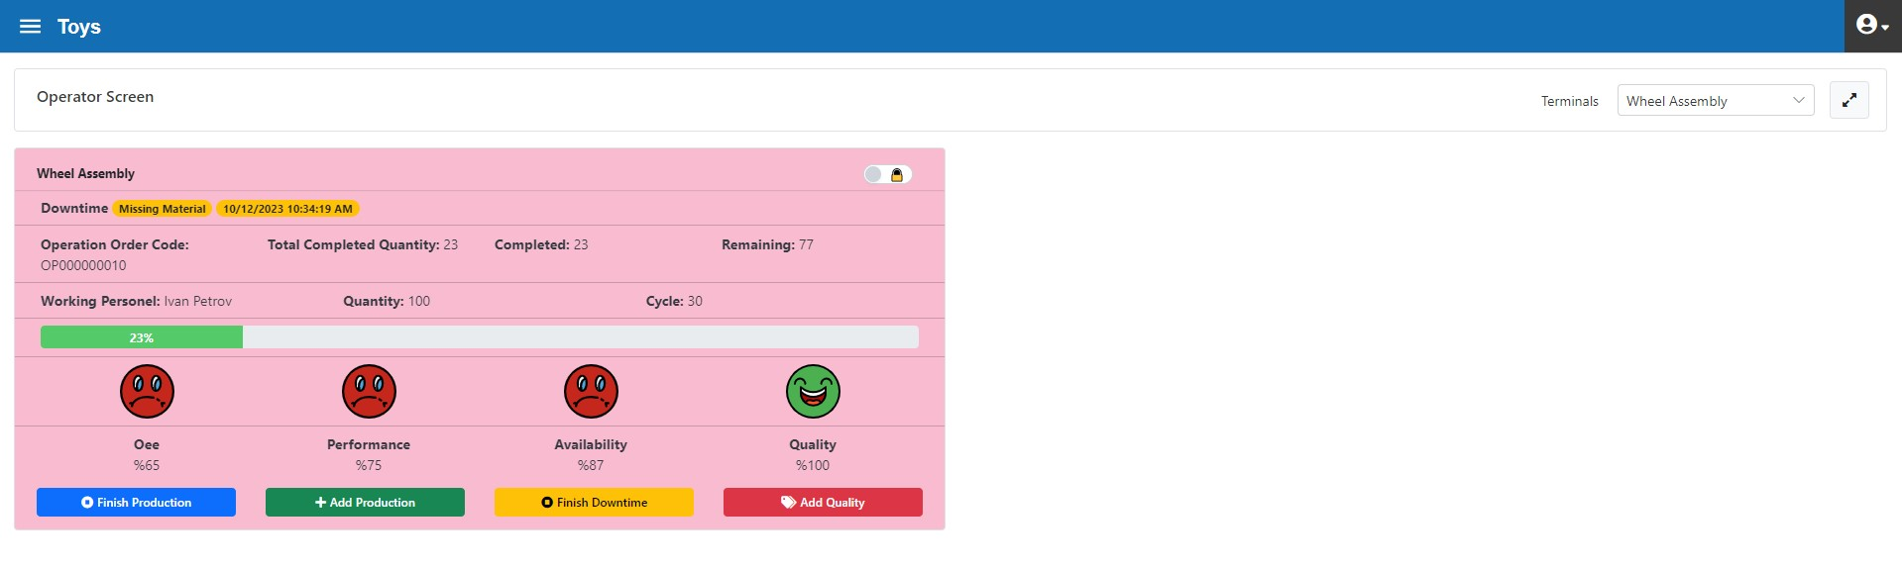
Figure 3.154. Wheel Assembly Operation Center, “Operator Interface” form During Downtime

End of "No Material" downtime with "Ending Info" definition (figure 3.155)

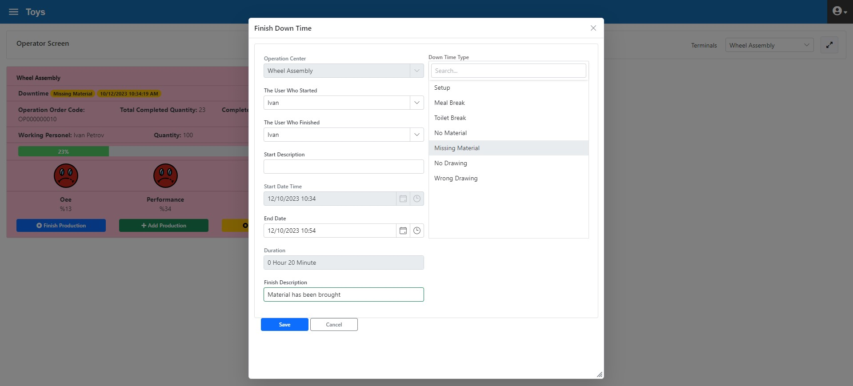
Figure 3.155. Wheel Assembly Operation Centre, End of Downtime

- 5 Short Measurement Quality Loss (Figure 3.156)

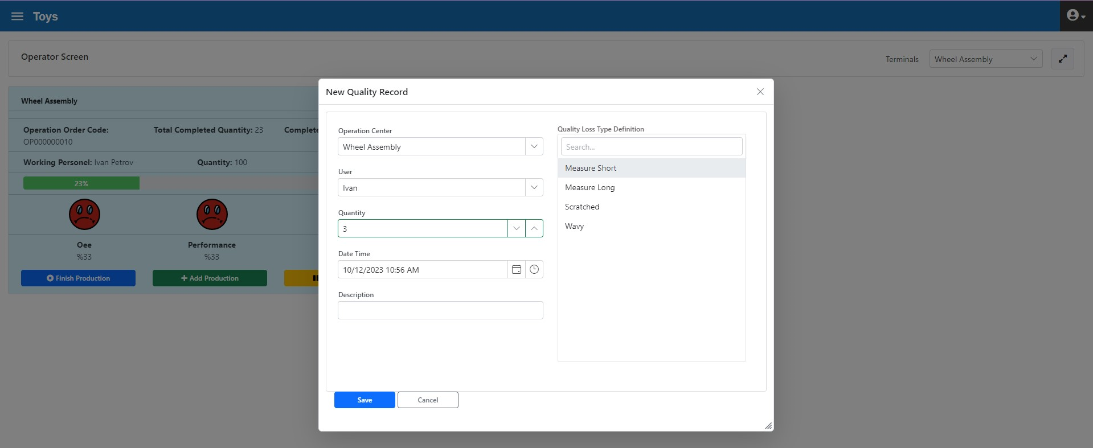
Figure 3.156. Wheel Assembly Operation Center, Quality Loss Input

Calculation of “Quality Rate” value is as follows (Figure 3.149):
Total Produced = 23
Quality Loss= 3
Quality Rate= (23-3)/23= 87 %

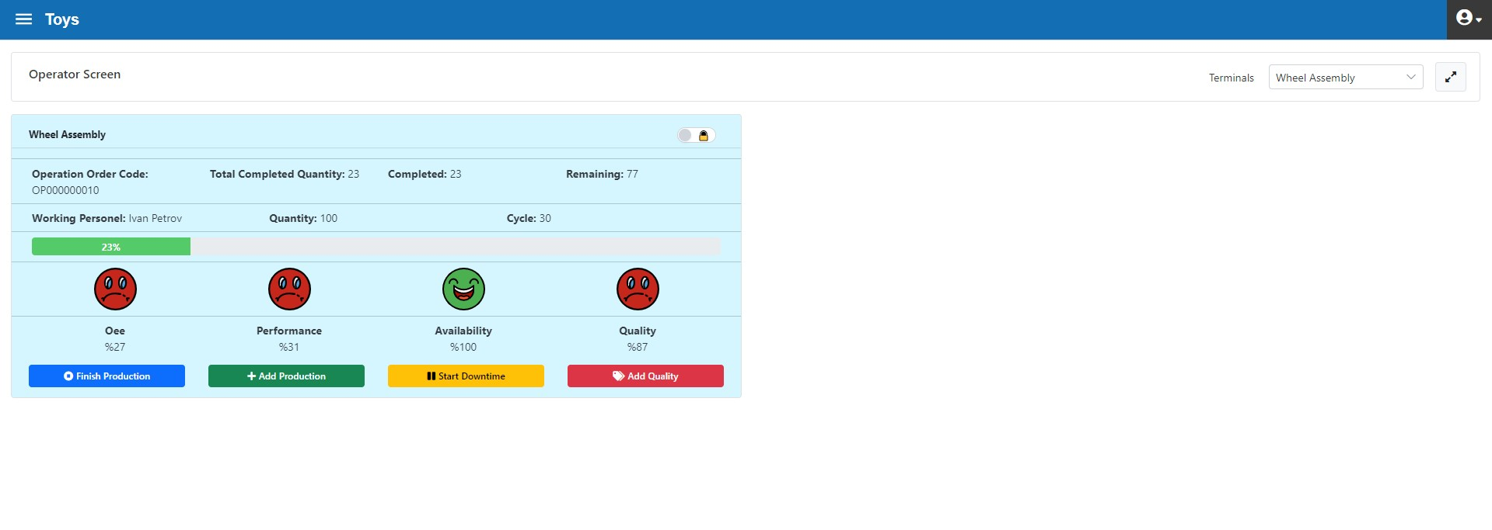
Figure 3.157. Wheel Assembly Operation Center, Operator Interface after Quality Loss Input

- 40 min. production
- Remaining 77 pieces production
- End of operation order (figure 3.158)
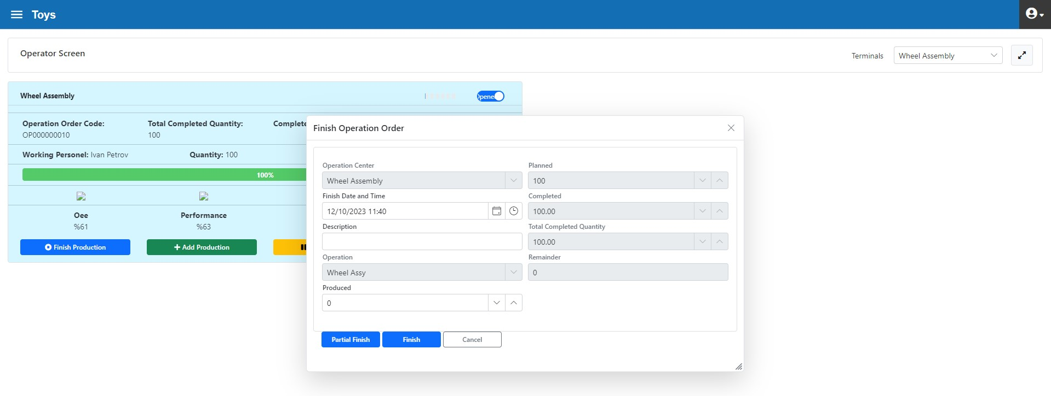
Figure 3.158. Wheel Assembly Operation Center, end of Operation Order

Sometime after the closing of the Operation Order, the Quality Division provided Quality Loss information for 1 product
- 1 “scratched” quality loss has occurred

Since this quality loss is detected after the Operation Order is closed, it is not possible to enter loss info with the "Operator Interface" form. Instead, it should be entered in the "Transactions > Quality Transactions" tab (figure 3.159).
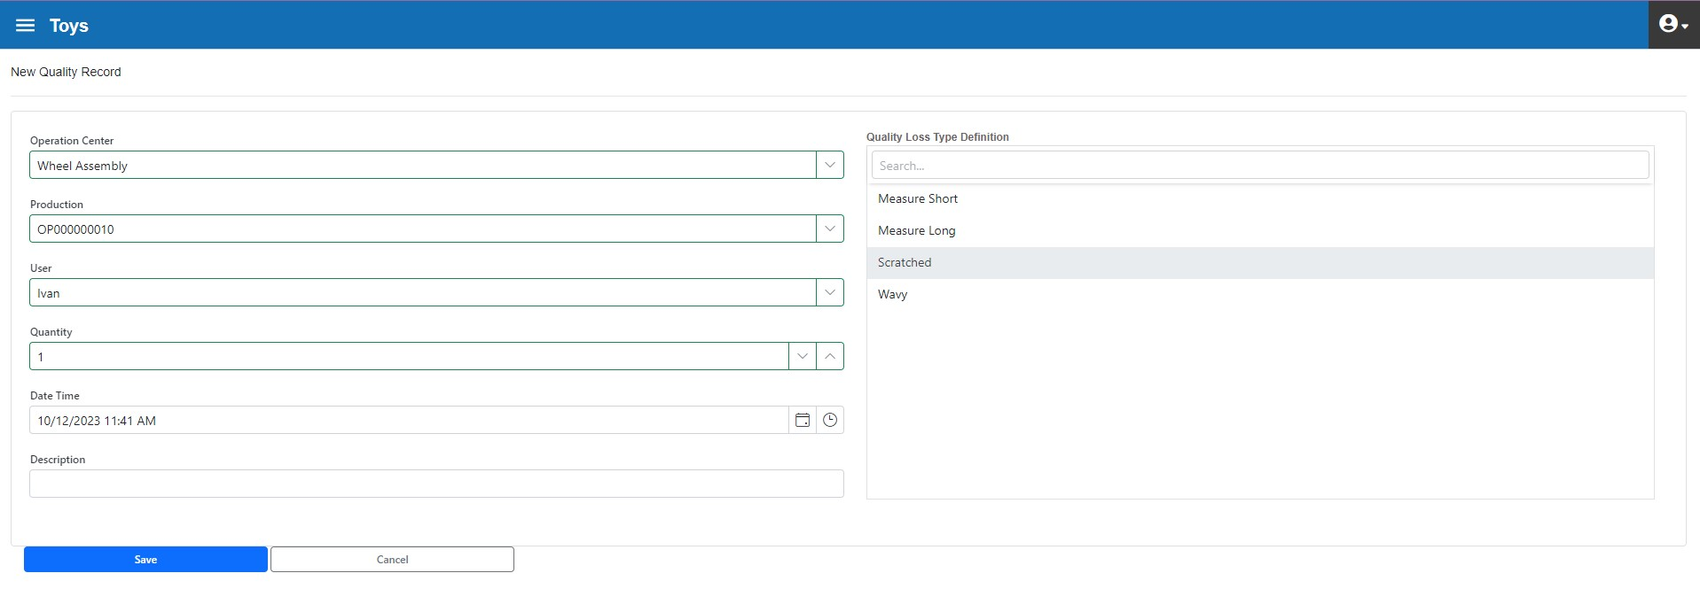
Figure 3.159. Wheel Assembly Operation Center, Quality Loss Input while Operation Order is Ended

Wheel Assembly Operation Center Review

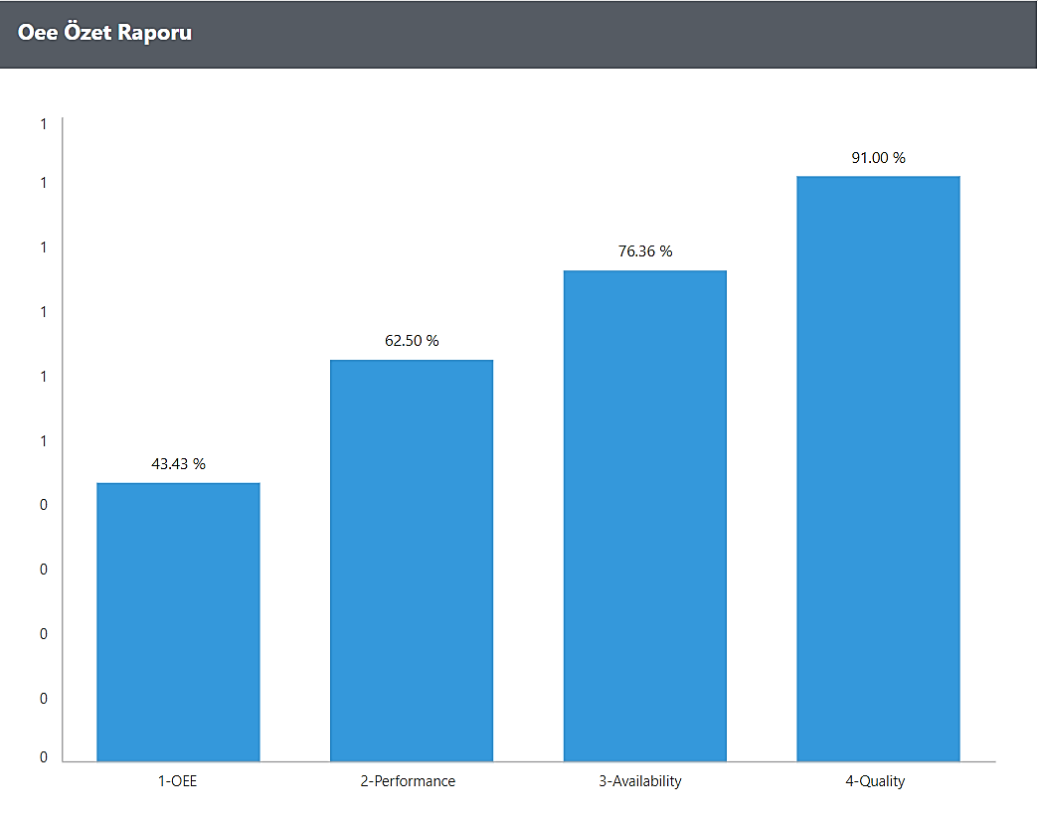
Figure 3. 160. Wheel Assembly Operation Center, Daily OEE Report

The target-actualized OEE report can be seen in Figure 3.161. According to the report, OEE and all other parameters are well below the targets.

The target cycle time was 30 seconds, while the actual cycle time was 48 seconds.
Availability is another low parameter. 50 minutes of downtime occurred in the operations centre, 40 minutes of which was material-related downtime.
In addition, 18 quality losses occurred in this operation centre. Therefore, the Quality Rate is low as well
In this operation centre, downtimes, performance and quality loss issues that reduce OEE should be analysed in detail and remedial actions should be taken.
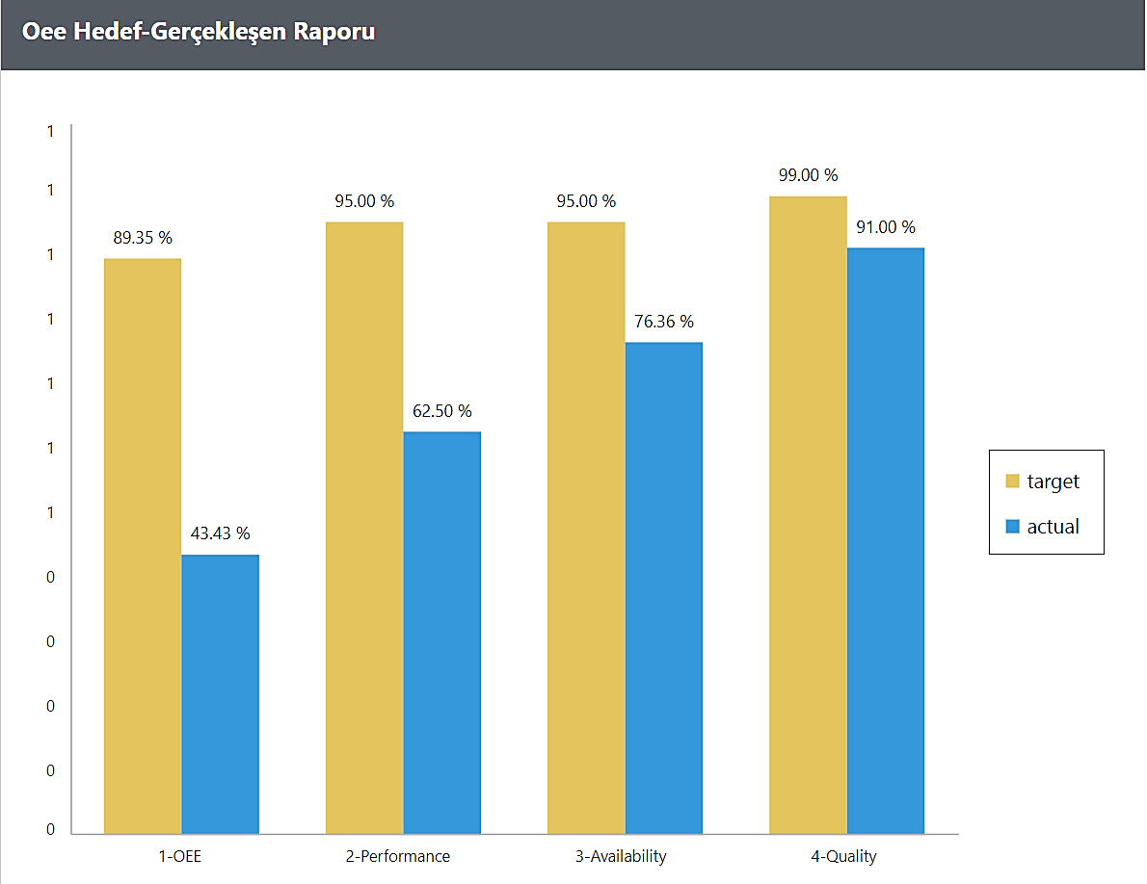
Figure3.161. Wheel Assembly Operation Center, OEE Target-Actual Report

General Review of Operation Centers
General review of Operation Centres are as follows:
Operation Centre | Availability % | Performance % | Quality Rate % | OEE %
Upper Part Bending 1 | 78,57 | 90,91 | 100,00 | 71,43
Upper Part Bending 2 | 86,96 | 100,00 | 98,00 | 85,22
Wheel | 87,48 | 95,45 | 100,00 | 83,50
Lower Part Bending | 90,00 | 83,33 | 98,00 | 73,50
Lower-Upper Assembly | 88,14 | 90,91 | 99,50 | 79,73
Wheel Assembly | 76,36 | 62,50 | 91,00 | 43,43
Table 3.4. OEE Values and Parameters of All Operations Centers

Factory Monitoring
The Factory Monitoring form is used to instantly monitor the activities in all Operation Centres within the plant. These activities include information such as tracking of selected Operation Orders and percentages complete, OEE and OEE parameters, work status of Operations Centre and downtime status, if any.
It is often preferred to monitor the Factory Monitoring form on large TV screens in areas such as shop floor entrance, restaurant, social facilities and to make it visible to managers and employees
The factory monitoring form can be viewed in list (figure 3.162) or box form (figure 3.164)

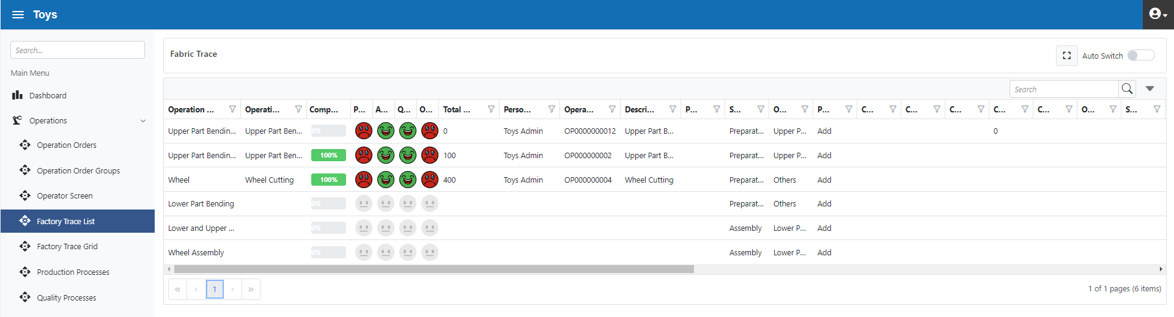
Figure 3.162. Factory Monitoring List Form

Figure 3.164. Factory Monitoring Box Form

Operation Orders
The Operation Orders form is below (figure 3.165). With this form, the general status of the operation orders can be seen and edited.

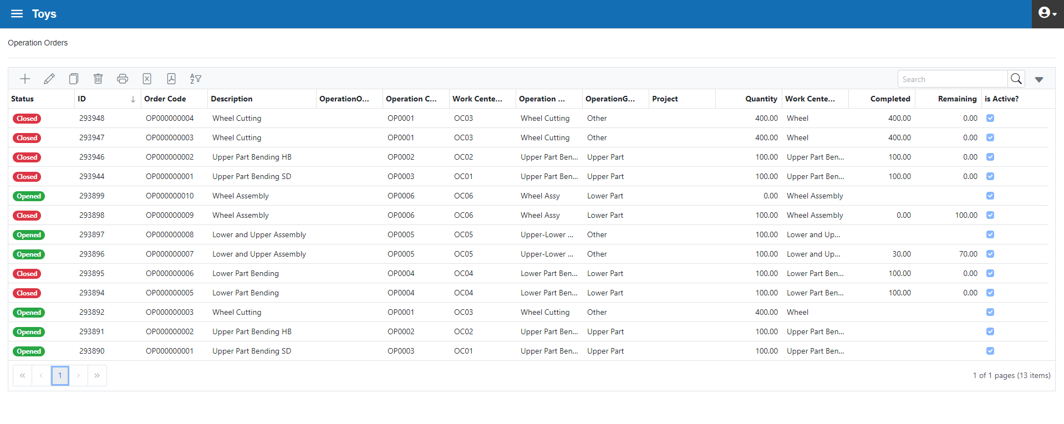
Figure 3.165. Operation Orders

Production Transactions
With the "Production Transactions" form, all operation orders can be modified while the operation is in progress or after it ends. With this form, the start and end date and time, production quantity, production employee and cycle time can be modified for any operation order (figure 3.166). In addition, an Operation Order in progress can be closed with this form
Thus, data that is not entered by the employee during production or entered incorrectly can be corrected.
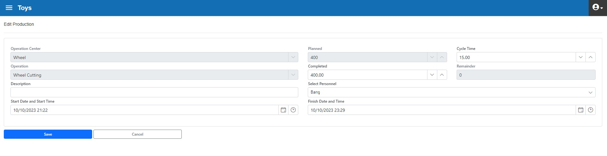
Figure 3.166. Production Transactions form, Production Correction

Quality Transactions

With the "Quality Transactions" form, all quality transactions can be modified while the operation is in progress or after it ends. With this form, quality loss type, quantity, employee can be modified for any operation order (figure 3.167).
Thus, quality loss data that is not entered by the employee during production or entered incorrectly can be corrected.
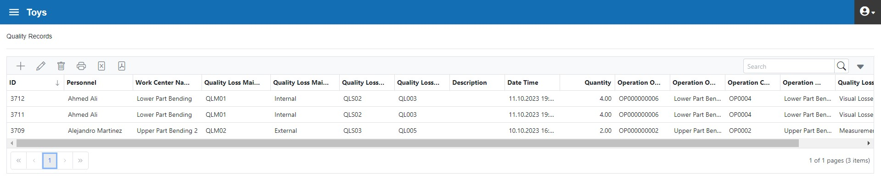
Figure 3.167. Quality Transactions

Downtime Transactions
With the "Downtime Transactions" form, all downtime transactions can be modified while the operation is in progress or after it ends. With this form, downtime type, quantity can be modified for any operation order (figure 3.168).
Thus, downtime data that is not entered by the employee during production or entered incorrectly can be corrected.
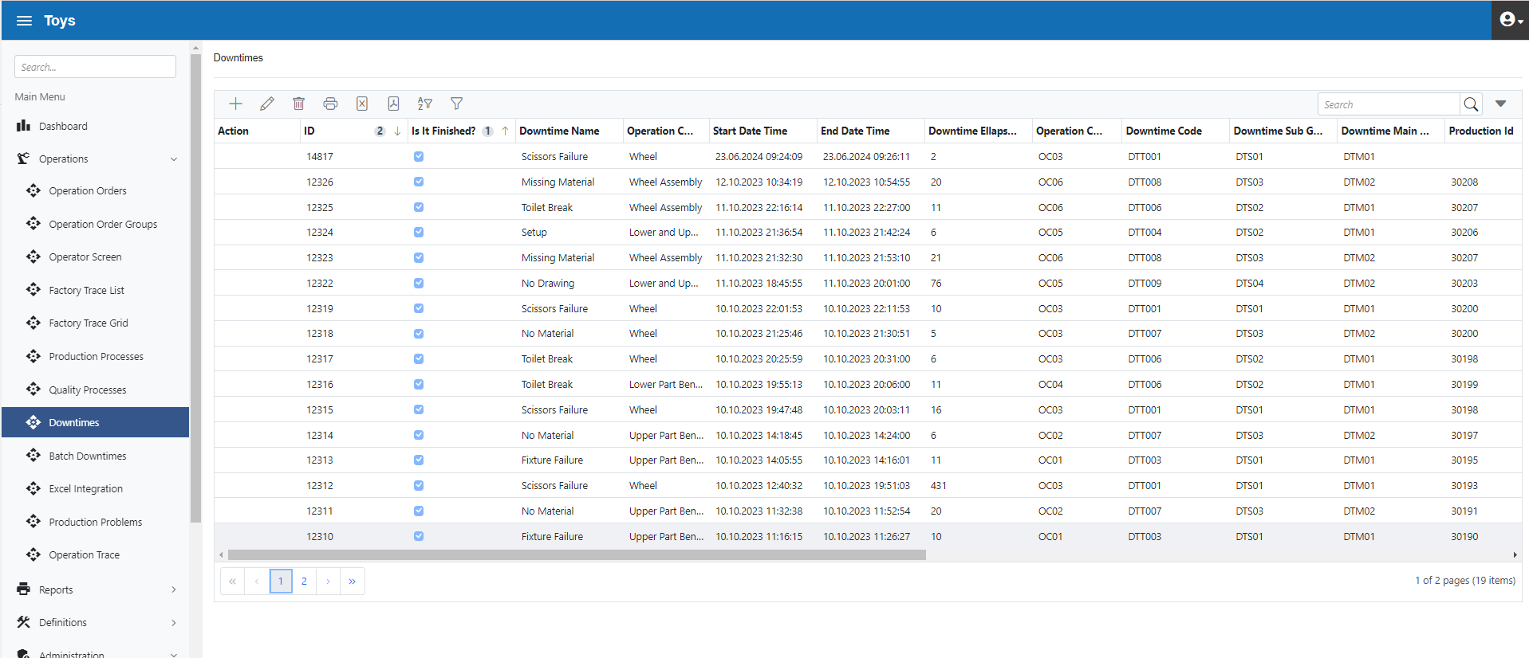
Figure 3.168. Downtime Transaction
A large number of forms of "Batch Downtimes" are used to initiate downtimes simultaneously (such as Meal Downtimes) (Figure 3.169)
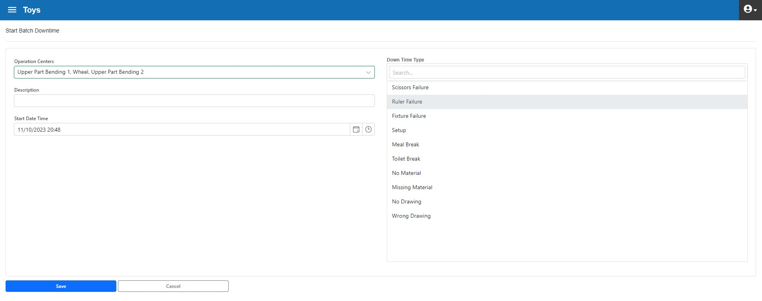
Figure 3.169. Batch Downtime Form

Excel Integration
The "Excel Integration" form is used to import bulk data from Excel into the MES Quick system. This information can be data such as operation orders, inventory items created in 3rd party systems.
In standard usage, the data transfer process works as follows:
- Select the data type to be imported (e.g. "Operation Orders")
- Export Excel template for selected data type
- Fill the data referring to exported template format
- Import Excel file into MES quick

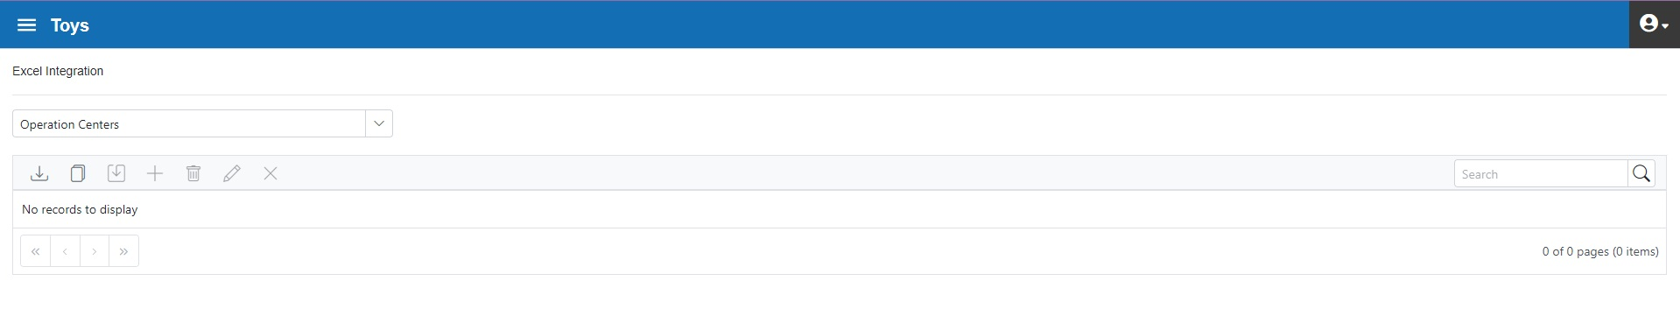
Figure 3.170. Excel Integration

Reports
Production, OEE, downtime and quality reports are available in the system.

Production Reports
A sample production report is provided below.
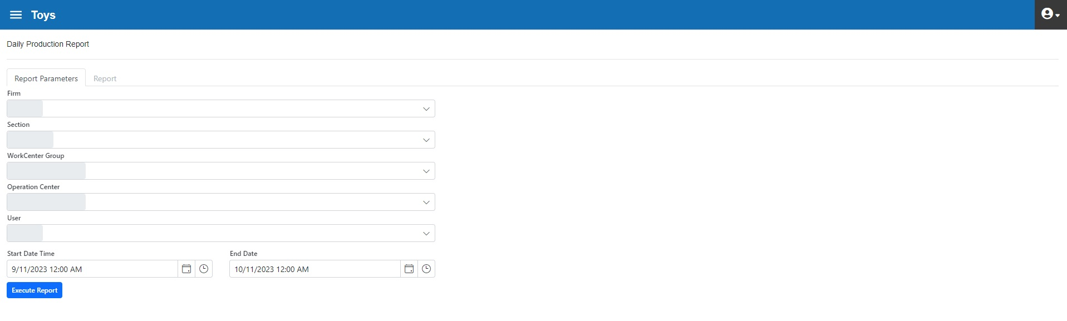
Figure 3.171. Production report filter form

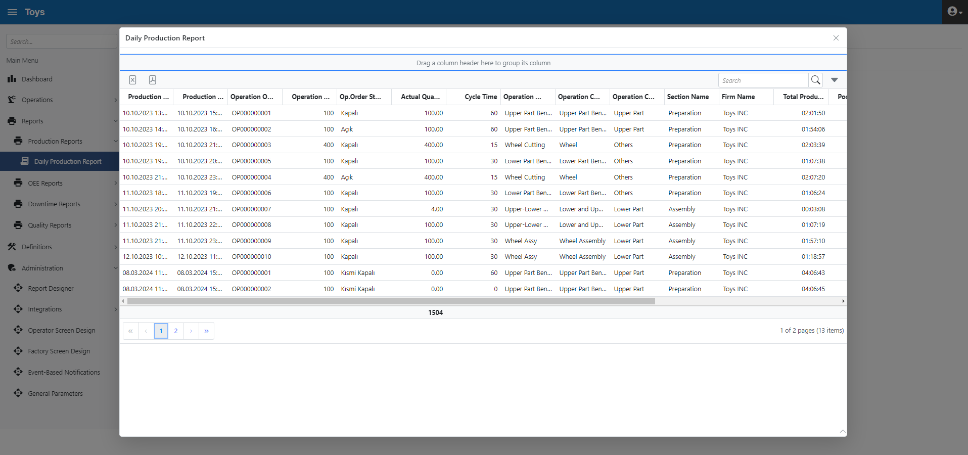
Figure 3.172. Production report

OEE Reports
The system has standard reports such as OEE Report, OEE Target-Actual Report, OEE Trend Report, and OEE Detail Trend Report
Examples of OEE reports and OEE Target-Actual Report reports are shown in this document, under "Case Scenario, Production Data".
With OEE Trend Report, OEE course can be reported in the desired breakdown. The following example shows the target OEE value and the daily realized OEE values (Figure 3.173). Below the target value should be analysed and measures should be taken
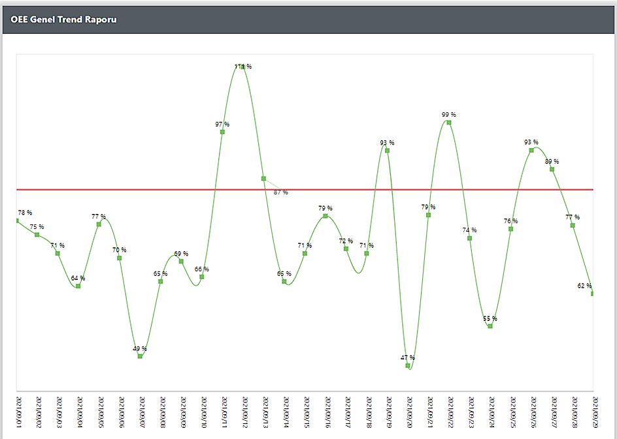
Figure 3.173. OEE Trend Report

Downtime Reports
Downtime reports can be obtained in Downtime Main Groups, Downtime Sub-Groups or Downtime Types (figure 3.174).
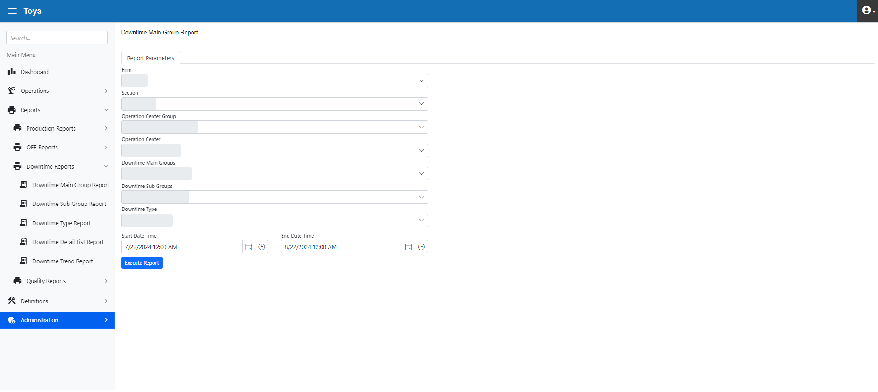
Figure 3.174. Downtime Reports
Below (figure 3.175) shows the Downtime Report in the "Downtime Main Groups" breakdown.
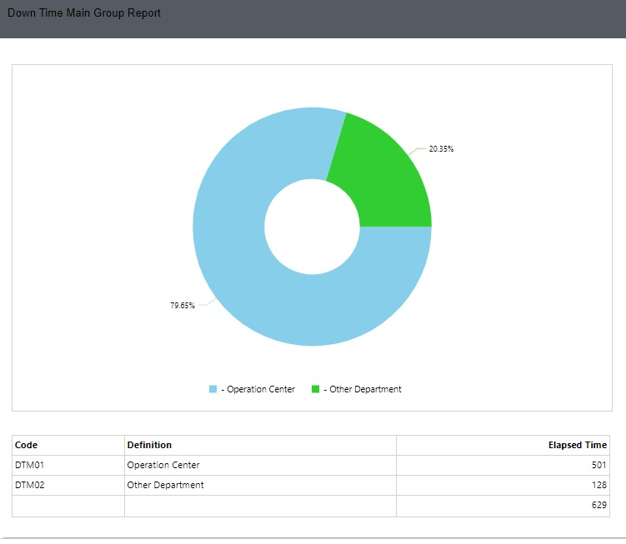
Figure 3.175. Downtime Main Groups Report
Below (figure 3.176) shows the Downtime Report in the "Downtime Sub-Groups" breakdown.

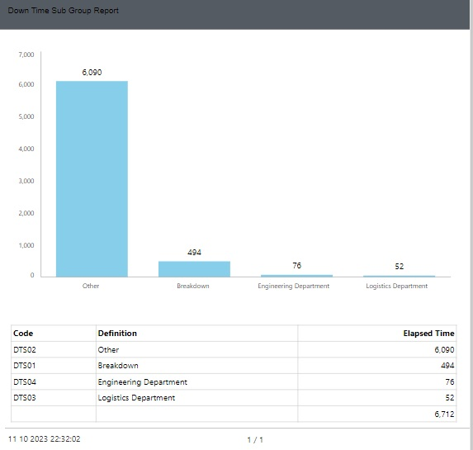
Figure 3.176. Downtime Sub-Groups Report
Below (figure 3.177) shows the Downtime Report in the "Downtime Types" breakdown.

"No material" and "Missing material" can be grouped as material-induced breakdown and resulted in a total breakdown of 70 hours (50+20)
This problem seems to be an issue that needs to be analysed as a priority and corrective measures should be taken to improve plant efficiency
In addition, 35 minutes of fixture failure and 20 minutes of scissor failure occurred. The problem should be addressed with problem solving techniques such as fishbone, 8D, A3 etc. and corrective action should be taken
Finally, toilet break, which has a share of about 20%, is seen as a downtime that affects capacity and is waiting to be improved

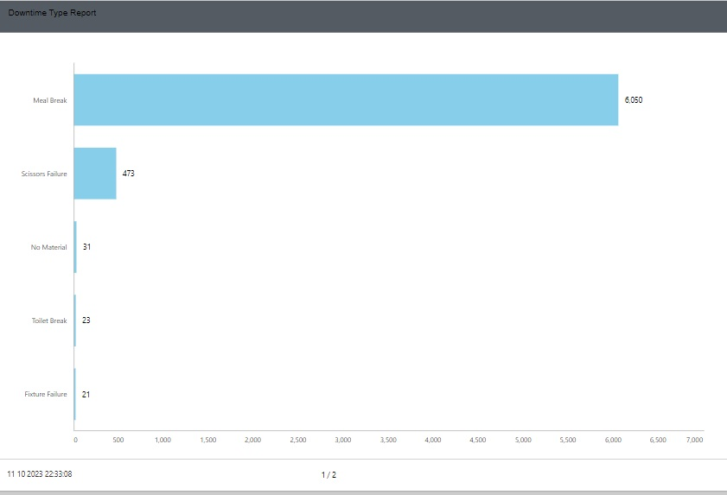
Figure 3.177. Downtime Type Report
Below is the Downtime Trend report. With this report, the downtime course for the selected dowtime can be monitored. Thus, downtime repetition rates are seen and focused for problem solving (figure 3.178)
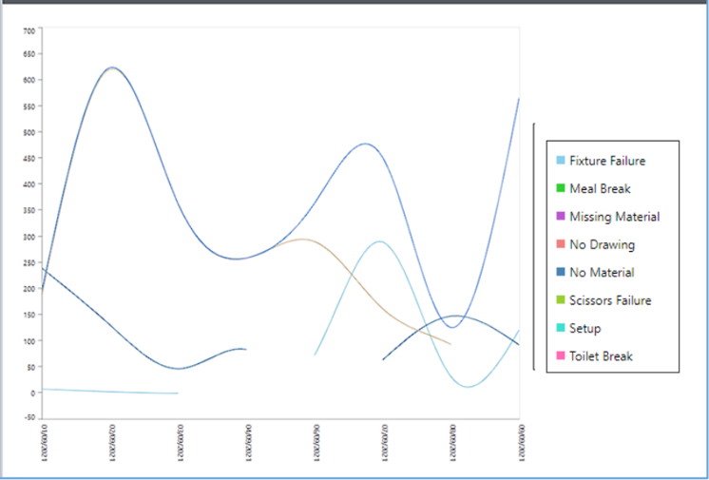

Figure 3.178. Downtime Trend Report

Quality Loss Reports
Quality loss reports can be obtained in Quality Main Groups, Quality Sub-Groups or Quality Types (figure 3.179).

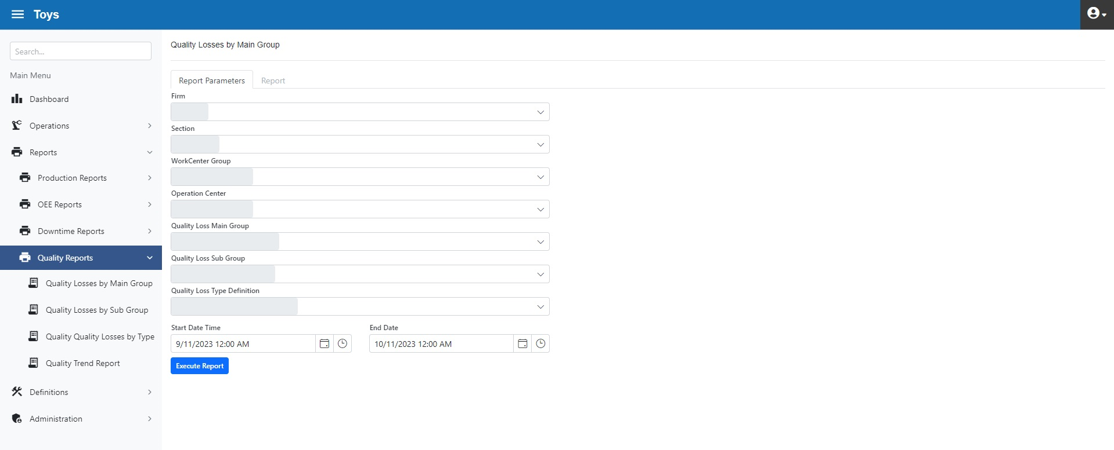
Figure 3.179. Quality Loss Reports, Filtering

Below (figure 3.180) shows the Quality Loss Report in the "Quality Main Groups" breakdown.
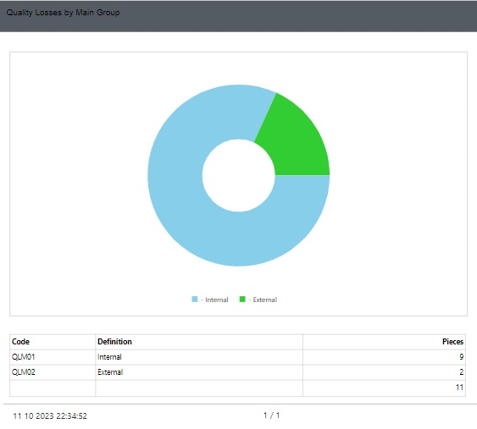
Figure 3.180. Quality Loss, Main Group Report
Below (figure 3.181) shows the Quality Loss Report in the "Quality Sub-Groups" breakdown.

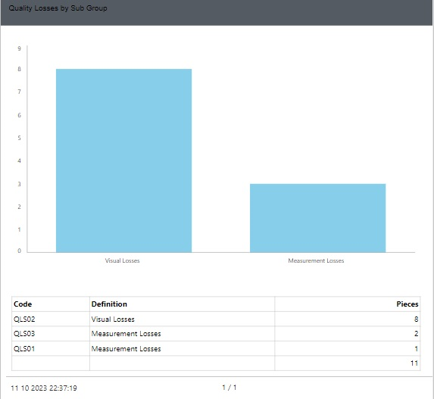
Figure 3.181. Quality Loss, Sub-Group Report
Below (figure 3.181) shows the Quality Loss Report in the "Quality Types" breakdown.

The first place is taken by "Wavy" quality loss with 10 pieces. The source of the problem may be storage conditions, transportation conditions, etc. It should be reviewed and precautions should be taken.
Other quality losses should be handled and improved in a similar way

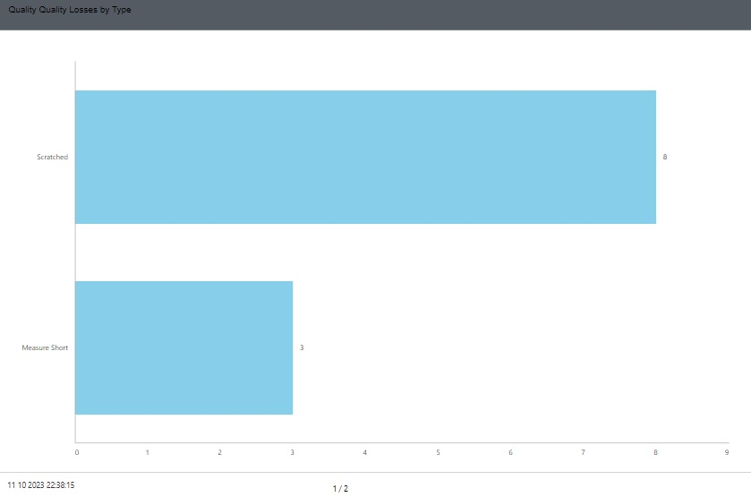
Figure 3.182. Quality Loss, Quality Type Report

Below is the Quality Loss Trend report. With this report, the Quality Loss course for the selected item can be monitored. Thus, quality loss repetition rates are seen and focused for problem solving (figure 3.183)

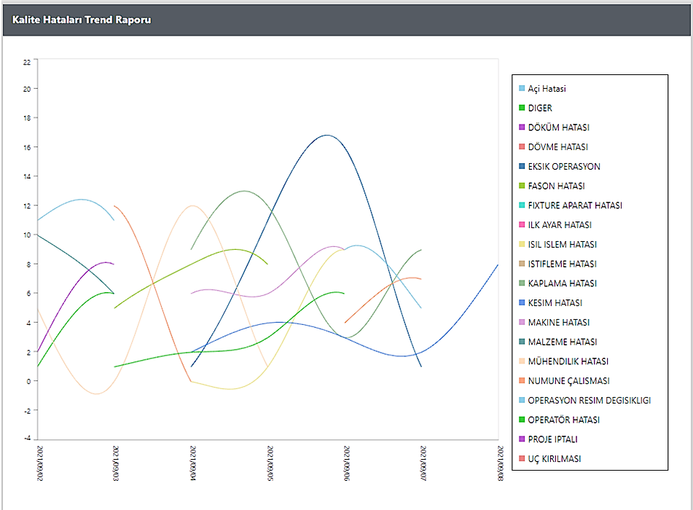
Figure 3.183. Quality Loss Trend Report

Dashboard
"Dashboard" is a form that shows real-time Plant status for administrators. Information such as OEE, workload, Operation Center working status, downtimes can be monitored in real-time.
The following example (figure 3.184) shows real-time data for 6 Operation Centers.
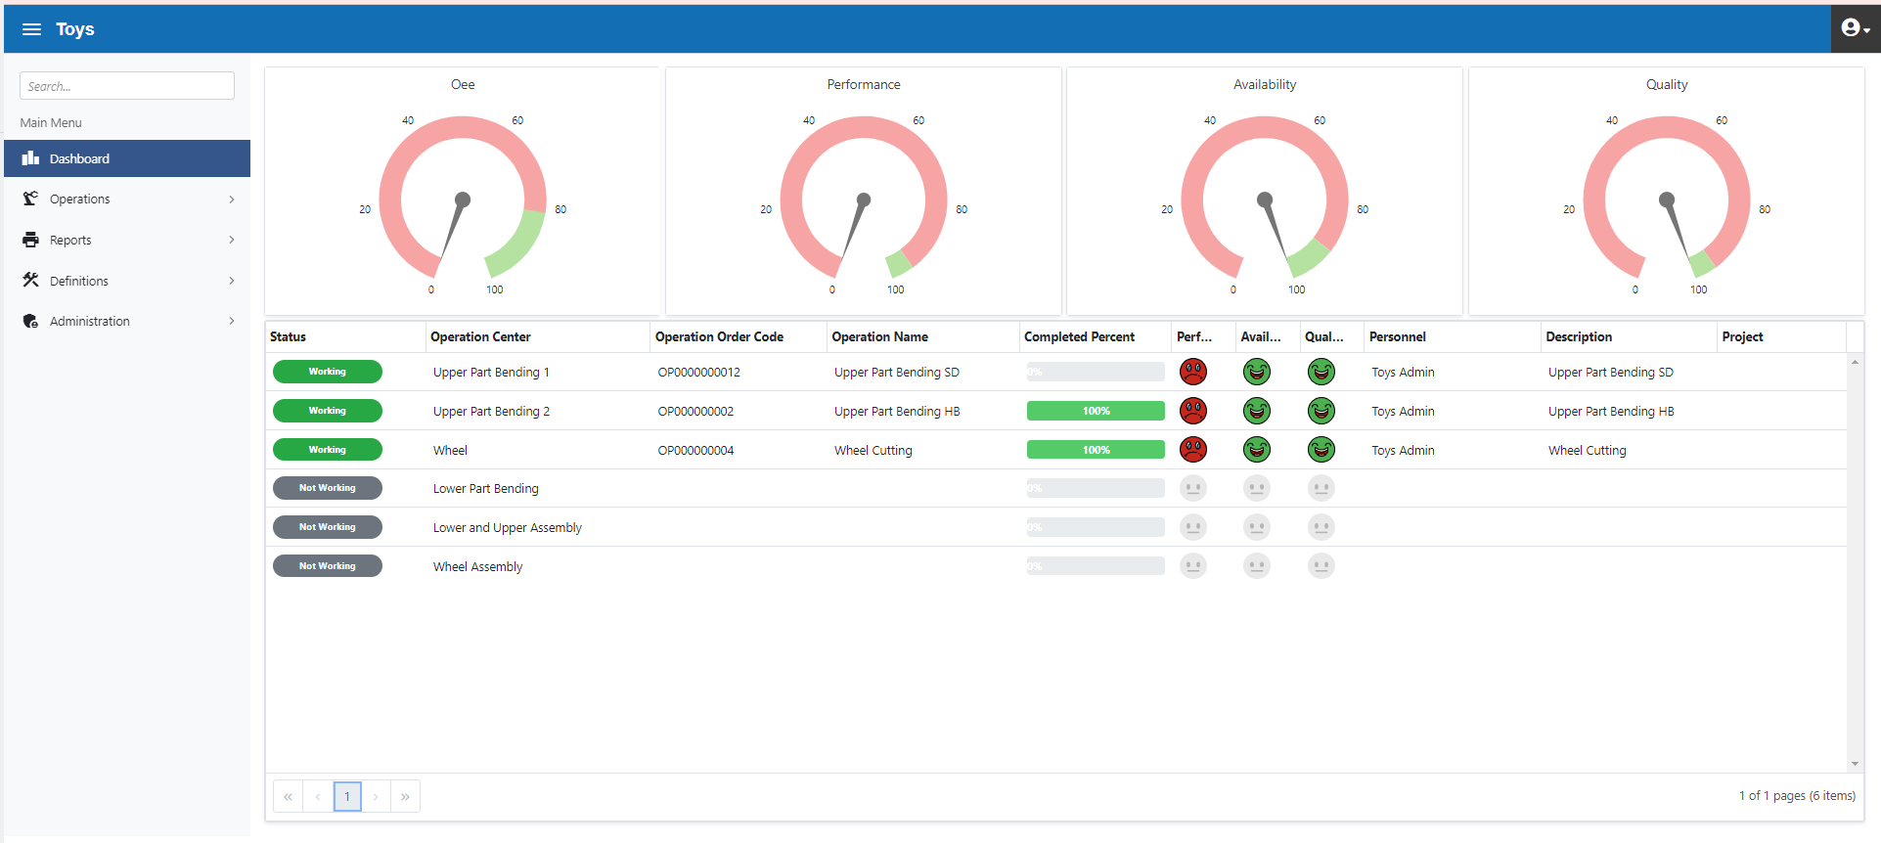
Figure 3.184. Dashboard -1

